Placement of Elements — Teacher Guide

Cover
Unit: The Periodic Table — Lesson 01: Placement of Elements East Meadow Schools × Valley Stream Central High School District Strategy chips: ACTIVE LEARNING · RESTORATIVE CIRCLE

Curated Resources (from East Meadow Scope & Sequence)

NYSSLS Standards
HS-PS1-1 — Use the periodic table as a model to predict the relative properties of elements based on the patterns of electrons in the outermost energy level of atoms. This lesson establishes the foundational claims that the rest of the unit depends on:
- (i) The arrangement of the main groups reflects the patterns of outermost (valence) electrons — elements in the same column have the same number of valence electrons, which is why they behave alike.
- (ii) Elements are arranged by the number of protons in the atom (atomic number), in order, left to right and top to bottom.
HS-PS1-2 is previewed here: the outermost (valence) electron state of an atom — which determines how it reacts — can be read directly from the element’s position in the table. A student who knows an element sits in Group 1 already knows it has one valence electron and will tend to lose it. Position encodes electron configuration, and electron configuration drives chemistry.
The Cross-Cutting Concept of Patterns is the explicit lens: the periodic table is not a random grid but a repeating pattern. The same outer-electron arrangement recurs every time you start a new row, which is exactly why properties repeat periodically — and why the table has the staircase shape it does.

Phenomenon
Project a blank periodic table — just the outline, no symbols — and ask students why it looks the way it does. It is not a neat rectangle. The top row has two boxes hanging far apart with a huge gap between them. The next two rows are short. Then the rows suddenly get much longer, and a separate two-row block floats detached at the bottom. No other chart students have ever seen looks like this. Why would scientists draw it this way on purpose?
The hook is the contrast between arbitrary and meaningful. A phone book is alphabetical — a human convenience. A calendar is a grid — but every box is the same. The periodic table’s lumpy, staircase shape looks arbitrary, but it is the opposite: every notch and gap is forced by the way electrons fill up around the nucleus. The shape is a map of electron arrangement. By the end of the period, students can look at the shape and read the chemistry hidden in it.
Driving question: Why does the periodic table have such a strange, lumpy shape instead of being a plain rectangle?

Javalab / Labs
- Mendeleev “Predict the Element” activity (core ABCs investigation): Students receive a set of element-property cards (mass-like ordering value, reactivity, a common compound formula, metal/nonmetal). Working in groups, they sort the cards so that similar properties line up in columns. One card is deliberately missing, leaving a gap. Using the pattern in the surrounding cards, students predict the properties of the missing element before the teacher reveals it — re-enacting exactly what Dmitri Mendeleev did in 1869 when he predicted “eka-silicon” (later discovered as germanium). The Javalab simulation “Mendeleev’s Periodic Table” (javalab.org) lets students drag element tiles into a grid and watch the periodic pattern emerge; use it as a digital extension or whole-class projection after the card sort.
- Bohr-model column check: Using figures/group1_bohr_li_na.png, students compare the atomic structure of two elements that landed in the same column of their sort (Li and Na). They count outer-shell electrons and discover that both have exactly one — the structural reason the column repeats.
- Period-3 valence trace: Using figures/period3_valence_pattern.png, students walk across one row and watch the valence-electron count climb 1 → 8, connecting horizontal position to electron count.

Assessments
- Element-placement reasoning quiz (district checkpoint, following lesson): given an element’s group and period, students state its number of valence electrons and predict one property (metal/nonmetal, reactive/inert); given an atomic number, students place the element in the correct period and group. See Assessments/ once created.
- Exit Ticket (Phase 5): three items — locate an element from its atomic number, read valence electrons from a group number, and write one Cause/Patterns sentence explaining why two elements in the same group behave alike. The Exit Ticket uses Group 2 (Be vs. Mg) and Group 17, deliberately different elements than the Group 1 (Li/Na) pair practiced on the worksheet. See Answer_Key.docx.

Lesson Overview
Duration | 42 minutes (1 period)
NYSSLS link | HS-PS1-1 (arrangement by atomic number; main-group pattern reflects valence electrons); HS-PS1-2 previewed (position → valence state)
CCC focus | Patterns — the periodic table is a repeating pattern of outer-electron arrangements; properties recur periodically because electron configuration recurs. Position in the table is the pattern.
Strategy chips | ACTIVE LEARNING (Mendeleev card-sort discovery — students build the table before it is named); RESTORATIVE CIRCLE (unit-opening circle)
Materials | Element-property card sets (one per group of 3–4; see Companion Materials), a projected blank periodic table outline, the 2025 NYS Chemistry Reference Tables (Periodic Table), figures/group1_bohr_li_na.png and figures/period3_valence_pattern.png projected, optional device access to javalab.org “Mendeleev’s Periodic Table”
Safety | No chemicals, no lab hazards — this is a modeling and sorting lesson. Standard classroom procedures apply.
Prior knowledge | Unit 06 (Atomic Structure): atomic number = number of protons; Bohr models / electron shells (2, 8, 8…); the idea that electrons occupy energy levels. Students should be able to draw or read a simple Bohr model before this lesson.
Lesson objectives — students can:
- Explain that elements are arranged in the periodic table in order of increasing atomic number (number of protons).
- Identify the period (row) and group (column) of an element from its position.
- State how many valence electrons an element has by reading its main-group number, and explain why elements in the same group share similar properties.
- Explain, using the Patterns CCC, why the periodic table has its characteristic shape — the shape is a map of repeating outer-electron arrangements.

Phase 1 · Engage (0 – 10 min)

0–3 min · Opening Circle + Do Now
Begin with the Restorative Circle (see Strategy Spotlight — this is the opening lesson of the Periodic Table unit, so a unit-opening circle fits naturally). Everyone — teacher included — answers in one sentence: “Think of a time you sorted or organized a big pile of things — cards, clothes, music, a game collection. What did you use to decide the order?” One round, every voice, pass allowed. This surfaces the intuition that good organization follows a rule — and primes the idea that the periodic table is organized by a rule, not by chance.
Then post the Do Now:
“Look at the shape on the screen — the outline of the periodic table with no symbols in it. Write one sentence: what looks strange or unexpected about this shape compared to a normal grid or chart?”
Give students 2 minutes to write silently, then take two or three responses.
Anticipated student responses to Do Now:
- “It’s not a rectangle — there’s a big gap in the top row.” — affirm; that gap is a clue, not a mistake. Hold the thought.
- “Some rows are short and some are long.” — exactly; ask: what could make a row decide to be short or long?
- “There’s a separate chunk floating at the bottom.” — good noticing; that detached block is part of the same puzzle. We will not fully explain that block today, but the rest of the shape we can crack.

3–8 min · Phenomenon hook — the strange shape on purpose
Teacher actions. Project the blank periodic-table outline. Trace the odd features with your finger: the lonely two boxes at the top with the wide gap, the short period-2 and period-3 rows, the sudden widening, the floating bottom block. Then offer the contrast.
Sample teacher language:
“A phone book is alphabetical — that’s just a human convenience; we chose A-to-Z. This table looks like someone spilled it. But here is the strange part: scientists drew this shape on purpose, and they will not let you redraw it as a tidy rectangle. Every gap, every short row, every place where it suddenly gets wider — something is forcing it. The question for today is: what?”
“Here’s my claim, and you’re going to test it: the shape is not a decoration. The shape is a map. By the end of class you’ll be able to point at a box and tell me something true about that atom’s electrons — just from where it sits.”
Anticipated student responses:
- “Maybe the gaps are where elements haven’t been discovered yet?” — interesting hypothesis; great instinct — that is literally how Mendeleev used the table, which we’ll see in the activity. But the gaps in the shape are about structure, not undiscovered elements.
- “Are the rows short because there are fewer of those kinds of atoms?” — close to the real idea; the rows are short or long because of how many electrons fit in each energy level. Hold that.
- “I think it’s just how it ended up.” — fair guess; today’s whole job is to find out whether it is random or forced.
Driving question (post on the board and leave it there):
Why does the periodic table have such a strange, lumpy shape instead of being a plain rectangle?

8–10 min · Notice & Wonder + Turn-and-Talk #1
Two columns on the board: I notice… / I wonder…
Collect 3–4 responses about the blank outline. Then:
“Turn to your partner: if the shape is a map of something — like a subway map is a map of stations — what do you think it could be a map of? What about an atom could possibly decide what column or row it goes in?”
Target insight (leave open if no one lands it): something inside the atom — how many protons it has, or how its electrons are arranged — sets its address in the table. We will pin this down in the Explore phase before naming it.

Phase 2 · Explore (10 – 30 min)

10–16 min · ABCs Activity — Mendeleev card sort (before any formal vocabulary)
Before any formal vocabulary is introduced, students recreate the discovery of the periodic table by sorting element-property cards — the ACTIVE LEARNING core of the lesson. Hand each group of 3–4 a card set. Each card lists, for one element: an ordering value (a stand-in for atomic mass/number), a reactivity note, a common compound formula, and metal/nonmetal.
The task (post on the board):
“You are 1869. The word ‘periodic table’ does not exist yet. Arrange these cards so that (1) the ordering value increases as you go and (2) cards with similar properties line up underneath each other in columns. One card is missing — leave a gap where it belongs.”
Students physically arrange the cards on the desk. Circulate and resist naming anything yet.
Teacher facilitation language (circulate):
“Don’t tell me the answer yet — show me the columns. Why did you put this card under that one? What do they have in common?”
“You left a gap — good. What does the pattern around the gap tell you about the card that’s missing? Could you describe the element that should be there even though you’ve never seen it?”
Anticipated student responses during ABCs:
- “We put all the ones that react violently with water in the same column.” — excellent; that column is going to turn out to be Group 1. Ask: what do they all form? the same kind of compound?
- “The formulas repeat — every element in this column makes an XCl compound.” — that is the pattern doing the work; affirm strongly.
- “The missing one should be a metal, react like its neighbors, and have an ordering value between these two.” — that is exactly Mendeleev’s move; celebrate it. They just predicted an element.

16–22 min · Initial Model — predict the missing element
Prompt on the board:
“Before we reveal anything: write a short ‘wanted poster’ for the missing element. Predict (a) metal or nonmetal, (b) roughly how reactive, (c) the formula of a compound it would form — using only the pattern in the cards above and below the gap.”
Students write individually for 3 minutes, then compare with their group.
Teacher actions. Reveal the missing element (e.g., the activity’s stand-in for germanium, which Mendeleev predicted as “eka-silicon” in 1871 and which was discovered in 1886 — its real properties matched his prediction closely). Project the Javalab “Mendeleev’s Periodic Table” simulation if devices are available, and let students see the full pattern snap into place.
Sample teacher language:
“Mendeleev did exactly what you just did. He left gaps in his table and predicted the missing elements’ properties from the pattern around the gap. Years later, those elements were discovered — and his predictions were right. That is the power of a pattern: it lets you describe something you have never seen.”
Anticipated student responses:
- “How could he be sure?” — he wasn’t sure; he predicted, and the prediction was testable. When germanium was found, it matched. That is science: pattern → prediction → test.
- “So the gaps were undiscovered elements?” — yes — in the real table. And the reason the pattern existed at all is the thing we’re about to uncover with the Bohr models.

22–30 min · Investigation — why do the columns repeat? (Bohr-model evidence)
Now connect the sort to atomic structure. Bring up the two Bohr models of elements that landed in the same column of the sort.
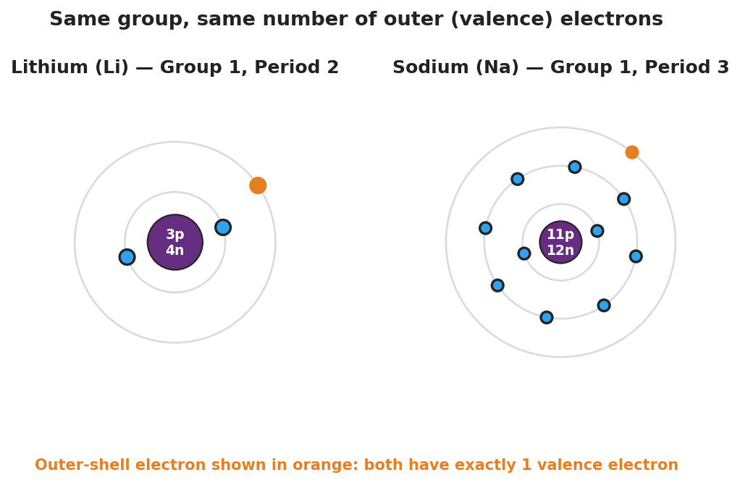
Side-by-side Bohr models of lithium (3 protons, 4 neutrons, electron shells 2 and 1) and sodium (11 protons, 12 neutrons, electron shells 2, 8, and 1). In each atom the single outer-shell electron is highlighted in orange. A caption notes that both elements, although different sizes, have exactly one valence (outer-shell) electron because both belong to Group 1.
Task: students count the outer-shell electrons on each model and record them in the worksheet.
Teacher facilitation language:
“These two elements landed in the same column in your sort because they behave alike. Now look inside them. Count the electrons in the outermost ring on each one. Lithium: how many? Sodium: how many? What do you notice?”
“They’re different sizes — sodium has way more electrons total. But the outer ring? Same number: one. That is not a coincidence. That one outer electron is what makes both of them react the same way.”
Then trace a single row using the second figure:
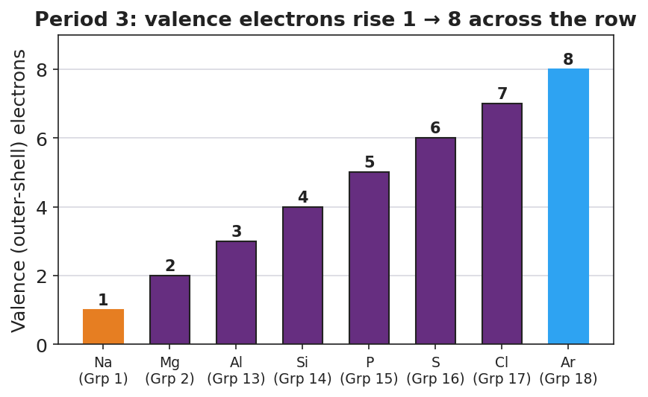
Bar chart titled ‘Period 3: valence electrons rise 1 to 8 across the row.’ Eight bars show the number of outer-shell (valence) electrons for the Period 3 elements from sodium (group 1, one valence electron) on the left rising one at a time to argon (group 18, eight valence electrons) on the right. Sodium’s bar is orange and argon’s bar is blue to mark the ends of the row.
“Now walk across one row instead of down a column. Sodium has 1 outer electron, magnesium 2, aluminum 3 … all the way to argon with 8. The outer-electron count climbs by one each step across the row. When the row ‘fills up’ at 8, the table starts a brand-new row — and the count resets to 1. That is why the rows end where they do. The shape is forced by how electrons fill.”
Anticipated student responses:
- “So going down a column keeps the outer electrons the same, but going across a row adds one each time?” — yes, exactly — you just stated the entire logic of the table.
- “Is that why the first row is so short — only two boxes?” — yes; the very first energy level holds only 2 electrons, so period 1 has only 2 elements. The shape literally counts electron capacity. (Full detail comes in later lessons; the intuition is enough today.)
- “So the gaps and short rows are about electrons, not about missing elements?” — right; two different ideas. Mendeleev’s gaps were undiscovered elements; the shape itself is set by electron filling.

28–30 min · Reconnect + surface the method
Bring groups back together. Point at the blank-outline shape from Phase 1 again.
“Return to the strange shape. You now have two facts: (1) every element is placed in order of its number of protons, and (2) columns share outer-electron count while rows build it up to 8 and then restart. Put those together: the shape is a map of how electrons arrange themselves. Same column = same outer electrons = same chemistry. That is the secret the shape was hiding.”
Surface the key idea, still in plain language: the table is ordered by proton count, columns repeat outer-electron arrangement, and that repetition is why properties are periodic — the root of the word “periodic table.”

Phase 3 · Explain (30 – 36 min)

30–33 min · Turn-and-Talk #2 + class consensus
“Look at your card sort and your two Bohr models. Turn to your partner: in your own words, what does an element’s column tell you, and what does its row tell you? Try to say it without using the words ‘period’ or ‘group’ — describe the actual electron idea.”
Target consensus: the column tells you how many outer electrons an atom has (so the column tells you how it will react); the row tells you how many electron energy levels (shells) the atom has, because each new row starts a new shell. Elements line up in order of proton count.
“If I tell you a brand-new element sits directly below lithium and sodium in that first column, what can you already predict about it — without looking it up?”
Target: it has 1 outer electron, it is a reactive metal, and it forms the same kind of compounds (e.g., an XCl). Position predicts chemistry.

33–36 min · Vocabulary introduction (exactly 3 terms)
Sample teacher language:
“Let’s name the three things you’ve been working with all period. The horizontal rows are called periods — period 1, period 2, and so on. The row number tells you how many electron shells the atom is filling. The vertical columns are called groups — and for the main-group elements, the group number tells you the number of outer electrons. And those outer electrons — the ones in the highest energy level, the ones that do all the reacting — are called valence electrons.”
“So here is the whole lesson in one breath: elements are placed in order of atomic number; the period (row) tells you how many shells; the group (column) tells you how many valence electrons; and valence electrons decide chemistry. Position in the table is electron configuration.”
Post the three terms on the board. Students fill them in on their notes.
Discussion prompts to deploy here:
- “Sodium is in Period 3, Group 1. Translate that into electrons.” — Expected response: 3 shells (period 3) and 1 valence electron (group 1) — exactly the Bohr model 2, 8, 1.
- “Two elements are in the same group but different periods. What is the same about them, and what is different?” — Expected response: same number of valence electrons (same chemistry), different number of shells (different size). That is the Li-vs-Na figure.

Phase 4 · Elaborate (36 – 40 min)

36–39 min · Revise the model + Because/But/So expansion
Students return to their Initial Model (the “wanted poster” prediction). They revise it by labeling, with the new vocabulary, why their prediction worked: the missing element shared a group, so it shared the same number of valence electrons, so it behaved like its column-mates.
Then run a Because / But / So sentence about the phenomenon. Starter on the board:
“Lithium and sodium are in different periods but the same group.”
Model one aloud:
“Lithium and sodium behave almost identically because they are in the same group, so they have the same number of valence electrons — exactly one — but they are in different periods, so sodium has one more electron shell than lithium and is a larger atom — so the periodic table places them in the same column to show that their chemistry matches even though their size differs.”
Then have students write their own B/B/S using one of these starters:
- “The periodic table starts a brand-new row after the outer shell fills…” (hint: outer electrons reach 8, then reset to 1)
- “An element in Group 17 reacts very differently from an element in Group 1…” (hint: 7 valence electrons vs. 1)
Anticipated student responses:
- “Because they both have one outer electron.” — good start; push for the full frame: “because both are in Group 1 with one valence electron, but they sit in different periods, so they share chemistry but differ in size.”
- “Because Group 17 has 7 valence electrons and Group 1 only has 1.” — excellent; push for the So: “so one tends to gain/share an electron and the other tends to lose one — opposite chemistry, set entirely by position.”

39–40 min · Return to the phenomenon
“Return to the strange shape we started with. Can you now answer the driving question in one sentence? Why does the table have that lumpy, staircase shape instead of being a rectangle?”
Target: the shape is forced by how electrons fill energy levels — each row builds outer electrons up to a full set, then a new row (and a new shell) begins, so rows are short or long depending on how many electrons that level holds; columns line up atoms with matching outer electrons. The shape is a map of electron arrangement, not a decoration.
“That’s the payoff. The table isn’t a rectangle because atoms aren’t built like a rectangle. The shape is the chemistry.”

Phase 5 · Evaluate (40 – 42 min)

40–42 min · Exit Ticket + Closing Reflection
Post or read aloud:
(a) Element X has atomic number 12. State its number of protons, and use the Periodic Table to give its period and group. (b) Beryllium (Be) and magnesium (Mg) are both in Group 2. How many valence electrons does each have, and what does that tell you about how they react? (c) In one sentence, explain — using the idea of valence electrons — why two elements in the same group behave alike even though one is much larger than the other.
Expected answers are in Answer_Key.docx. Note: the Exit Ticket uses Group 2 (Be, Mg) and atomic number 12, deliberately distinct from the Group 1 (Li, Na) pair students practiced on the worksheet, so the exit check measures transfer rather than recall.
Closing Reflection (SEL, 30 seconds):
“Today a shape that looked random turned out to be a hidden map. In one sentence: what is one thing that surprised you about how organized the periodic table really is — and who, a partner or a moment in the activity, helped you see it?”
Collect worksheets; note which students can translate a position (period + group) into electron information versus students who can name period/group but cannot yet connect group number to valence electrons. The group → valence-electron link is the key transfer skill — target those students for a brief check at the start of the next lesson.

Common Misconceptions
- Misconception: “Elements are arranged by atomic mass / by weight.” → Correction: Elements are arranged by atomic number — the number of protons — in strictly increasing order. Mendeleev originally used mass and it mostly worked, but there are places (e.g., Te before I, Ar before K) where the masses run backwards while the chemistry is right. Moseley’s work showed proton count is the true ordering principle. Mass and atomic number usually increase together, which hides this distinction unless you look closely.
- Misconception: “The group number and period number are just labels, like seat numbers — they don’t mean anything physical.” → Correction: For main-group elements they are physically meaningful: the period number equals the number of occupied electron shells, and the group number tells you the number of valence electrons. Position encodes electron configuration.
- Misconception: “Elements in the same group are the same element, or are isotopes of each other.” → Correction: Same-group elements are different elements with different numbers of protons. They are alike only in their number of valence electrons, which is why their chemistry is similar — but lithium and sodium are not the same substance.
- Misconception: “The strange shape of the table means scientists haven’t finished organizing it / it’s just historical sloppiness.” → Correction: The shape is forced, not sloppy. Rows are short or long because of how many electrons each energy level holds; the staircase is the most honest way to keep same-valence elements in the same column. Re-drawing it as a rectangle would break the pattern that makes it useful.
- Misconception: “Valence electrons are all the electrons in the atom.” → Correction: Valence electrons are only the electrons in the outermost energy level. Sodium has 11 electrons total but only 1 valence electron. The inner electrons exist, but it is the outer ones that determine how the atom bonds and reacts — which is why the group, not the total electron count, predicts chemistry.

Access & Differentiation
- ELL/ENL supports: Sentence frames for the card sort and Exit Ticket: *“These elements belong in the same column because ___.”* and *“An element in Group ___ has ___ valence electrons, so it ___.”* Word-choice box displayed on the board throughout: {period, group, valence electrons, atomic number, column, row, pattern}. Pair vocabulary with gestures: sweep a hand down a column for “group / same valence electrons,” sweep across a row for “period / building up shells.” Provide the card set with both a picture cue (metal = shiny block, nonmetal = matte) and the English property word.
- IEP/SPED supports: Provide a pre-structured card-sort mat with the column and row outlines already drawn and the “ordering value” axis pre-labeled, so the student’s task is to place cards into a scaffold rather than build the grid from scratch. Pre-highlight the outer ring on each Bohr model figure so the valence electrons are visually isolated. Offer a partially completed Bohr-count table (lithium = 1 already filled in) and ask the student to complete sodium. Provide Exit-Ticket sentence starters.
- Extensions: (1) Mendeleev left a gap for “eka-silicon” and predicted its density, mass, and oxide formula; research germanium and list two of his predictions that turned out correct. (2) Find one place in the modern table where ordering by atomic mass would put two elements in the wrong order (Ar/K or Te/I) and explain why ordering by atomic number fixes it. (3) The detached block at the bottom (lanthanides/actinides) is normally pulled out to keep the table narrow. Sketch where it would go if the table were drawn at full width, and write a sentence on why publishers detach it.

Strategy Spotlight
ACTIVE LEARNING — discovery card sort (the Mendeleev re-enactment). Active learning means students construct the concept through a task before the teacher names it, rather than receiving the definition first and applying it after. For this lesson, students literally build the periodic table from property cards — sorting, finding the repeating pattern, locating a gap, and predicting the missing element — exactly as Mendeleev did in 1869. The term “periodic table,” and the words period, group, and valence electron, are withheld until Phase 3, after the pattern has already done its work in the students’ hands.
Why active learning fits this content: the periodic table is, more than almost any object in chemistry, a discovered pattern. Handing students the finished table and asking them to memorize group numbers teaches the table as trivia. Having them rebuild it teaches the table as a logic. Students who have personally left a gap and predicted what fills it understand, at a gut level, that position predicts properties — the core idea of HS-PS1-1.
How to run it in this lesson (Phase 2):
- Give each group a card set with one element missing; do not pre-explain the goal beyond “increasing order, similar things in columns.”
- Circulate with questions, not answers: Why did this card go under that one? What does the gap tell you?
- Have each group write a “wanted poster” prediction for the missing element before the reveal (Phase 2 Initial Model).
- Reveal the missing element and, if devices allow, project the Javalab “Mendeleev’s Periodic Table” simulation so the full pattern snaps into place.
- Only then (Phase 3) attach the formal vocabulary to the structure students already built.
RESTORATIVE CIRCLE (unit-opening circle). Because this is the first lesson of the Periodic Table unit, a brief opening circle (2–3 min) welcomes every voice before the content begins. The prompt — “a time you sorted or organized a big pile of things, and what you used to decide the order” — is chosen to surface the lived intuition that organization follows a rule. When students later discover that the table is organized by electron arrangement, they recognize their own sorting logic in it. The circle is not graded and not about chemistry; it is about belonging and about priming the day’s big idea.
CRSE connection: the card sort is a hands-on, low-language-barrier entry point that does not privilege students who have pre-memorized the table. Every group starts from the same cards and the same question, so prior exposure matters less than careful observation — leveling the field. The Mendeleev story also models science as a human, revisable enterprise: a 19th-century chemist made a bold prediction, left honest gaps, and was later proven right, which positions students’ own predictions as legitimate scientific acts.

NYSSLS Observation Checklist Crosswalk
# | Checklist item | Where it appears in this lesson
1 | Local/relatable phenomenon | Phase 1 — the “strange shape” of the blank periodic-table outline; return in Phase 4 to explain why the shape is forced, not arbitrary
2 | Turn and Talk (2–3×) | Phase 1 (TT#1 — what could the shape be a map of?); Phase 3 (TT#2 — what does a column tell you vs. a row, in electron terms?)
3 | Students develop questions/models/procedures | Phase 2 Mendeleev card sort (build the table); Initial Model “wanted poster” prediction; Bohr-model valence count; Phase 4 model revision
4 | CCC defined and used | Lesson Overview · Patterns; explicit in Phase 2 (repeating columns), Phase 3 vocabulary, and Phase 4 B/B/S (same group → same valence electrons)
5 | ENL — ≤ 3 vocab, second half | Phase 3 — vocabulary introduced at 33–36 min: period / group / valence electrons
6 | Revisit phenomenon with evidence | Phase 4 — students return to the strange shape and explain it using atomic-number ordering + the row/column valence pattern from the Bohr-model and Period-3 figures
7 | ENL/SPED supports | Access & Differentiation block: sentence frames, word-choice box, gesture cues, pre-structured sort mat, pre-highlighted valence electrons, partial Bohr-count table
8 | Assessment check | Phase 5 — Exit Ticket (locate element from atomic number; read valence electrons from group number; one Patterns sentence on same-group similarity), using Group 2 / atomic number 12 distinct from worksheet practice

Companion Materials
- Student_Worksheet.docx — the 5E student investigation (hand out at start of Phase 2)
- Student_Notes.docx — guided note-guide for vocabulary and the worked period/group example
- Answer_Key.docx — answers to “Make It Make Sense” prompts and the Exit Ticket
- Element-property card set — teacher-prepared deck for the Mendeleev sort (8–10 elements spanning two short periods, one element omitted to create the gap); a printable master can live in the unit’s _assets/ folder.

Key Vocabulary (max 3)
- period — a horizontal row of the periodic table; the period number tells you how many electron energy levels (shells) the atom’s electrons occupy. Period 3 elements, for example, fill three shells.
- group — a vertical column of the periodic table; for main-group elements, the group number tells you the number of valence electrons, which is why elements in the same group have similar chemical properties.
- valence electrons — the electrons in an atom’s outermost energy level; they determine how the atom bonds and reacts. The number of valence electrons can be read directly from an element’s group, which is how position in the table predicts chemistry.

