Classes of Elements — Teacher Guide

Cover
Unit: The Periodic Table — Lesson 03: Classes of Elements East Meadow Schools × Valley Stream Central High School District Strategy chips: BTC

Curated Resources (from East Meadow Scope & Sequence)

NYSSLS Standards
HS-PS1-1 / HS-PS2-6 (applied) — Students use patterns in observable physical properties to classify the elements into metals, nonmetals, and metalloids, and they connect those property patterns to a substance’s tendency to react. Per the East Meadow Scope & Sequence, the emphasis here is explicitly not on memorizing group names — it is on the reactivity and property patterns that distinguish the three classes. Students practice SEP-4 (Analyzing and Interpreting Data) by collecting qualitative property data in a hands-on comparison and SEP-2 (Developing and Using Models) by sorting elements into a property-based classification model.
The Cross-Cutting Concept of Patterns is the explicit lens: the same cluster of properties — luster, conductivity, malleability — repeats across many elements, and that repeated pattern is what lets a chemist predict an element’s behavior (including how readily it reacts) before ever running a reaction. Classification is not labeling for its own sake; it is a predictive tool.

Phenomenon
Hold up two everyday objects side by side: a bright copper pipe coupling (or a stripped copper wire) and a yellow lump of sulfur (or a piece of charcoal / graphite from a pencil). Tap each one — the copper rings and stays intact; bend it and it flexes without breaking. The sulfur is dull, and if you press or drop it, it crumbles into powder. Touch each to a simple battery-and-bulb circuit: the copper lights the bulb, the sulfur does nothing. Same shelf, same lab — two solids that could not behave more differently. Why is one shiny, bendable, and able to carry electricity, while the other is dull, brittle, and an insulator? The contrast is immediate and physical, and it sets up the central question: what is it about these elements that makes them act so differently — and can we predict which “team” a brand-new element belongs to before we test it?

Javalab / Labs
- Metal vs. nonmetal property-comparison lab: Students test a small tray of element samples (copper, aluminum or iron, carbon/graphite, sulfur, and a silicon or boron sample if available) for three properties — electrical conductivity (battery + bulb or a conductivity tester), malleability (gentle tap with a mallet: does it flatten or shatter?), and luster (shiny or dull?). They record results in a table and sort the samples into “metal-like” and “nonmetal-like” piles, then notice the in-between sample. Connect to figures/metal_vs_nonmetal_properties.png.
- The Ductility and Malleability of Metal — Javalab: the interactive simulation (javalab.org, “Ductility and Malleability of Metal”) lets students stretch and hammer a metal’s atomic lattice on screen and watch the atoms slide past one another without the bonds breaking — a clean visual for why metals bend instead of shatter. Use it during Explore as a virtual station, or project it during Explain to model the particle behavior behind malleability.
- Classification figure: figures/classes_of_elements.png summarizes the three classes, their property clusters, and example elements — use for the consensus model in Phase 3/4.

Assessments
- Metal / nonmetal / metalloid classification check (district formative): students are given a short list of mystery elements with their measured properties (luster, conductivity, brittleness) and must classify each as metal, nonmetal, or metalloid and justify with the property evidence. See Assessments/ folder once created.
- Exit Ticket (Phase 5): a previously-untested mystery element (“Element Z”) is described by its properties; students classify it, cite two property reasons, and write one sentence about its likely reactivity. See Answer_Key.docx. The Exit Ticket element is deliberately distinct from any sample tested on the worksheet.

Lesson Overview
Duration | 42 minutes (1 period)
NYSSLS link | HS-PS1-1 applied — classify elements by physical-property patterns (metal / nonmetal / metalloid); connect property cluster to reactivity. No group-name memorization.
CCC focus | Patterns — the recurring cluster of properties (luster, conductivity, malleability) defines each class and lets us predict an unknown element’s behavior, including its tendency to react
Strategy chips | BTC (Building Thinking Classrooms) — visibly random groups working at vertical non-permanent surfaces on the sorting task; thin-slice property prompts
Materials | Element sample tray (copper, aluminum or iron, carbon/graphite, sulfur; a silicon or boron chip if available), conductivity tester (battery + bulb or multimeter), small mallet + safety surface, whiteboards/markers for BTC vertical surfaces, figures/classes_of_elements.png and figures/metal_vs_nonmetal_properties.png projected.
Safety | Sulfur dust is irritating — keep samples in trays, no grinding; goggles on for the mallet test; do not taste or inhale any sample. Standard lab safety applies. The conductivity tester uses a low-voltage battery only.
Prior knowledge | Lesson 01 (Placement of Elements) and Lesson 02 (Electron Configuration) — students can locate an element on the Periodic Table and read its symbol; they have seen that the table is organized. No group-name knowledge is assumed or required.
Lesson objectives — students can:
- Classify a sample element as a metal, nonmetal, or metalloid using physical-property evidence (luster, electrical conductivity, malleability/brittleness).
- Describe the property cluster typical of each class and contrast metals with nonmetals point by point.
- Explain, using the Patterns CCC, how a known property cluster lets you predict an untested element’s behavior — including whether it is likely to react readily.
- Identify a metalloid as an element with intermediate / in-between properties that does not fit cleanly into either the metal or nonmetal pile.

Phase 1 · Engage (0 – 10 min)

0–3 min · Opening Circle + Do Now
Begin with a brief community-building opening circle (2–3 min). Everyone — teacher included — answers in one sentence: “Name something you can sort people, objects, or foods into just by looking or touching — and what’s the giveaway feature you use?” One round, no judgment. This primes the day’s core move: sorting by an observable feature. Keep it to a sentence each.
Then post the Do Now:
“Two solids are on the front table: a piece of bright copper and a lump of dull yellow sulfur. In one sentence, list two ways they look or feel different — and predict which one you think could carry electricity.”
Give students 2 minutes to write silently, then take two or three responses.
Anticipated student responses to Do Now:
- “The copper is shiny and the sulfur is dull; I think copper carries electricity.” — affirm; ask what makes you say copper carries it? (prior experience with wires is great evidence).
- “The sulfur looks like it would break and the copper would bend.” — excellent; this is malleability vs. brittleness, exactly today’s pattern.
- “I don’t know which carries electricity.” — validate: that’s what we’ll test in a few minutes.

3–8 min · Phenomenon hook — copper vs. sulfur
Teacher actions. Hold up the two samples. Tap the copper (it rings, stays intact); flex it slightly (it bends). Then show the sulfur is dull, and demonstrate that it crumbles to powder under light pressure. Touch each to the battery-and-bulb circuit: copper lights the bulb, sulfur does not.
Sample teacher language:
“Look at these two. Same lab, same shelf — both are pure elements, just one kind of atom each. But watch: the copper is shiny, it bends, and it lights the bulb. The sulfur is dull, it shatters into powder, and the bulb stays dark. Nothing I did was a trick. So the question is — what is it about these two elements that makes them behave like they belong to completely different teams?”
Anticipated student responses:
- “Because copper is a metal.” — capture the word; ask “and what does being a metal actually mean — what does a metal do?” That question drives the lesson; we’ll define it with evidence in Phase 3.
- “Sulfur is more like a rock.” — good intuition; we’ll sharpen “dull, brittle, doesn’t conduct” into the nonmetal property cluster.
- “The copper has electricity in it.” — gently redirect: copper doesn’t store electricity, it lets electricity pass through — it conducts. Note the word.
Driving question (post on the board and leave it there):
Why are metals shiny, bendable, and able to carry electricity, while nonmetals are dull, brittle, and insulators — and can we predict which class a new element belongs to?

8–10 min · Notice & Wonder + Turn-and-Talk #1
Two columns on the board: I notice… / I wonder…
Collect 3–4 responses about the two samples. Then:
“Turn to your partner: I have a third mystery sample in my hand. Before you see it, what features would you want to test to decide whether it acts more like the copper or more like the sulfur? Name the specific tests.”
Target insight (leave open if no one lands it): you’d test whether it’s shiny, whether it bends or shatters, and whether it conducts electricity. Those three tests are exactly the property cluster — and we’ll name the three classes in Phase 3 after the data is in.

Phase 2 · Explore (10 – 30 min)

10–14 min · BTC launch — visibly random groups to vertical surfaces
Before any formal vocabulary is introduced, launch the Building Thinking Classrooms routine (see Strategy Spotlight). Form visibly random groups of three (deal cards or use a randomizer), send each group to a vertical non-permanent surface (whiteboard / window), and give one marker per group.
Post the launch task (thin-sliced, low floor):
“Your group has a tray of element samples. Without using any labels, sort them into two piles: ‘acts like the copper’ and ‘acts like the sulfur.’ On your board, write the one property you used first to decide. Be ready to defend it.”
Teacher facilitation language (circulate, do not rescue):
“Don’t tell me the answer — show me the test. What did you do to that sample to decide which pile it goes in?”

14–24 min · Investigation — property-comparison lab
Each group tests every sample for the three properties and records results on their vertical surface (then transfers to the worksheet table). The three tests:
- Luster — shiny or dull?
- Electrical conductivity — does it light the bulb / complete the circuit?
- Malleability vs. brittleness — under a gentle mallet tap, does it flatten (malleable) or shatter into pieces/powder (brittle)?
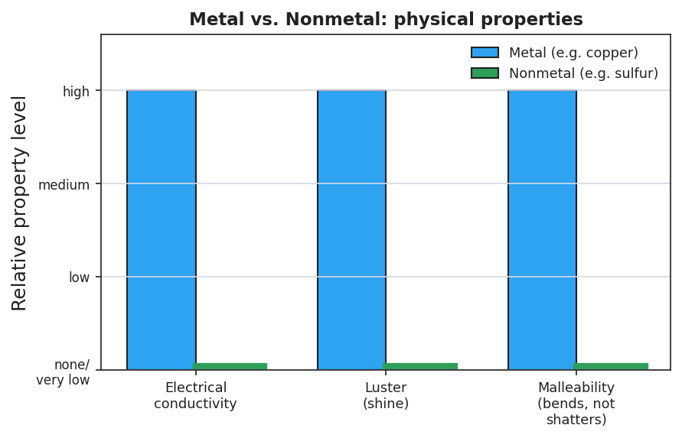
Side-by-side bar chart titled ‘Metal vs. Nonmetal: physical properties’ comparing a metal (copper, blue bars) and a nonmetal (sulfur, green bars) across three properties — electrical conductivity, luster, and malleability. The copper bars all reach ‘high’ while the sulfur bars are at ‘none/very low,’ showing metals score high on all three property tests and solid nonmetals score low on all three.
Sample results (your answer-key reference):
Sample | Luster | Conducts? | Mallet test | Pile
Copper (Cu) | shiny | yes | flattens (malleable) | metal-like
Aluminum / Iron (Al/Fe) | shiny | yes | flattens (malleable) | metal-like
Carbon — graphite (C) | dull/dark | poorly* | crumbles (brittle) | nonmetal-like
Sulfur (S) | dull | no | shatters to powder (brittle) | nonmetal-like
Silicon / Boron (Si/B) | partly shiny | a little (semi) | brittle | in-between
*Graphite is an unusual nonmetal that conducts somewhat — note this for the extension; for the core sort, students will place it as nonmetal-like on luster + brittleness.
Teacher facilitation prompts (circulate):
“Two of your samples both went in the ‘sulfur’ pile — but did they behave exactly the same? Where did one of them surprise you?”
“You found a sample that’s a little shiny but shatters like sulfur, and conducts only a little. Which pile does it belong in? What if it belongs in neither?”
Anticipated student responses during the investigation:
- “Copper, aluminum, and iron all bend and conduct — they’re the same kind.” — affirm; that repeating cluster of properties is the pattern we’re after.
- “Sulfur and carbon are both dull and break.” — yes; another cluster, the opposite of the metals.
- “The silicon one is weird — kind of shiny but it shatters and barely conducts.” — celebrate this; that ‘weird’ sample is the whole reason a third class exists. Hold the name until Phase 3.

24–28 min · Javalab — why metals bend instead of break
Bring up “The Ductility and Malleability of Metal” (Javalab). Project it (or run as a station). Students watch the metal’s atomic lattice get stretched and hammered: the atoms slide past one another into new positions but the metal stays in one piece.
“Look at what happens to the atoms when you hammer the metal. Do the atoms fly apart, or do they slide and rearrange? Now picture the sulfur — its particles can’t slide like that, so when you hit it, it cracks. That’s the difference between malleable and brittle, right there at the particle level.”

28–30 min · Gallery walk + surface the pattern
Groups do a 90-second gallery walk past two other boards, then return. Ask:
“Every group’s ‘copper pile’ shared three things — what were they? Every group’s ‘sulfur pile’ shared the opposite three. And almost every group had one sample that wouldn’t sit cleanly in either pile. Hold that thought — we’re about to name all three.”

Phase 3 · Explain (30 – 36 min)

30–33 min · Turn-and-Talk #2 + class consensus
“Look at your data table. Turn to your partner: write the pattern in one sentence — ‘Things in the copper pile are always , , and ; things in the sulfur pile are always , , and .’ Fill in the six blanks from your evidence.”
Target consensus:
“Copper-pile elements are always shiny, conductive, and bendable (malleable). Sulfur-pile elements are always dull, non-conductive (insulating), and brittle. A few elements are in-between and don’t fit either pile cleanly.”
“Now the prediction power: if I hand you a brand-new element and tell you it’s shiny, bends, and conducts — without running any reaction, what ‘team’ is it on? What about an element that’s dull, brittle, and an insulator?”
Target: students can place an unknown element by its property cluster — that is the Patterns CCC doing predictive work.

33–36 min · Vocabulary introduction (exactly 3 terms)
Sample teacher language:
“Let’s name the three teams you just discovered. The shiny, bendable, conductive pile — copper, aluminum, iron — those are the metals. Metals share a property cluster: luster, high electrical and heat conductivity, and malleability, and most metals are fairly reactive — they tend to lose electrons in reactions. The dull, brittle, insulating pile — sulfur, carbon, oxygen — those are the nonmetals. Nonmetals are the opposite: no luster, poor conductors, brittle when solid, and many of them are reactive too, but they tend to gain or share electrons. And that weird in-between sample — partly shiny, barely conductive, brittle — that’s a metalloid. A metalloid has a mix of metal and nonmetal properties; silicon and boron are the classic examples.”
“Notice what we are not doing today: we are not memorizing group names. We are sorting by what the element does — its properties and its tendency to react. The class an element belongs to lets you predict how it will behave.”
Post the three terms on the board. Students fill them in on their notes.
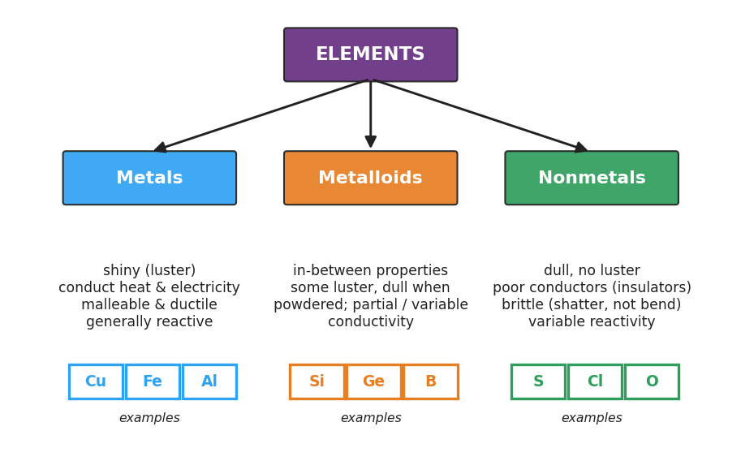
Flowchart titled ‘ELEMENTS’ branching into three classes — Metals (blue), Metalloids (orange), and Nonmetals (green). Under Metals: shiny luster, conduct heat and electricity, malleable and ductile, generally reactive, with examples copper, iron, aluminum. Under Metalloids: in-between properties, some luster but dull when powdered, partial or variable conductivity, with examples silicon, germanium, boron. Under Nonmetals: dull with no luster, poor conductors (insulators), brittle (shatter not bend), variable reactivity, with examples sulfur, chlorine, oxygen.
Discussion prompts to deploy here:
- “If an element conducts electricity and bends under a hammer, which class is it — and how confident are you?” — Expected response: metal; very confident, because two strong metal properties point the same way.
- “Why does a metalloid like silicon matter so much in electronics — what’s special about its conductivity?” — Expected response: it conducts a little, in between a metal and an insulator. That ‘semi’ conductivity (semiconductor) is exactly what makes silicon useful in chips. Accept the everyday connection as a bonus.

Phase 4 · Elaborate (36 – 40 min)

36–39 min · Revise the model + Because/But/So expansion
Students return to their Initial Model (the two-pile sort they wrote on the worksheet). They revise it by: (a) re-labeling the piles with the real class names, (b) moving the in-between sample into a third “metalloid” column, and (c) adding the property cluster under each heading. Then run a Because/But/So sentence about the phenomenon. Starter on the board:
“Copper lights the bulb and bends under a hammer, but sulfur shatters and leaves the bulb dark.”
Model one aloud:
“Copper conducts electricity and bends because its atoms share a ‘sea’ of loose electrons that carry current and let the atoms slide past one another without breaking apart — but sulfur’s electrons are locked into fixed positions, so they can’t carry current and the particles can’t slide — so copper behaves like a metal (shiny, conductive, malleable) while sulfur behaves like a nonmetal (dull, insulating, brittle), and knowing this pattern lets us predict any new element’s class before we test it.”
Then have students write their own B/B/S using one of these starters:
- “A new element is dull, brittle, and does not conduct electricity…” (hint: which class, and why?)
- “Silicon is a little shiny and conducts only a little…” (hint: why is it a metalloid, not a metal?)
Anticipated student responses:
- “Because it has all three nonmetal properties.” — good start; push for the So: “so it belongs in the nonmetal pile, and we’d predict it reacts by gaining or sharing electrons, not by conducting current.”
- “Because silicon isn’t shiny enough or conductive enough to be a metal.” — excellent; push for the But/So: “but it isn’t fully dull and insulating like a nonmetal either, so it sits between the two as a metalloid.”

39–40 min · Return to the phenomenon
“Return to our opening question. Copper lit the bulb and bent; sulfur stayed dark and shattered. Can you now explain, in one sentence using the word pattern, why we could have predicted that result before we ever touched the battery?”
Target: “Copper fits the metal property pattern (shiny, conductive, malleable) and sulfur fits the nonmetal pattern (dull, insulating, brittle), so once we recognize the pattern, the behavior is predictable — that’s why classification is useful.”

Phase 5 · Evaluate (40 – 42 min)

40–42 min · Exit Ticket + Closing Reflection
Post or read aloud:
A mystery element, “Element Z,” was tested in the lab. It is dull and grayish, shatters into pieces when tapped, and does not light the conductivity bulb. (a) Classify Element Z as a metal, nonmetal, or metalloid. (b) Give two property observations from the description that support your classification. (c) In one sentence, predict one thing about how Element Z is likely to behave (its reactivity or how it would act in a circuit), and explain why your classification lets you make that prediction.
Expected answers are in Answer_Key.docx. Note: Element Z is deliberately distinct from every sample tested on the worksheet — students must apply the pattern to a new case, not recall a lab result.
Closing Reflection (SEL, 30 seconds):
“Today you sorted elements into teams by what they do, not what they’re called. In one sentence: what is one property you’ll now remember to look for first when you meet a new element — and who in your group helped you see it?”
Collect worksheets; note which students could classify the in-between (metalloid) sample versus those who forced every sample into only two piles. The metalloid ‘third category’ is the main conceptual stumbling block — target those students for a brief one-on-one check at the start of the next lesson.

Common Misconceptions
- Misconception: “Every element is either a metal or a nonmetal — there are only two kinds.” → Correction: There are three classes. Metalloids (silicon, boron, germanium) have a mix of metal and nonmetal properties and form a staircase between the two on the table. The ‘in-between’ sample in the lab is the evidence: it was partly shiny but brittle and only weakly conductive — it fits neither pile cleanly.
- Misconception: “Shiny always means metal.” → Correction: Luster is one property, not the whole story. A freshly broken nonmetal can look slightly shiny, and some metalloids have luster. Classification needs the cluster — luster and conductivity and malleability — not a single observation. This is why the lab tests three properties, not one.
- Misconception: “Metals are reactive and nonmetals are not (or vice versa).” → Correction: Both metals and nonmetals can be highly reactive; the difference is in how they react. Reactive metals tend to lose electrons; reactive nonmetals tend to gain or share them. Reactivity is not what separates the classes — the physical-property cluster is. (We focus on the property pattern, not group names, in this lesson.)
- Misconception: “If it conducts electricity even a little, it’s a metal.” → Correction: Partial / ‘semi’ conductivity is the signature of a metalloid, not a metal. A true metal conducts well; an insulating nonmetal essentially does not conduct; a metalloid conducts only a little — which is exactly why silicon is used in semiconductors.
- Misconception: “Brittle means weak, and malleable means strong.” → Correction: Brittle and malleable describe how a material responds to force, not how strong it is. Brittle materials shatter rather than bend (the particles can’t slide); malleable materials flatten and reshape because their atoms slide past one another. A brittle nonmetal can still be hard; a malleable metal can still be tough.

Access & Differentiation
- ELL/ENL supports: Property word-choice box displayed throughout: {luster / shiny, dull, conduct, insulator, malleable, brittle, metal, nonmetal, metalloid}. Pair each property with a gesture: rub fingers for luster, bend hands for malleable, snap fingers for brittle. Sentence frame for the sort: *“This sample is a ___ because it is ___ and ___.”* Provide a picture-supported data table where each property column has a small icon (a lightbulb for conductivity, a hammer for the mallet test, a shine mark for luster).
- IEP/SPED supports: Pre-fill the data-table headers and the sample names so the student’s task is to observe and record (not set up the table). Pre-sort the tray into a smaller set (one clear metal, one clear nonmetal, one metalloid) to make the three-way pattern visible without overload. Assign clear BTC roles: one student tests, one records on the board, one reports. Offer the Exit Ticket with the classification choices as a check-the-box so the student focuses on the justification sentence.
- Extensions: (1) Graphite (carbon) is a nonmetal that conducts electricity — research and explain why this exception doesn’t break the classification system (hint: it’s still dull and brittle). (2) Find the ‘staircase’ line on a Periodic Table and explain how the metalloids cluster along it — without using group names, describe the region where metals, metalloids, and nonmetals sit. (3) Look up why silicon’s ‘in-between’ conductivity (semiconductor behavior) made the entire computer industry possible — write two sentences connecting a property to a real technology.

Strategy Spotlight
BTC — Building Thinking Classrooms. Peter Liljedahl’s Building Thinking Classrooms framework is built on three moves that this lesson uses directly: visibly random groups, vertical non-permanent surfaces (whiteboards/windows), and thin-sliced thinking tasks. The classification sort is an ideal BTC task because it has a low floor (anyone can sort two obviously-different samples) and a high ceiling (the in-between metalloid sample forces genuine reasoning and defense).
How to run it in this lesson (Phase 2):
- Visibly random groups of three — deal cards or use a randomizer in front of the class so students see the grouping is fair and not teacher-chosen. New groups each lesson keeps thinking fresh and breaks up fixed social roles.
- Send groups to vertical surfaces with one marker per group. The single marker forces students to talk before writing — the marker passes, so the thinking is shared, not owned by one student.
- Launch with a thin-sliced task: start with “sort into two piles by one property,” then add “now test all three properties,” then “now place the sample that fits neither pile.” Each slice raises the demand only as far as the previous slice succeeded.
- Circulate without rescuing. Answer questions with questions (“What test would settle it?”). The teacher’s job in BTC is to keep groups in flow, not to hand them conclusions.
Why vertical surfaces matter here: when the sort is on a whiteboard at eye level, every group can see every other group’s piles during the gallery walk. The pattern — that the metal pile always shares three properties and the nonmetal pile the opposite three — becomes visible across the whole room at once. That shared visibility is what makes the Phase 3 consensus feel discovered rather than told.
CRSE connection: the opening circle invites students to name the everyday sorting they already do (sorting laundry by fabric, foods by texture, recyclables by material). Classification by observable property is a skill students already own from daily life; the lesson honors that out-of-school expertise and renames it as scientific practice. Grounding the abstract metal/nonmetal/metalloid system in objects students can hold and test keeps the science continuous with their lived experience.

NYSSLS Observation Checklist Crosswalk
# | Checklist item | Where it appears in this lesson
1 | Local/relatable phenomenon | Phase 1 — copper vs. sulfur contrast (shiny/conductive/bendable vs. dull/insulating/brittle); return in Phase 4 with the prediction-of-class move
2 | Turn and Talk (2–3×) | Phase 1 (TT#1 — what tests would you run on a mystery sample?); Phase 3 (TT#2 — write the six-blank property pattern)
3 | Students develop questions/models/procedures | Phase 2 BTC two-pile sort at vertical surfaces; property-comparison lab (3 tests); Phase 4 revise the model into three classes
4 | CCC defined and used | Lesson Overview · Patterns, explicit in Phase 3 consensus (predict an unknown element’s class) and Phase 4 B/B/S + return-to-phenomenon
5 | ENL — ≤ 3 vocab, second half | Phase 3 — vocabulary introduced at 33–36 min: metal / nonmetal / metalloid
6 | Revisit phenomenon with evidence | Phase 4 — students re-explain copper vs. sulfur using the property cluster and the Javalab particle model; predict class of a new element
7 | ENL/SPED supports | Access & Differentiation block: property word-choice box, gestures, sentence frames, picture-supported table, pre-filled headers, BTC roles
8 | Assessment check | Phase 5 — Exit Ticket (classify Element Z, cite two property reasons, predict behavior) — distinct from worksheet samples

Companion Materials
- Student_Worksheet.docx — the 5E student investigation (hand out at start of Phase 2)
- Student_Notes.docx — guided note-guide for vocabulary and the worked classification example
- Answer_Key.docx — answers to “Make It Make Sense” prompts and the Exit Ticket

Key Vocabulary (max 3)
- metal — an element with a cluster of properties: luster (shiny), high electrical and heat conductivity, and malleability/ductility (bends and reshapes without shattering); most metals tend to lose electrons when they react; examples include copper, iron, and aluminum
- nonmetal — an element that is the property-opposite of a metal: dull (no luster), a poor conductor / insulator, and brittle when solid (shatters rather than bends); many nonmetals react by gaining or sharing electrons; examples include sulfur, oxygen, and chlorine
- metalloid — an element with intermediate, in-between properties that does not fit cleanly as either a metal or a nonmetal: it may have partial luster and conducts electricity only a little (semiconductor); silicon and boron are the classic examples

