Collision Theory & Rates of Reaction — Teacher Guide

Cover
Unit: Kinetics & Equilibrium — Lesson 01: Collision Theory & Rates of Reaction East Meadow Schools × Valley Stream Central High School District Strategy chips: ACTIVE LEARNING · RESTORATIVE CIRCLE

Curated Resources (from East Meadow Scope & Sequence)

NYSSLS Standards
HS-PS1-5 — “Apply scientific principles and evidence to provide an explanation about the effects of changing the temperature or concentration of the reacting particles on the rate at which a reaction occurs.” For the 2025 NYSSLS-aligned Regents, students must construct an explanation built on a molecular collision model: a chemical reaction happens when particles collide, and it happens faster when those collisions are (1) more frequent and (2) more energetic. As the kinetic energy of colliding particles increases and the number of collisions per second increases, the reaction rate increases. Students apply this model to predict and explain the effect of four controllable factors — temperature, concentration, surface area, and a catalyst.
The Cross-Cutting Concept of Cause and Effect is the explicit lens: each factor is a cause that acts on collisions (more collisions, harder collisions, or a lower energy barrier), and the effect is a measurable change in how fast the reaction proceeds. Students learn to trace the cause all the way down to the particle level rather than stopping at “it just goes faster when it’s hot.”

Phenomenon
A glow stick glows by a chemical reaction. Snap two identical glow sticks at the same moment. Drop one into a beaker of hot tap water and the other into a beaker of ice water. Within a minute the hot one is noticeably brighter — but the cold one keeps glowing long after the hot one has faded to almost nothing. Same chemistry, same starting materials, opposite outcomes: heat makes the reaction run hard and burn out fast; cold makes it run gently and last for hours. The visceral, observable contrast — brightness now vs. brightness later — is a direct readout of reaction rate, and it sets up the driving question without a single equation.

Javalab / Labs
- Alka-Seltzer rate investigation (core lab): Students time how long an Alka-Seltzer tablet takes to fully dissolve/react in water under two manipulated variables — temperature (ice water vs. room-temperature vs. hot water) and surface area (whole tablet vs. tablet crushed into powder). The reaction (citric acid + sodium bicarbonate → sodium citrate + water + CO₂ gas) produces visible bubbling, so “rate” is read directly from time-to-finish or from how fast gas is released. This is the hands-on backbone of the ACTIVE LEARNING strategy.
- Glow-stick rate demo (anchor): Two snapped glow sticks, one in hot water and one in ice water, observed across the period (brightness comparison at 1 min, 10 min, end of class). For a digital interactive option, a Javalab “collision model” or PhET “Reactions & Rates” simulation lets students raise temperature and concentration sliders and watch the collision frequency change on screen — useful as an Explore extension or for absent-student make-up.

Assessments
- Reaction rate factor lab report (district checkpoint, following this lesson): students write up the Alka-Seltzer investigation — claim (which factor sped up the reaction), evidence (their timed data), and reasoning (the collision-model explanation). The CER format reinforces the HS-PS1-5 explanation target.
- Exit Ticket (Phase 5): three items — predict and justify the effect of crushing a tablet (surface area), explain in one sentence why refrigerating milk slows spoilage (temperature), and identify which factor a catalyst changes. The Exit-Ticket factors are deliberately different from the worksheet practice. See Answer_Key.docx.

Lesson Overview
Duration | 42 minutes (1 period)
NYSSLS link | HS-PS1-5 (effect of temperature and concentration on reaction rate; molecular collision model; extended to surface area and catalysts)
CCC focus | Cause and Effect — each controllable factor (temperature, concentration, surface area, catalyst) is a cause that changes the frequency and/or energy of particle collisions; the effect is a measurable change in reaction rate.
Strategy chips | ACTIVE LEARNING (hands-on Alka-Seltzer timing investigation; students manipulate a variable and read rate directly) · RESTORATIVE CIRCLE (unit-opening circle — share something that goes faster when you heat it up or speed it up)
Materials | Two glow sticks, beaker of hot water + beaker of ice water (anchor demo), Alka-Seltzer tablets (2–3 per group), beakers/cups, ice, hot tap water, thermometers, stopwatches/phone timers, mortar-and-pestle or a spoon and paper towel to crush a tablet, figures/activation_energy_diagram.png and figures/rate_factors_bar.png projected.
Safety | Goggles on for the Alka-Seltzer lab (vigorous fizzing can splash). Hot water from the tap, not boiling — no open flame needed. Do not cut open or drink glow-stick fluid; if a stick leaks, follow the SDS and wash skin with soap and water. Standard lab safety applies.
Prior knowledge | Unit 09 (Chemical Reactions) — reactants form products, balanced equations; Unit 03 (Heat & Energy) — temperature is a measure of average kinetic energy of particles. Students should already know that particles are in constant motion and that higher temperature means faster-moving particles.
Lesson objectives — students can:
- State the collision model: a reaction occurs only when reactant particles collide with enough energy and the correct orientation.
- Predict and explain how raising temperature, raising concentration, increasing surface area, and adding a catalyst each change the reaction rate, tracing the cause to the frequency and/or energy of collisions.
- Define reaction rate, collision theory, and activation energy and use each term correctly in a sentence.
- Explain, using Cause and Effect, why a glow stick glows brighter but for a shorter time in hot water than in cold water.

Phase 1 · Engage (0 – 10 min)

0–3 min · Opening Circle + Do Now
Begin with a brief Restorative Circle (2–3 min; see Strategy Spotlight — this is the unit-opening circle for Kinetics & Equilibrium). Everyone — teacher included — answers in one sentence: “Name something in your everyday life that goes faster when you heat it up or speed it up. What changes?” One round, every voice, pass allowed. This surfaces the everyday intuition the lesson formalizes: heat, mixing, breaking something into smaller pieces — all make things happen faster.
Then post the Do Now:
“I just snapped two identical glow sticks. One is sitting in hot water, one is sitting in ice water. In one sentence: which one do you think will glow brighter, and which one will keep glowing longer?”
Give students 2 minutes to write silently, then take two or three responses (don’t reveal the answer yet — the demo will).
Anticipated student responses to Do Now:
- “The hot one glows brighter.” — capture; and ask: if it’s brighter, what’s happening to the chemicals faster?
- “The cold one lasts longer because it’s saving energy.” — interesting framing; we’ll sharpen “saving energy” into “reacting slower” in Phase 3.
- “They’ll be the same — it’s the same glow stick.” — great tension to hold; validate, then point at the two beakers: let’s watch and see.

3–8 min · Phenomenon hook — the glow-stick race
Teacher actions. Snap two identical glow sticks at the same time (or hold up two you snapped just before class). Drop one into the hot-water beaker, one into the ice-water beaker. Hold them side by side. Within a minute the hot stick is visibly brighter. Tell students you’ll check both again at the end of the period — and predict aloud that the cold one will still be glowing when the hot one has gone dim.
Sample teacher language:
“Nothing is different about these two sticks. Same brand, same chemicals, snapped at the same second. The only difference is the temperature of the water around them. So why is the hot one already brighter? And why am I so sure the cold one will outlast it? The brightness is telling us something about how fast the chemical reaction inside is happening.”
Anticipated student responses:
- “Heat makes the reaction go faster.” — yes; capture it and push: what is heat actually doing to the particles inside?
- “The hot one is using up its chemicals quicker, so it dies first.” — excellent; that is the whole idea — faster rate means the reactants are consumed sooner.
- “Cold slows it down like food in a fridge.” — perfect everyday connection; hold it for the Exit Ticket.
Driving question (post on the board and leave it there):
Why does a glow stick glow brighter but for less time in hot water than in cold water — and what does that tell us about controlling how fast any reaction goes?

8–10 min · Notice & Wonder + Turn-and-Talk #1
Two columns on the board: I notice… / I wonder…
Collect 3–4 responses about the two glow sticks. Then:
“Turn to your partner: the glow comes from particles reacting. If hot water makes the reaction faster, what do you think is physically happening to the particles in the hot stick compared to the cold stick? Try to describe the particles, not just say ‘it’s faster.’”
Target insight (leave open if no one lands it yet): in the hot stick the particles are moving faster, so they bump into each other more often and harder. That picture — particles colliding — is collision theory, which we’ll name formally in Phase 3.

Phase 2 · Explore (10 – 30 min)

10–14 min · Initial Model (silent / individual)
Prompt on the board:
“Before we name anything: draw or write your best model of WHY heating speeds up a reaction. Draw the reacting particles in cold conditions and in hot conditions. What is different about how the particles move and meet? Then list any OTHER change you think would make a reaction go faster.”
Students work silently for 3–4 minutes. Collect the range: most will draw faster-moving dots when hot; few will mention “they hit each other more” explicitly, and even fewer will connect surface area or concentration. That gap is the instructional target — the hands-on lab will fill it.

14–27 min · ABCs Investigation — Alka-Seltzer rate lab (ACTIVE LEARNING)
This is the activity that comes BEFORE the vocabulary. Students manipulate a variable and read the rate directly, building the collision intuition with their hands before any term is defined.
Hand out the worksheet. Groups of 3–4 run two quick trials and time each one to completion (full dissolve / fizzing stops).
Trial set 1 — Temperature (same tablet form, change the water temperature):
- Cup A: whole tablet in ice water (record temperature, e.g., ~5 °C).
- Cup B: whole tablet in hot tap water (record temperature, e.g., ~50 °C).
- Time each from drop-in to “fizzing stops.” Hot finishes much faster.
Trial set 2 — Surface area (same temperature, change the tablet form):
- Cup C: whole tablet in room-temperature water.
- Cup D: a tablet crushed to powder, in room-temperature water (same volume, same temperature as C).
- Time each. The powder reacts dramatically faster.
The reaction is citric acid reacting with sodium bicarbonate:
3 NaHCO₃ + C₆H₈O₇ → 3 CO₂ + 3 H₂O + Na₃C₆H₅O₇
The CO₂ bubbling is the visible rate signal.
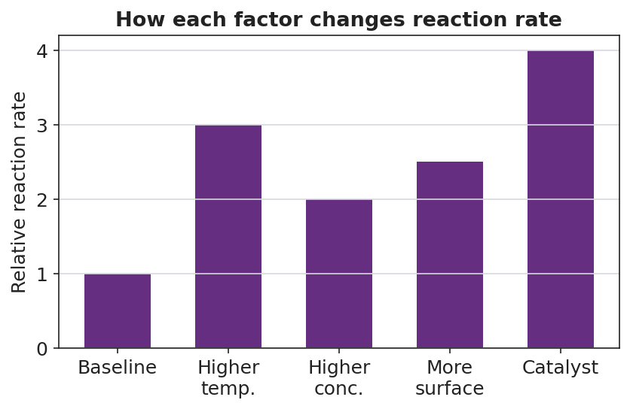
Bar chart titled “How each factor changes reaction rate” with a “Relative reaction rate” y-axis. A baseline bar at 1.0 is followed by taller bars for higher temperature (3.0), higher concentration (2.0), more surface area (2.5), and catalyst added (4.0), showing that each factor raises the rate above baseline.
Teacher facilitation language (circulate):
“Don’t tell me ‘the hot one was faster’ — tell me how much faster. Write down the seconds. We’re collecting evidence, not opinions.”
“For the crushed tablet, you didn’t change the temperature and you didn’t add more water. The only thing that changed is how the tablet is broken up. So whatever made it faster has to come from that — the surface where the water can touch the tablet.”
Anticipated student responses during the lab:
- “The hot one was done in like 20 seconds and the cold one took over a minute.” — exactly the data we want; ask them to record the actual temperatures next to each time.
- “The crushed one went crazy fast.” — affirm; probe: the chemicals are identical to the whole tablet — what’s different about how much of the tablet the water can reach at once?
- “Why does breaking it up matter if it’s the same amount of stuff?” — hold this; this is the surface-area insight we formalize in Phase 3. More broken-up tablet = more exposed surface = more places for collisions to happen at once.

27–30 min · Connect the trials — what does every change have in common?
Bring groups back. On the board, build a quick class data summary (fastest → slowest). Then pose:
“Look at all four conditions — hot, cold, whole, crushed. In every case where the reaction went faster, what do you think was happening to the meetings between particles? More meetings? Harder meetings? Both?”
Surface the through-line without naming it yet: every factor that sped the reaction up did so by changing how the reacting particles collide — either how often they collide or how hard they collide. That common cause is exactly what Phase 3 names.

Phase 3 · Explain (30 – 36 min)

30–33 min · Turn-and-Talk #2 + class consensus
“Hot water sped up the reaction. Crushing the tablet sped it up. Turn to your partner: hot water didn’t break the tablet, and crushing it didn’t heat it up — so these are two different causes. Do they speed the reaction up the same way, or in two different ways? Try to say what each one does to the colliding particles.”
Target consensus:
“Higher temperature makes the particles move faster, so they collide MORE OFTEN and with MORE ENERGY. More surface area exposes more of the solid, so more particles are available to be hit at once — again, MORE collisions per second. Both increase the rate, but temperature also adds energy to each collision.”
Then extend to concentration:
“What if I dropped a tablet into very concentrated vinegar instead of plain water — more acid particles packed into the same space? Would the collisions happen more or less often?” — Expected: more often, because the particles are crowded closer together, so they bump into the tablet more frequently. Higher concentration → more collisions → faster rate.

33–36 min · Vocabulary introduction (exactly 3 terms)
Sample teacher language:
“Let’s name what we’ve been watching all period. The whole idea — that a reaction only happens when reactant particles physically run into each other, and that they have to hit with enough energy and the right orientation to react — is called collision theory. Every collision is a chance to react; not every collision succeeds, but no collision means no reaction.”
“The minimum energy a collision needs in order to actually cause a reaction has a name: activation energy. It’s the energy barrier the colliding particles have to get over. If two particles drift into each other too gently, they just bounce apart — they didn’t have the activation energy. Heat the system up and more collisions clear that barrier, so the reaction speeds up.”
Project the energy diagram:
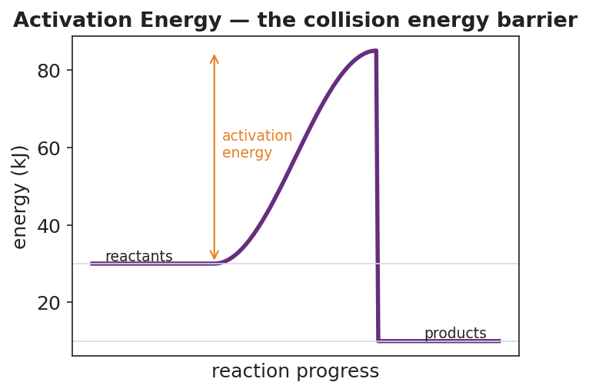
Reaction-coordinate diagram titled “Activation Energy — the collision energy barrier.” The purple curve starts at the reactant energy level (about 30 kJ), rises over a hump to a peak (about 85 kJ), and drops to a lower product energy level (about 10 kJ). An orange double-headed arrow from the reactant level up to the peak is labeled “activation energy,” marking the energy barrier a collision must clear to react.
“And the thing we’ve been measuring with our stopwatches — how fast reactants turn into products — is the reaction rate. A fast rate means reactants are used up quickly (the hot glow stick, the crushed tablet); a slow rate means it takes a long time (the cold glow stick, the whole tablet).”
Post the three terms on the board. Students fill them in on their notes.
Discussion prompts to deploy here:
- “A catalyst speeds a reaction up without being used up. Looking at the activation-energy diagram, what do you think a catalyst does to the barrier?” — Expected response: it lowers the activation energy, so more of the everyday collisions now have enough energy to react. The reactants and products stay at the same energy levels; only the hump gets lower.
- “On the diagram, does the activation energy depend on whether the reaction is fast or slow that day?” — Expected response: activation energy is a fixed barrier for a given reaction; temperature and concentration don’t lower the barrier — they just send more (or more energetic) collisions at it. Only a catalyst lowers the barrier itself.

Phase 4 · Elaborate (36 – 40 min)

36–39 min · Revise the model + Cause-and-Effect expansion
Students return to their Initial Model (the cold-vs-hot particle drawing). They revise it by adding: (a) collision arrows showing particles hitting each other, (b) a label noting “more collisions / more energy” on the hot side, and (c) a second pair of drawings for whole vs. crushed tablet. Then run a Because/But/So sentence:
“A crushed Alka-Seltzer tablet reacts faster than a whole one at the same temperature.” “This is true because ______, but _______, so _______.”
Model one aloud:
“A crushed tablet reacts faster because breaking it into powder exposes far more surface area, but the amount and type of chemical is exactly the same as the whole tablet, so the speed-up comes only from more water particles being able to collide with the tablet at once — more collisions per second means a faster rate.”
Then have students write their own B/B/S for the temperature trial (hot vs. cold water).

39–40 min · Return to the phenomenon
“Return to our two glow sticks. Check them now — the hot one is dim, the cold one is still glowing. Using the words collision and rate, explain in one sentence why the hot stick is brighter at first but dies sooner.”
Target: “In hot water the particles collide more often and with more energy, so the reaction rate is high — it glows brightly but uses up its reactants quickly; in cold water the rate is low, so it glows dimly but its reactants last much longer.”

Phase 5 · Evaluate (40 – 42 min)

40–42 min · Exit Ticket + Closing Reflection
Post or read aloud (note: these scenarios are different from the worksheet practice):
(a) A campfire builder splits a log into thin kindling instead of burning the whole log. Using collision theory, explain why the kindling catches fire and burns faster. (b) Refrigerating milk slows down the reactions that spoil it. In one sentence, explain why lowering the temperature slows those reactions, in terms of particle collisions. (c) A catalyst speeds up a reaction without being used up. Which feature of the reaction does a catalyst change: the energy of the reactants, the activation-energy barrier, or the number of products? Explain in one sentence.
Expected answers are in Answer_Key.docx.
Closing Reflection (SEL, 30 seconds):
“Today we explained a glowing-stick mystery with invisible particle collisions. In one sentence: what is one moment in today’s lab where the data changed your mind about how a reaction works — and who in your group helped you see it?”
Collect worksheets; flag which students still say “heat just makes it faster” without naming collisions — target them for a 30-second check before the lab report.

Common Misconceptions
- Misconception: “Heating a reaction adds more reactant, so it has more to react.” → Correction: Heating adds no reactant at all. The same particles are present; they simply move faster, so they collide more often and with more energy. Rate goes up because of how the existing particles collide, not because there is more of them.
- Misconception: “Crushing a tablet gives you more chemical, so it reacts faster.” → Correction: Crushing changes the surface area, not the amount. A whole tablet and a crushed tablet contain identical chemicals in identical quantity. The powder reacts faster only because more of its surface is exposed to collisions at the same time.
- Misconception: “A catalyst gets used up in the reaction, like a reactant.” → Correction: A catalyst is regenerated and emerges unchanged; it speeds the reaction by lowering the activation-energy barrier so more collisions succeed. It does not appear in the overall balanced equation and is not consumed.
- Misconception: “Activation energy is the energy released by the reaction.” → Correction: Activation energy is the energy a collision must put in to start the reaction — the height of the barrier on the energy diagram, measured from the reactants up to the peak. It is different from the overall energy change (reactants vs. products) and is required even for reactions that release energy overall.
- Misconception: “Every collision between reactant particles causes a reaction.” → Correction: Only collisions with at least the activation energy and a suitable orientation lead to a reaction. Gentle or poorly aimed collisions just bounce apart. That is why raising temperature (which raises both collision frequency and collision energy) is so effective.

Access & Differentiation
- ELL/ENL supports: Sentence frames for the lab and Exit Ticket: *“When I increased the , the reaction got because the particles collided ___.”* and *“A catalyst makes the reaction faster because it lowers the ___.”* Word-choice box displayed throughout: {collision, reaction rate, activation energy, temperature, concentration, surface area, catalyst, faster, slower}. Pair each vocabulary term with a gesture: two fists bumping for collision, a low jump over a low bar vs. a high bar for activation energy. Allow students to record data in numbers/drawings first, then translate to a sentence.
- IEP/SPED supports: Pre-fill the lab data table with the variable names and units (temperature in °C, time in seconds) so the student records only the measured values. Assign clear roles: timer, recorder, pourer, reporter. Provide the collision drawing as a partially completed model (cold side already drawn) so the student only completes the hot side. Offer sentence starters for the Exit Ticket and allow oral responses scribed by a partner.
- Extensions: (1) Design a third trial that tests concentration (e.g., a tablet in dilute vs. concentrated acid) — predict the result using collision theory and, if time allows, run it. (2) On the activation-energy diagram, draw a second, lower hump to show what a catalyst does, and write a caption explaining why the reactant and product energy levels do not move. (3) Research one real-world catalyst (the catalytic converter in a car, or an enzyme in your saliva such as amylase) and write two sentences on which reaction it speeds up and why lowering activation energy matters there.

Strategy Spotlight
ACTIVE LEARNING — manipulate a variable, read the rate. Active learning means students generate the evidence with their own hands before the teacher names the concept. In this lesson the Alka-Seltzer investigation is the engine: each group physically changes one variable (temperature, then surface area), times the result, and records real numbers. Because students cause the rate change themselves, the collision model in Phase 3 lands as a name for something they already observed rather than as an abstract rule to memorize.
How to run it for maximum learning (Phase 2):
- Keep the trials short (under 2 minutes of fizzing each) so groups can run both temperature trials and both surface-area trials within the 13-minute window. Pre-fill water and ice at lab stations to save setup time.
- Insist on one changed variable at a time. The temperature trials use the same tablet form; the surface-area trials use the same temperature. This is the heart of the lesson — students learn that a clean cause→effect claim requires controlling everything else.
- Have each group post one number on the board (e.g., “hot whole = 22 s, cold whole = 78 s”). The class data set makes the pattern undeniable and primes the Phase 3 consensus.
- Circulate with the single question “What changed, and what stayed the same?” — this trains the controlled-variable habit that the lab report will assess.
Connection to Cause and Effect (CCC): Active learning here is not just “hands-on for engagement.” Each trial isolates one cause (a single factor) and measures its effect (the time). When students later write the collision-model explanation, they are explaining a cause→effect chain they personally established with data — the strongest possible foundation for the HS-PS1-5 explanation standard.
RESTORATIVE CIRCLE (unit-opening circle). Because this is the first lesson of the Kinetics & Equilibrium unit, open with a brief circle (“Name something that goes faster when you heat it up or speed it up”). It gives every student a voice in the first three minutes and surfaces the everyday intuition (cooking, defrosting, dissolving) that the collision model formalizes. The circle is not graded; it builds the trust that makes the messier, fizzier lab go smoothly.

NYSSLS Observation Checklist Crosswalk
# | Checklist item | Where it appears in this lesson
1 | Local/relatable phenomenon | Phase 1 — glow-stick race (hot vs. ice water); revisited in Phase 4 by re-checking both sticks at end of class
2 | Turn and Talk (2–3×) | Phase 1 (TT#1 — what’s physically different about particles in the hot stick?); Phase 3 (TT#2 — do temperature and surface area speed it up the same way?)
3 | Students develop questions/models/procedures | Phase 2 Initial Model (cold-vs-hot particle drawing); Alka-Seltzer investigation (manipulate temperature, then surface area, and time it); Phase 4 model revision with collision arrows
4 | CCC defined and used | Lesson Overview · Cause and Effect; explicit in Phase 3 consensus (each factor → collision frequency/energy) and Phase 4 B/B/S (crushed vs. whole tablet)
5 | ENL — ≤ 3 vocab, second half | Phase 3 — vocabulary introduced at 33–36 min: collision theory / activation energy / reaction rate
6 | Revisit phenomenon with evidence | Phase 4 — students re-observe both glow sticks and explain the brightness/duration difference using collision and rate, backed by their Alka-Seltzer data
7 | ENL/SPED supports | Access & Differentiation block: sentence frames, word-choice box, gestures, pre-filled data table, partner roles, partially completed model
8 | Assessment check | Phase 5 — Exit Ticket (kindling/surface area, refrigerated milk/temperature, catalyst/activation energy); leads into the CER lab report

Companion Materials
- Student_Worksheet.docx — the 5E student investigation (hand out at start of Phase 2)
- Student_Notes.docx — guided note-guide for vocabulary and the worked collision-model example
- Answer_Key.docx — answers to “Make It Make Sense” prompts and the Exit Ticket

Key Vocabulary (max 3)
- collision theory — the model that a chemical reaction occurs only when reactant particles collide with enough energy and the correct orientation; more frequent and more energetic collisions produce a faster reaction
- activation energy — the minimum energy a colliding pair of particles must have for a reaction to occur; the height of the energy barrier on a reaction-coordinate diagram, measured from the reactants up to the peak. A catalyst speeds a reaction by lowering this barrier
- reaction rate — how fast reactants are converted to products; a high rate means reactants are used up quickly (bright, short-lived glow stick), a low rate means the reaction proceeds slowly (dim, long-lived glow stick)

