Spontaneous Reactions — Teacher Guide

Cover
Unit: Kinetics & Equilibrium — Lesson 04: Spontaneous Reactions East Meadow Schools × Valley Stream Central High School District Strategy chips: ACTIVE LEARNING

Curated Resources (from East Meadow Scope & Sequence)

NYSSLS Standards
This lesson develops the qualitative reasoning behind spontaneous (naturally occurring) change — the conditions of enthalpy and entropy that determine whether a process happens on its own. It supports the kinetics-and-equilibrium strand of the NYS Chemistry course and the Cross-Cutting Concept of Energy and Matter: flows, cycles, and conservation, paired with the idea that systems tend toward states of lower energy and greater disorder. There is no single content performance expectation tagged for this introductory, qualitative treatment; per East Meadow guidance, students reason about spontaneity using two factors — does the process release energy (exothermic, ΔH < 0) and does it increase disorder (entropy increase, ΔS > 0) — without computing ΔG numerically. Students practice the Science and Engineering Practice of Constructing Explanations by predicting, from a process description, whether it is spontaneous and citing the energy and disorder evidence for that claim. This qualitative foundation is what later quantitative free-energy work (in AP Chemistry or college) is built on.

Phenomenon
A messy room never tidies itself, but a tidy room becomes messy on its own. Leave a perfectly organized bedroom for a week — clothes migrate to the floor, papers spread across the desk, the bed un-makes itself through use. The reverse never happens: scattered clothes do not climb back onto hangers while you sleep. Why is the “messy” direction the one that happens for free, while the “tidy” direction always requires someone to do work? The same one-way tendency shows up in chemistry: a drop of dye spreads through a glass of water and never gathers back into a drop; a hot drink cools to room temperature and never spontaneously reheats; a gas released into a room fills the whole room and never crowds back into its bottle. These everyday one-way changes are all spontaneous — they proceed without continuous outside help — because nature tends toward states of lower energy and greater disorder. The messy-room story makes the abstract idea of entropy concrete: there are vastly more “messy” arrangements than “tidy” ones, so random change almost always lands on messy.

Javalab / Labs
- Entropy demonstration stations (Explore): Set up three quick teacher-run or small-group stations that each show disorder increasing on its own. (1) Gas diffusion — open a bottle of a strong-smelling but safe substance (vanilla extract, peppermint oil, or a freshly peeled orange) at the front; students raise a hand when they smell it, showing the gas spreading to fill the room. Connect to figures/entropy_diffusion.png. (2) Dissolving — drop a single crystal of colored drink mix or a dye tablet into still water and watch the color spread without stirring. (3) Mixing — pour layered colored solutions or simply mix two colors of sand/beads and ask whether they will ever un-mix on their own. Discussion across all three: the disordered, spread-out state happens by itself; the ordered state never does.
- Spontaneity card sort (Explore → Explain): Students sort a deck of process cards (ice melting at room temperature, water freezing in a freezer, wood burning, a phone battery charging, iron rusting, dye spreading in water, a ball rolling downhill, a ball rolling uphill) into “happens on its own” vs. “needs to be forced,” then justify each placement using the energy/disorder language. The sort surfaces student intuition before any vocabulary is named.

Assessments
- Spontaneity prediction check (district formative; this is the Exit Ticket below). Students are given short process descriptions and predict spontaneous vs. non-spontaneous, citing the enthalpy (energy in/out) and entropy (order/disorder) evidence for each prediction.
- The Make It Make Sense worksheet section is the in-class formative check: students classify processes and explain each using the two-factor reasoning. The Exit Ticket values and examples are kept distinct from the worksheet practice. See Answer_Key.docx.

Lesson Overview
Duration | 42 minutes (1 period)
NYSSLS link | Kinetics & Equilibrium strand — qualitative spontaneity (enthalpy + entropy); SEP: Constructing Explanations; no numeric ΔG
CCC focus | Energy and Matter — systems tend toward lower energy (exothermic, releasing energy) and greater disorder (entropy increase); spontaneity is favored when both push the same way, and is temperature-dependent when they conflict
Strategy chips | ACTIVE LEARNING — station-based entropy demos and a spontaneity card sort put every student in motion, predicting and sorting before any term is defined
Materials | Card-sort decks (one per pair), entropy demo materials (vanilla/peppermint/orange for diffusion; colored drink mix or dye tablet + clear cups of water for dissolving; two colors of sand or beads for mixing), figures/spontaneity_grid.png and figures/entropy_diffusion.png projected, student worksheet and notes
Safety | Demo substances are food-safe (vanilla, peppermint, drink mix). No open flame in class — the wood-burning and combustion examples are described, not performed. Standard lab safety applies. Students with scent sensitivities should be seated away from the diffusion station.
Prior knowledge | Lesson 02 (Energy in Reactions) — exothermic (ΔH < 0, releases energy) vs. endothermic (ΔH > 0, absorbs energy); reading a reaction-energy diagram. Students should already associate “exothermic” with releasing energy. This lesson adds the second factor, disorder/entropy.
Lesson objectives — students can:
- Define a spontaneous process as one that proceeds without continuous outside help, and give two everyday examples.
- Identify the two factors that favor a spontaneous change: releasing energy (exothermic, ΔH < 0) and increasing disorder (entropy increase, ΔS > 0).
- Predict, qualitatively, whether a described process is spontaneous, and justify the prediction by naming the energy and disorder evidence.
- Explain, using Energy and Matter, why a messy room forms on its own but a tidy room must be made — connecting it to entropy.

Phase 1 · Engage (0 – 10 min)

0–3 min · Opening Circle + Do Now
Begin with a brief community-building opening circle (2–3 min). Everyone — teacher included — answers in one sentence: “Name one thing in your life that gets messy or runs down all by itself, no matter how hard you try to keep it neat or charged.” One round, one sentence each, no judgment. Answers like “my locker,” “my phone battery,” “my little brother’s room” surface the intuition the whole lesson runs on: some changes happen for free, and they always go toward messy.
Then post the Do Now:
“A perfectly tidy bedroom is left alone for a week. Write one sentence: what happens to it, and why does the opposite — a messy room tidying itself — never happen?”
Give students 2 minutes to write silently, then take two or three responses.
Anticipated student responses to Do Now:
- “It gets messy because people use it and don’t clean up.” — affirm; push: why doesn’t it un-mess itself when you’re not there? What makes “messy” the automatic direction?
- “Cleaning takes work but messing up is easy.” — exactly the seed of the idea; validate and hold onto the word work.
- “There are way more ways for it to be messy than tidy.” — gold; if a student says this, you have the entropy idea already in plain English. Capture it for Phase 3.

3–8 min · Phenomenon hook — the room that won’t tidy itself
Teacher actions. Tell the messy-room story vividly, then widen it. Describe the tidy room slowly going to chaos over a week with no one touching it on purpose. Then ask the class to imagine the film running backwards: clothes leaping onto hangers, papers stacking themselves, the bed making itself. Everyone laughs — because it never happens. Then connect to chemistry: a drop of dye spreading through water and never re-gathering; a hot drink cooling and never reheating itself; a smell filling a room and never crowding back into the bottle.
Sample teacher language:
“Every one of these changes runs in one direction for free. The messy direction, the spread-out direction, the cooled-down direction — those happen on their own. The reverse always needs someone, or something, to do work. Today’s whole question is: what makes a change go in the ‘for free’ direction?”
Anticipated student responses:
- “Things just naturally fall apart.” — affirm; we are going to make “naturally fall apart” precise with two factors: energy and disorder.
- “Heat always spreads out.” — great observation; that is one of the two factors (energy spreading), and we’ll name it.
- “Messy is easier than clean.” — yes — and why is it easier? Because there are far more messy arrangements than tidy ones. Hold this; it is the entropy idea.
Driving question (post on the board and leave it there):
Why do some changes happen all by themselves, while their opposites never do?

8–10 min · Notice & Wonder + Turn-and-Talk #1
Two columns on the board: I notice… / I wonder…
Collect 3–4 responses about the messy-room story or the dye/heat examples. Then:
“Turn to your partner: a hot drink cools down on its own, but a room-temperature drink never heats itself up. What is the drink losing when it cools — and which direction does that lost thing always travel?”
Target insight (leave open if no one lands it): the drink loses energy (heat) to the surroundings, and energy always spreads out from hot to cold on its own. That is one of the two factors. We name it formally in Phase 3.

Phase 2 · Explore (10 – 30 min)

10–18 min · ACTIVE LEARNING — entropy demonstration stations (activity before vocabulary)
Before any formal vocabulary is introduced, students build intuition by observing disorder increase on its own at three quick stations. Run them as a teacher-led rotation through demos, or as small-group stations — whichever fits the room. Students record what they observe and answer one prediction question per station on the worksheet.
Station 1 — Gas diffusion. Open a bottle of vanilla extract (or peppermint oil, or a freshly peeled orange) at the front of the room. Ask students to raise a hand the moment they smell it. The wave of raised hands moving back through the room is the gas spreading to fill the space. Project figures/entropy_diffusion.png.
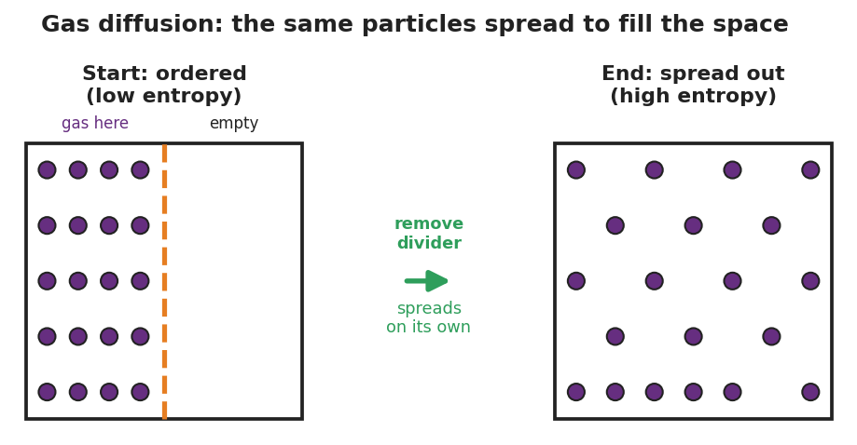
Three-panel particle model of gas diffusion. Left panel ‘Start: ordered (low entropy)’ shows twenty purple particles confined to the left half of a box behind a dashed divider while the right half is empty. A center arrow labeled ‘remove divider — spreads on its own’ points right. Right panel ‘End: spread out (high entropy)’ shows the same twenty particles distributed evenly across the entire box.
Station 2 — Dissolving. Drop a single crystal of colored drink mix (or a dye tablet) into a clear cup of still water. Do not stir. The color spreads on its own until the whole cup is uniformly tinted.
Station 3 — Mixing. Mix two colors of sand or beads (or pour two colored solutions together). Ask: will they ever separate back into two pure colors on their own?
Teacher facilitation language (circulate):
“At every station, ask yourself the same two questions. First: which state is more spread out or more mixed — the start or the end? Second: did the spread-out state happen by itself, or did someone force it? You did not stir the cup. You did not push the smell across the room. It went on its own.”
Anticipated student responses during the stations:
- “The smell reached me but I didn’t do anything.” — exactly the point; the gas spread without any push. The spread-out state is the one that happens for free.
- “If I stir, the color spreads faster.” — true, but notice it spreads even without stirring. Stirring changes the speed (that’s kinetics from earlier lessons); spontaneity is about which direction happens at all.
- “The colors will never un-mix on their own.” — right. Could you separate them? Yes — but only by doing work (sorting, filtering). Un-mixing is the messy-room-tidying-itself direction: it needs outside effort.

18–28 min · Investigation — the spontaneity card sort
Hand each pair a card-sort deck. Each card names a process: ice melting at room temperature, water freezing in a freezer, wood burning, a phone battery charging, iron rusting over years, a drop of dye spreading in water, a ball rolling downhill, a ball rolling uphill. Pairs sort every card into two piles: “happens on its own” and “needs to be forced,” then write a one-line justification for each card on the worksheet.
Teacher facilitation prompts (circulate):
“For each card, ask the same two questions you used at the stations. Does it spread energy out or take energy in? Does it make things more disordered or more ordered? Put the card where your reasoning lands.”
“You have ice melting AND water freezing in your deck. Both happen — but not in the same place. Where does ice melt on its own? Where does water freeze on its own? What’s different about those two rooms?”
Anticipated student responses during the card sort:
- “Wood burning happens on its own once it starts.” — agree; and notice it both releases energy (you feel the heat) and increases disorder (a solid log becomes spreading gases and ash). Both factors push the same way. Hold this; it is the “always spontaneous” case.
- “Water freezing needs a freezer, so it’s forced.” — careful and rich. Inside a freezer (cold), freezing is spontaneous — it happens on its own there. Whether freezing or melting happens for free depends on the temperature. Flag this card for the Explain phase; it is the temperature-dependent case.
- “A phone battery charging needs a charger, so it’s forced.” — exactly. Charging is non-spontaneous; it needs electrical work pushed in. Discharging (using the phone) is the spontaneous direction. This mirrors the messy room: the ‘ordered/charged’ state must be made.
- “A ball rolls downhill on its own but never uphill.” — perfect everyday spontaneity: downhill releases energy and happens for free; uphill takes energy in and must be forced.

28–30 min · Reconnect + surface the pattern
Bring pairs back together. Ask two pairs to share one card and its pile. Then push the class toward the pattern:
“Look across the ‘happens on its own’ pile. Two things keep showing up: the process either releases energy, or it increases disorder — or both. Look across the ‘forced’ pile: those take energy in, or decrease disorder, or both. Energy and disorder are the two levers. When both levers push the same way, the answer is obvious. When they fight each other — like freezing, which releases energy but increases order — the answer depends on conditions like temperature.”
Surface the key idea but do not name the vocabulary yet — that is Phase 3.

Phase 3 · Explain (30 – 36 min)

30–33 min · Turn-and-Talk #2 + class consensus
“Look at your sorted cards. Turn to your partner: what do all the ‘happens on its own’ processes have in common? Try to name not one thing but two — one about energy, one about order.”
Target consensus: the processes that happen on their own tend to (1) release energy to the surroundings and/or (2) increase disorder — they spread things out, mix them, or break order down. When both are true, the change is always spontaneous. When the two factors disagree, temperature decides.
“Here’s the tricky case to chew on. Wood burning releases a huge amount of energy AND increases disorder — easy, that one always happens once lit. But what about water freezing? It releases energy as it freezes — but it makes the molecules MORE ordered (locked into a crystal). The two factors disagree. So what decides whether freezing happens on its own?”
Target: temperature. In the cold (freezer), the energy factor wins and freezing is spontaneous. In a warm room, the disorder factor wins and the reverse (melting) is spontaneous instead.

33–36 min · Vocabulary introduction (exactly 3 terms)
Sample teacher language:
“Let’s name what we’ve been reasoning about all period. A change that proceeds on its own, without continuous outside help, is a spontaneous process. Spontaneous does not mean fast — rust is spontaneous but takes years; it means happens by itself without being forced. The messy room, the spreading dye, the cooling drink — all spontaneous.”
“The first factor we tracked was energy. We already have a word for energy released or absorbed in a chemical change from the energy unit: enthalpy — the heat content of a system. When a process releases energy (exothermic, ΔH < 0), the enthalpy change favors spontaneity. Releasing energy is one of the two pushes toward ‘happens on its own.’”
“The second factor — disorder — gets its own name: entropy, the measure of disorder or how spread-out a system is. A spread-out gas, a dissolved crystal, a mixed pile have high entropy; a confined gas, an undissolved crystal, a sorted pile have low entropy. Nature tends toward higher entropy because there are vastly more disordered arrangements than ordered ones — that is exactly why the room goes messy and never tidy on its own. An increase in entropy (ΔS > 0) is the second push toward spontaneity.”
Post the three terms on the board. Students fill them in on their notes. Then project the decision grid and read it together:
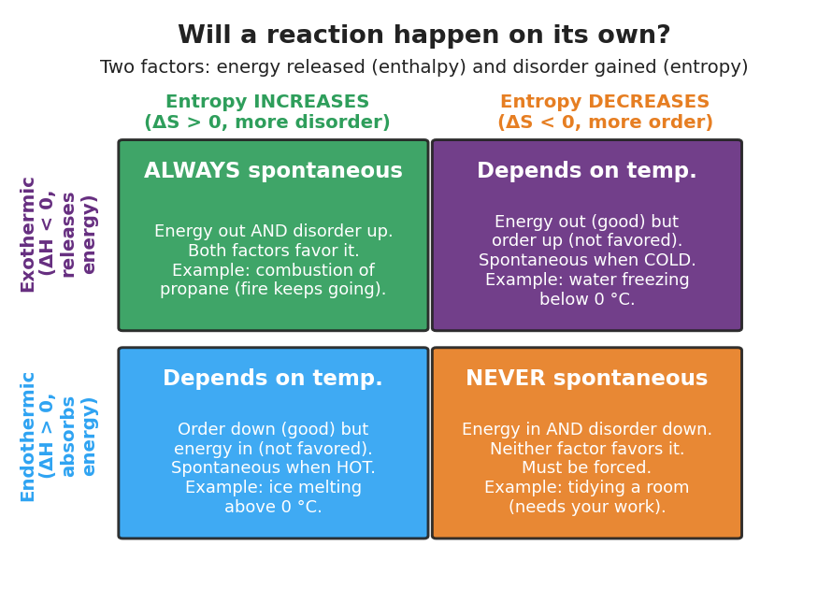
Two-by-two decision grid titled ‘Will a reaction happen on its own?’ with subtitle ‘Two factors: energy released (enthalpy) and disorder gained (entropy).’ Columns are entropy increases versus entropy decreases; rows are exothermic versus endothermic. The exothermic-and-entropy-increase cell reads ALWAYS spontaneous (example: combustion of propane). The exothermic-and-entropy-decrease cell reads Depends on temperature, spontaneous when cold (example: water freezing below zero Celsius). The endothermic-and-entropy-increase cell reads Depends on temperature, spontaneous when hot (example: ice melting above zero Celsius). The endothermic-and-entropy-decrease cell reads NEVER spontaneous (example: tidying a room, which needs your work).
Discussion prompts to deploy here:
- “Which corner of this grid is the messy-room story — a tidy room forming on its own?” — Expected response: the bottom-right “NEVER spontaneous” corner. Tidying takes energy in (endothermic in the analogy) and decreases disorder. Neither factor favors it, so it never happens for free — you must do the work.
- “Wood burning sits in which corner?” — Expected response: top-left “ALWAYS spontaneous.” It releases energy (exothermic) and increases disorder (solid log to spreading gases). Both factors agree.

Note on temperature
Keep temperature qualitative here. Students should be able to say “when the two factors disagree, temperature decides — heat favors disorder, cold favors order.” They do not compute ΔG = ΔH − TΔS in this lesson; that formula is named only as a preview for the strongest students (see Extensions).

Phase 4 · Elaborate (36 – 40 min)

36–39 min · Revise the model + Because/But/So expansion
Students return to their card-sort placements. They revise by adding, for each of two cards, a label: energy factor (does it release or absorb energy?) and entropy factor (does it increase or decrease disorder?). Then they place two of their cards onto the four-corner grid.
Then run a Because/But/So sentence about the phenomenon. Starter on the board:
“A messy room forms on its own, but a tidy room never does.”
Model one aloud:
“A messy room forms on its own because there are far more disordered arrangements than tidy ones, so random change almost always increases disorder (entropy increases) but a tidy room is just one special low-entropy arrangement that random change will not stumble into so making a room tidy is non-spontaneous and requires someone to do work, exactly like the bottom-right corner of our grid.”
Then have students write their own B/B/S using one of these starters:
- “Wood burning is spontaneous once it is lit…” (hint: both factors — releases energy AND increases disorder)
- “A phone battery charges only when plugged in…” (hint: charging is the non-spontaneous, ordered/forced direction)
Anticipated student responses:
- “Because wood burning releases heat.” — good start; push for both factors in the Because: “because burning both releases energy (exothermic) and increases disorder (a solid log becomes spreading gases), so both factors favor it.” Then the So: “so it keeps going on its own without being forced.”
- “Because charging needs a charger.” — yes; push for the entropy framing: “but the spontaneous direction is discharging — using the phone — so charging is the forced, non-spontaneous direction, like tidying the room.”

39–40 min · Return to the phenomenon
“Return to our messy room. You now have two factors and a four-corner grid. In one sentence using the word entropy, explain why the room goes messy on its own but never tidies itself.”
Target: “A messy room has much higher entropy than a tidy one, and because nature tends toward higher entropy, the messy direction is spontaneous while tidying — which lowers entropy — must be forced.”

Phase 5 · Evaluate (40 – 42 min)

40–42 min · Exit Ticket + Closing Reflection
Post or read aloud:
(a) A sealed bottle of perfume is opened in the corner of a room, and soon the whole room smells of it. Is this spontaneous? Name the entropy evidence. (b) Salt dissolving in water both increases disorder and slightly cools the water (absorbs a little energy). Using the two-factor reasoning, explain why it can still be spontaneous. (c) In one sentence, explain why a melted ice cube never re-freezes on its own in a warm room, using the words energy or entropy.
Expected answers are in Answer_Key.docx. The Exit Ticket processes (perfume diffusion, salt dissolving, ice in a warm room) are deliberately different from the worksheet practice (dye, hot drink, rust, battery, ball) so the check measures transfer, not recall.
Closing Reflection (SEL, 30 seconds):
“Today we found out why some things in life happen for free and others take work. In one sentence: what is one everyday ‘it gets messy on its own’ moment you’ll now see differently — and who in here helped you see it?”
Collect worksheets; note which students treat spontaneous as meaning fast (the top misconception) versus happens on its own. Target those students for a brief one-on-one check next lesson.

Common Misconceptions
- Misconception: “Spontaneous means fast.” → Correction: Spontaneous means happens on its own without being forced — it says nothing about speed. Iron rusting is spontaneous but takes years; a diamond turning to graphite is spontaneous but takes geological time. Speed is kinetics (the earlier lessons); spontaneity is direction. A process can be spontaneous and still be extremely slow.
- Misconception: “Only exothermic reactions (energy-releasing) are spontaneous.” → Correction: Releasing energy favors spontaneity, but it is only one of two factors. Endothermic processes that increase disorder enough — ice melting in a warm room, a cold pack absorbing heat, ammonium nitrate dissolving — are spontaneous because the entropy increase wins. Energy is one lever; disorder is the other.
- Misconception: “Entropy increasing means the system gains energy or gets bigger.” → Correction: Entropy is about disorder and how spread-out the arrangement is, not about amount of matter or energy. The same particles can have low entropy (confined, sorted) or high entropy (spread, mixed). Diffusion increases entropy with no change in the number of particles — exactly what figures/entropy_diffusion.png shows: same twenty particles, more spread out.
- Misconception: “If a process is non-spontaneous, it can never happen.” → Correction: Non-spontaneous processes happen all the time — they just require continuous outside work. Charging a battery, tidying a room, and electrolyzing water are all non-spontaneous and all routinely done by supplying energy. “Non-spontaneous” means “won’t happen by itself,” not “impossible.”
- Misconception: “The two factors always agree.” → Correction: Often they conflict. Freezing releases energy (favored) but increases order (not favored). When the factors disagree, temperature decides which one wins — cold favors the energy/order side, heat favors the disorder side. That is why the same substance freezes on its own in a freezer but melts on its own in a warm room.

Access & Differentiation
- ELL/ENL supports: Word-choice box displayed throughout: {spontaneous, on its own, forced, enthalpy, energy released, entropy, disorder, order}. Sentence frames for the card sort and Exit Ticket: “This process is ___ (spontaneous / forced) because the energy is ___ (released / absorbed) and the disorder ___ (increases / decreases).” Pair each abstract term with a gesture: hands spreading apart for entropy/disorder, hands pulling together for order. Allow students to first sort and reason in their home language, then record the final placement and justification in English.
- IEP/SPED supports: Provide a pre-sorted half of the card deck (two cards already placed as worked models) so the student extends a pattern rather than starting cold. Offer a two-column graphic organizer with the headers “releases energy / absorbs energy” and “more disorder / more order” pre-printed, so the student fills two checkboxes per card instead of generating open text. Pre-highlight the matching corner on the spontaneity_grid.png for the worked cards. Sentence starters for the Exit Ticket.
- Extensions: (1) Preview the free-energy idea: tell the student chemists combine the two factors into one quantity, Gibbs free energy, ΔG = ΔH − TΔS, where a negative ΔG means spontaneous. Ask them to explain, using that formula in words, why raising the temperature can flip a process from non-spontaneous to spontaneous. (2) Find a real-world “non-spontaneous on purpose” technology — refrigeration, water electrolysis, electroplating, photosynthesis — and explain what energy is supplied to force the non-spontaneous direction. (3) Rank the three demo stations by how large the entropy increase is, and justify the ranking.

Strategy Spotlight
ACTIVE LEARNING — predict-and-sort before being told. Active learning replaces “teacher explains, then students practice” with “students do and predict, then the class names the pattern.” In this lesson, two active structures carry the cognitive load before a single vocabulary word is introduced: the entropy demonstration stations (students physically observe disorder increasing on its own and answer a prediction question at each) and the spontaneity card sort (students commit every card to a pile and justify it). Both put the reasoning in students’ hands first; the vocabulary in Phase 3 then labels thinking that already exists, rather than introducing thinking from scratch.
Why active-first works for spontaneity: The concept of entropy is notoriously abstract when it arrives as a definition. But every student has lived the messy-room phenomenon and can watch a smell fill a room. By predicting and sorting first, students generate the two factors (energy and disorder) themselves; the teacher’s job in Phase 3 is to put names — enthalpy, entropy, spontaneous — onto ideas the class has already produced. This is the core active-learning move: the definition is a label for a lived experience, not a fact to memorize.
How to run it in this lesson (Phase 2 → Phase 3):
- Run the three demo stations briskly (about 8 minutes). The point is observation and prediction, not lengthy lab write-ups — one prediction question per station.
- The card sort (about 10 minutes) is the heart of the active phase. Circulate and ask the two anchor questions (“energy in or out? more or less disorder?”) rather than giving answers. Let pairs argue about the temperature-dependent cards (freezing/melting) — that productive disagreement is exactly what you want.
- In the reconnect (28–30 min) and Turn-and-Talk #2 (Phase 3), surface the pattern from the students’ piles. Only after the pattern is on the board do you attach the three vocabulary terms.
CRSE connection: The opening circle and the messy-room phenomenon draw on universal, home-based experience — every student, regardless of background, knows what it is for something to get messy or run down on its own. Grounding an abstract thermodynamic idea in lived domestic experience (rooms, phone batteries, spilled things) honors students’ out-of-school knowledge and signals that their everyday observations are legitimate scientific data. The card sort’s collaborative structure also gives quieter students a low-stakes way to contribute — placing a card is a complete act of reasoning.

NYSSLS Observation Checklist Crosswalk
# | Checklist item | Where it appears in this lesson
1 | Local/relatable phenomenon | Phase 1 — the messy-room story (a room that won’t tidy itself); widened to dye, cooling drinks, spreading smells; returned to in Phase 4
2 | Turn and Talk (2–3×) | Phase 1 (TT#1 — what does a cooling drink lose, and which way does it travel?); Phase 3 (TT#2 — what do all the ‘happens on its own’ processes share?)
3 | Students develop questions/models/procedures | Phase 2 entropy demo stations (predict at each); spontaneity card sort (commit and justify every card); Phase 4 placing cards on the four-corner grid
4 | CCC defined and used | Lesson Overview · Energy and Matter; explicit in Phase 3 (two-factor reasoning) and Phase 4 (B/B/S on entropy and the messy room)
5 | ENL — ≤ 3 vocab, second half | Phase 3 — vocabulary introduced at 33–36 min: spontaneous / enthalpy / entropy
6 | Revisit phenomenon with evidence | Phase 4 — students return to the messy room with the two factors and the grid to explain why messy is spontaneous and tidy is forced
7 | ENL/SPED supports | Access & Differentiation block: word-choice box, sentence frames, two-column organizer, pre-sorted worked cards, highlighted grid corners
8 | Assessment check | Phase 5 — Exit Ticket (perfume diffusion, salt dissolving, ice in a warm room) — distinct from the worksheet practice

Companion Materials
- Student_Worksheet.docx — the 5E student investigation (hand out at start of Phase 2)
- Student_Notes.docx — guided note-guide for vocabulary and the worked spontaneity example
- Answer_Key.docx — answers to “Make It Make Sense” prompts and the Exit Ticket

Key Vocabulary (max 3)
- spontaneous — describing a process that proceeds on its own, without continuous outside help; spontaneous refers to direction, not speed (a spontaneous process can be very slow, like rusting); favored by releasing energy and/or increasing disorder
- enthalpy — the heat content of a system; a process that releases energy to the surroundings (exothermic, ΔH < 0) has an enthalpy change that favors spontaneity, while one that absorbs energy (endothermic, ΔH > 0) does not
- entropy — a measure of the disorder, randomness, or spread-out-ness of a system; nature tends toward higher entropy because disordered arrangements vastly outnumber ordered ones, so an increase in entropy (ΔS > 0) favors a spontaneous change

