Percent Composition — Student Notes
Unit: Safety and Measurement — Lesson 07 Name: _______________________ Date: __________ Period: ____

Learning Targets
By the end of today’s 42 minutes I can:
- Calculate the percent composition of each element in a compound using the formula % element = (n × atomic mass ÷ GFM) × 100.
- Identify the gram formula mass as the denominator in any percent-composition calculation and explain why.
- Define mass ratio and convert a mass ratio to a percent by multiplying by 100.
- Explain, using Scale, Proportion, and Quantity, why two compounds containing the same element can differ in how much of that element they deliver per gram.

Key Vocabulary
- percent composition — _______________________________________________ _______________________________________________
- gram formula mass — _______________________________________________ _______________________________________________
- mass ratio — _______________________________________________ _______________________________________________

Guided Notes
The big idea — Scale, Proportion, and Quantity: Percent composition tells us each element’s __________ of the whole compound mass. The proportions are __________ by the formula — every sample of a given compound has the same percent composition regardless of __________.
The percent-composition formula:
% element = ( n × atomic mass of element ) ÷ __________________ × 100
where: - n = the __________ of that element in the formula - atomic mass = from the __________ - the denominator = __________ — the total mass of the compound
Why the denominator is the GFM: The GFM is the __________ pie. Each element’s mass contribution is one __________. Dividing the slice by the whole gives a decimal (the __________); multiplying by 100 converts it to a percent.
The Hochman appositive definition:
Percent composition — _________________________ — is calculated by _________________________.
The figure — percent by mass in water (H₂O):
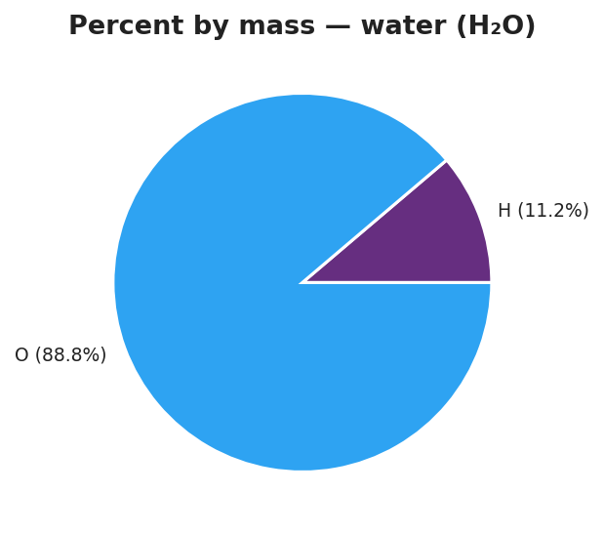
Pie chart titled ‘Percent by mass — water (H₂O)’ showing two slices: hydrogen (H) at 11.2% in light blue and oxygen (O) at 88.8% in dark blue; each slice is labeled with the element symbol, the percentage, and the corresponding mass contribution (H: 2 g/mol out of 18 g/mol; O: 16 g/mol out of 18 g/mol); the chart title notes that percentages sum to 100%.
From the figure above, fill in the blanks:
- GFM of water: ___________ g/mol
- Hydrogen’s mass contribution: ___________ g/mol → mass ratio = /18 = ________ → % = ___________%
- Oxygen’s mass contribution: ___________ g/mol → mass ratio = /18 = ________ → % = ___________%
- Sum of percents: __________ + __________ = __________% (always = __________)
The calculation table format (use this for every percent-composition problem):
Element | n (subscript) | Atomic mass (g/mol) | n × at. mass | ÷ GFM | × 100 = %
(symbol) | (from formula) | (Periodic Table) | (n × at. mass) | (÷ total mass) | (percent)

Worked Example
Scenario: A student needs to find the percent composition of each element in CO₂.
Step 1 — Find the GFM of CO₂:
Element | Atomic mass (g/mol) | Subscript | Mass contribution
C | ___ | 1 | ___
O | ___ | 2 | ___
GFM |  |  | ___ g/mol
Step 2 — Calculate each element’s percent:
% C = ( ___ × ___ ) ÷ ___ × 100 = ____%
% O = ( ___ × ___ ) ÷ ___ × 100 = ____%
Step 3 — Check:
% C + % O = % + % = ____% (should equal ___________)
Step 4 — Appositive sentence:
The percent carbon in carbon dioxide — % — is calculated by dividing g/mol (C’s contribution) by ___ g/mol (GFM) and multiplying by 100.
Step 5 — Because / But / So
If you used CO instead of CO₂ for this calculation, the percent carbon would change because _______________________________________________, but _______________________________________________, so _______________________________________________.
Check your reasoning: “because” should explain what changes in the formula; “but” should name what stays the same (carbon’s atomic mass); “so” should compare the two percent-carbon values.

Summary
Complete the appositive sentence:
Percent composition — _________________________ — is calculated by _________________________.
Complete the Because / But / So sentence:
Two fertilizer compounds both contain nitrogen, but the compound with the higher percent nitrogen by mass because __________________________________________, but __________________________________________, so __________________________________________.
Reminder: The percents for all elements in a compound must sum to 100%. If your sum is significantly different from 100%, check that (a) you used GFM as the denominator, not an individual atomic mass, and (b) you multiplied by 100 at the end.
Key formula (copy into your Reference Tables): % element = (n × atomic mass of element ÷ gram formula mass of compound) × 100

