Percent Composition — Student Worksheet
Unit: Safety and Measurement — Lesson 07 Name: _______________________ Date: __________ Period: ____

Phenomenon
Two fertilizer bags sit on the demonstration table. Both advertise “nitrogen” on the label. Both are applied at the same rate — same number of scoops per square foot. One grows noticeably greener, healthier grass than the other. The labels look almost identical. The difference is hidden in the chemistry.
Driving question: How can we tell what a compound is made of — and how much of each element — without taking it apart?

Notice & Wonder
I notice… | I wonder…
Turn & Talk #1: Look at the water pie chart your teacher is projecting.
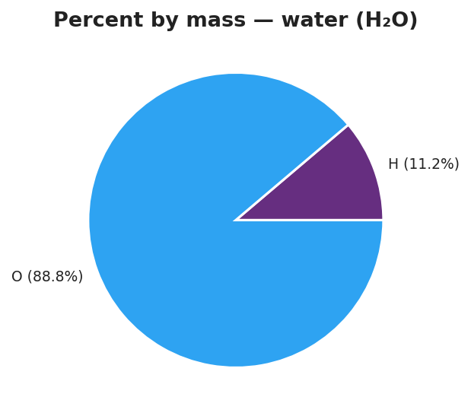
Pie chart titled ‘Percent by mass — water (H₂O)’ showing two slices: hydrogen (H) at 11.2% in light blue and oxygen (O) at 88.8% in dark blue; each slice is labeled with the element symbol, the percentage, and the corresponding mass contribution (H: 2 g/mol out of 18 g/mol; O: 16 g/mol out of 18 g/mol); the chart title notes that percentages sum to 100%.
Water has two hydrogen atoms per molecule and only one oxygen atom — but oxygen’s slice is much larger. In one sentence, explain why one oxygen atom outweighs two hydrogen atoms in the pie chart.

Initial Model
Before your teacher names the formula: use the water pie chart above to answer the following.
The whole pie represents the gram formula mass of water: 18 g/mol. Hydrogen’s contribution to the GFM: 2 g/mol. Oxygen’s contribution to the GFM: 16 g/mol.
- What fraction of the total mass is hydrogen? Write it as a division: ___ ÷ ___ = ___
- Multiply that fraction by 100 to get a percent: ____%
- What fraction of the total mass is oxygen? Division: ___ ÷ ___ = ___
- Multiply by 100: ____%
- Add your two percents: ____% + ____% = ____% Does this make sense? Why?

Investigation

Part 1 — ABCs: Predict before you calculate
Before calculating anything, look at the four formulas below. Rank them 1–4 by predicted percent oxygen (most oxygen by mass = 1; least = 4). Base your prediction on the formula alone.
Compound | Formula | My predicted rank for % oxygen
Carbon dioxide | CO₂
Water | H₂O
Table salt | NaCl
Ammonia | NH₃
After you complete Part 2, return and check: was your prediction correct? What surprised you?
After checking: _______________________________________________

Part 2 — BTC thin-slice (group work at vertical surface)
Your teacher will assign you to a random group and a vertical surface. As a group, solve the following — show all work on the vertical surface:
A compound has a gram formula mass of 44 g/mol. Carbon contributes 12 g/mol; oxygen contributes 32 g/mol.
- Percent carbon by mass: ___ ÷ ___ × 100 = ____%
- Percent oxygen by mass: ___ ÷ ___ × 100 = ____%
- Sum of percents: ____% + ____% = ____%
After the debrief — what compound was it? _______________

Part 3 — Individual calculation practice
Calculate the percent composition of each element in the compounds below. Use the formula: % element = (n × atomic mass ÷ GFM) × 100. Show every step.
Compound A: H₂O (verify with the pie chart above)
GFM of H₂O: ______ g/mol
Element | n (subscript) | Atomic mass (g/mol) | n × atomic mass | ÷ GFM | × 100 = % by mass
H | 2
O | 1
Sum of percents: ____% + ____% = ____% Does it match the pie chart? ______
Compound B: CO₂ (verify with your BTC answer)
GFM of CO₂: ______ g/mol
Element | n (subscript) | Atomic mass (g/mol) | n × atomic mass | ÷ GFM | × 100 = % by mass
C | 1
O | 2
Sum of percents: ____% + ____% = ____%

Make It Make Sense
For each problem below, calculate the percent composition of every element. Show your full table. These compounds are different from the Exit Ticket — work carefully.
1. Carbon dioxide, CO₂
GFM (calculate or use above): ______ g/mol
Element | n | Atomic mass (g/mol) | n × at. mass | ÷ GFM | % by mass
C | 1
O | 2
% C = ______ % O = ______ Sum = ______
2. Sodium chloride (table salt), NaCl
First, calculate GFM of NaCl:
Element | Atomic mass (g/mol) | Subscript | Mass contribution
Na |  | 1
Cl |  | 1
GFM |  |  | ______ g/mol
Now calculate percent composition:
Element | n × at. mass | ÷ GFM | % by mass
Na
Cl
% Na = ______ % Cl = ______ Sum = ______
3. Comparing nitrogen-rich compounds — which fertilizer is richer in nitrogen?
You have two compounds: ammonia (NH₃) and ammonium nitrate (NH₄NO₃). Your job: calculate the percent nitrogen by mass in each, then decide which delivers more nitrogen per gram.
Ammonia, NH₃:
GFM of NH₃:
Element | Atomic mass (g/mol) | Subscript | Mass contribution
N |  | 1
H |  | 3
GFM |  |  | ______ g/mol
% N in NH₃ = (1 × ____) ÷ ______ × 100 = ______%
Ammonium nitrate, NH₄NO₃:
GFM of NH₄NO₃:
Element | Atomic mass (g/mol) | Subscript | Mass contribution
N |  | 2
H |  | 4
O |  | 3
GFM |  |  | ______ g/mol
% N in NH₄NO₃ = (2 × ____) ÷ ______ × 100 = ______%
Which compound is richer in nitrogen by mass? _______________
In one sentence, explain what this means for the fertilizer phenomenon at the start of the lesson:

Vocabulary in Action
Use each term in a sentence about today’s investigation. Do not copy the definition — describe something you actually did or observed.
- percent composition: _______________________________________________ _______________________________________________
- gram formula mass: _______________________________________________ _______________________________________________
- mass ratio: _______________________________________________ _______________________________________________

Revise Your Model
Return to your Initial Model (the water pie chart fractions you calculated at the top of this worksheet). Add vocabulary labels:
- Circle the denominator in your calculation. Label it “gram formula mass.”
- Circle the numerator (element’s mass contribution). Label it “n × atomic mass.”
- Circle the final percent. Label it “percent composition.”
- Write a revised appositive sentence:
The percent composition of hydrogen in water — % — is calculated by dividing ____________________________________________ by _______________________________________________.
Then finish this Because / But / So sentence:
Urea (CO(NH₂)₂) grows greener grass than ammonium nitrate (NH₄NO₃) at the same application rate because __________________________________________, but __________________________________________, so __________________________________________.

Exit Ticket
For water, H₂O (gram formula mass = 18 g/mol):
(a) What is the percent hydrogen by mass? Show your setup.
% H = ( ___ × ___ ) ÷ ___ × 100 = ______%
(b) What is the percent oxygen by mass? Show your setup.
% O = ( ___ × ___ ) ÷ ___ × 100 = ______%
(c) In one sentence, why do the two percentages add up to 100%?

