Electric Charge — Student Notes
Unit: Electrostatics — Lesson 01 Name: _______________________ Date: __________ Period: ____

Learning Targets
By the end of today’s 42 minutes I can:
- State that there are two kinds of charge and that like charges repel while unlike charges attract.
- Explain a static phenomenon as a transfer of electrons (charge is conserved).
- Predict whether two charged objects attract or repel from their signs.

Key Vocabulary
- electric charge — _______________________________________________
- positive charge — _______________________________________________
- negative charge — _______________________________________________

Guided Notes
Big idea: All matter is made of atoms that contain __________ charge (protons) and __________ charge (electrons).
- There are exactly __________ kinds of charge: positive and negative.
- Like charges __________ (push apart). Unlike charges __________ (pull together).
- A neutral object has __________ amounts of positive and negative charge.
- Charge is quantized: it comes in whole multiples of the elementary charge e = __________ × 10⁻¹⁹ C.
- Charge is conserved: it is never created or destroyed, only __________ from one object to another.
Rubbing a balloon on hair:
- Electrons move from the __________ onto the __________.
- The balloon becomes __________ (gained electrons); the hair becomes __________ (lost electrons).
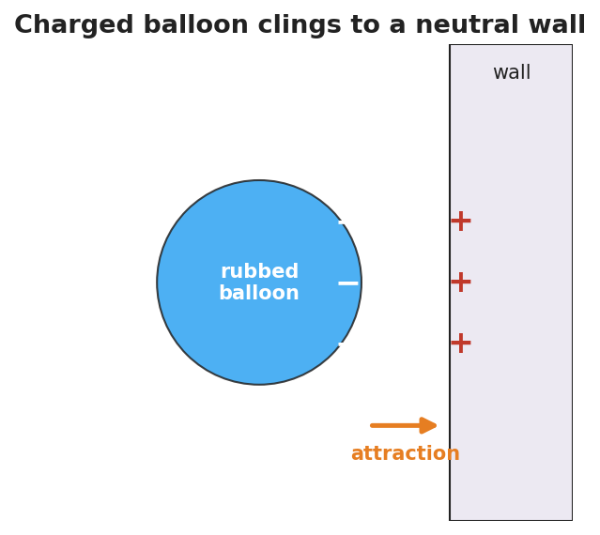
A negatively charged balloon clinging to a neutral wall; the wall surface nearest the balloon shows + signs.
The same kind repels; the opposite kind attracts — that single rule explains every demo today:
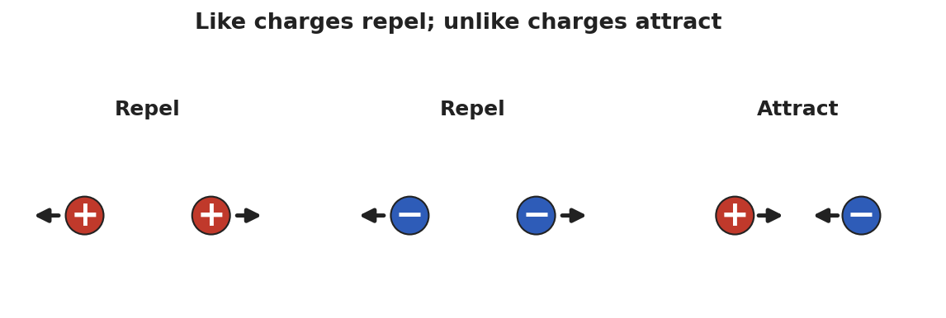
Three charge pairs: + with + repel, − with − repel, + with − attract.

Worked Example
Problem. A glass rod is rubbed with silk. The rod ends up with a charge of +6 units. What charge does the silk carry, and why?
Solution. 1. Rubbing only __________ charge — it does not create it (conservation of charge). 2. The rod became +6, so it __________ 6 units of negative charge (electrons). 3. Those electrons went __________ the silk, so the silk carries a charge of __________ units. 4. Total charge before = total charge after = __________.

Summary
Finish the sentence (Because / But / So):
Two balloons rubbed the same way push each other apart because __________________________________________, but a balloon and a neutral wall pull together __________________________________________, so __________________________________________.

