Electric Charge — Student Worksheet
Unit: Electrostatics — Lesson 01 Name: _______________________ Date: __________ Period: ____

Phenomenon
Your teacher rubs a balloon on their hair and it sticks to the wall — no glue. Held near your head, the balloon makes your hair rise toward it. Small bits of paper jump up to meet it.
Driving question: What invisible change does rubbing make, and why does it cause objects to pull or push on each other?

Notice & Wonder
I notice… | I wonder…
Turn & Talk #1: The balloon and the wall were both ordinary before. What changed, and why would they now pull on each other?

Initial Model
Draw the rubbed balloon next to the wall. Show what you think moved (and which direction) when the balloon was rubbed. Then predict: will the balloon stick to a second rubbed balloon, or push it away?

My prediction: _______________________________

Investigation
The diagram shows the rule you are testing: same kinds of charge repel; opposite kinds attract.
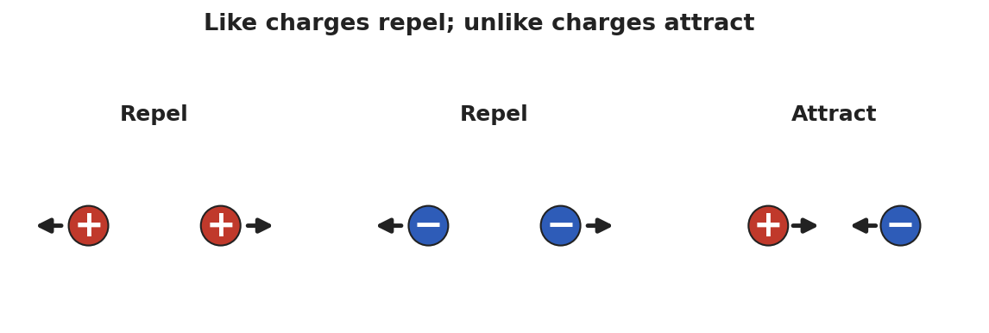
Three diagrams of charge pairs: two + charges repel, two − charges repel, and a + with a − attract.
Complete each station. Record what you observe and what it tells you.
Station | What I did | What happened | What it tells me
1. Two rubbed balloons on strings
2. Charged balloon + paper bits
3. Javalab electroscope
Key question: When did the two objects pull together, and when did they push apart? What was different about those cases?

Make It Make Sense
- Two balloons are each rubbed on the same wool sweater, then brought close. Do they attract or repel? How do you know?
- A balloon is rubbed and gains a negative charge. Where did that charge come from, and what sign is the object it was rubbed on?
- A neutral scrap of paper is pulled toward a charged balloon. Was the paper given a charge, or is something else going on?

Vocabulary in Action
Use each term in a sentence about today’s phenomenon.
- electric charge: _______________________________________________
- positive charge: _______________________________________________
- negative charge: _______________________________________________

Revise Your Model
Return to your Initial Model. Re-label what moved using electric charge and positive/negative. Rewrite your explanation of why the balloon sticks, using the idea that charge is conserved (only moved, never made).

Exit Ticket
Two small spheres hang side by side.
- When both are rubbed with the same cloth, they swing apart. What does that tell you about their charges?
- A third sphere is brought near, and the first sphere swings toward it. What sign is the third sphere?
- A balloon gains a charge of −8 units after being rubbed on a wool sock. What is the charge on the sock, and why?

