Conductors, Insulators, and Charging by Conduction — Student Notes
Unit: Electrostatics — Lesson 02 Name: _______________________ Date: __________ Period: ____

Learning Targets
By the end of today’s 42 minutes I can:
- Tell a conductor from an insulator and classify common materials.
- Explain charging by conduction and why both objects end with the same sign.
- Predict the sign of an object charged by conduction.

Key Vocabulary
- conductor — _______________________________________________
- insulator — _______________________________________________
- charging by conduction — _______________________________________________

Guided Notes
Big idea: Whether charge spreads depends on the __________ of the material.
- In a conductor (mostly __________), some electrons are free to move, so charge spreads __________.
- In an insulator (rubber, glass, plastic), electrons are __________, so charge stays __________.
- Charging by conduction = transferring charge by direct __________ with a charged object.
- After conduction, both objects have the __________ sign (the charge simply spreads from one to the other).
Electroscope:
- The metal is a __________, so charge from the rod travels down to the __________.
- The two leaves get the __________ sign, so they __________ (push apart).
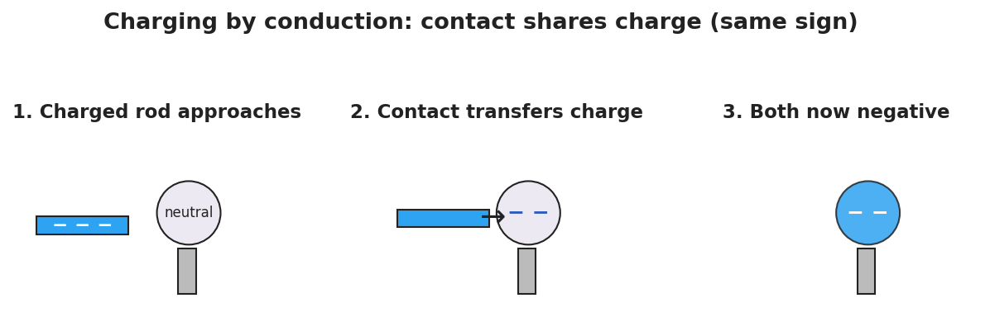
Three-step charging by conduction: a − rod approaches a neutral metal sphere, touches it, then leaves the sphere negative.
Conductor vs. insulator at the particle level:
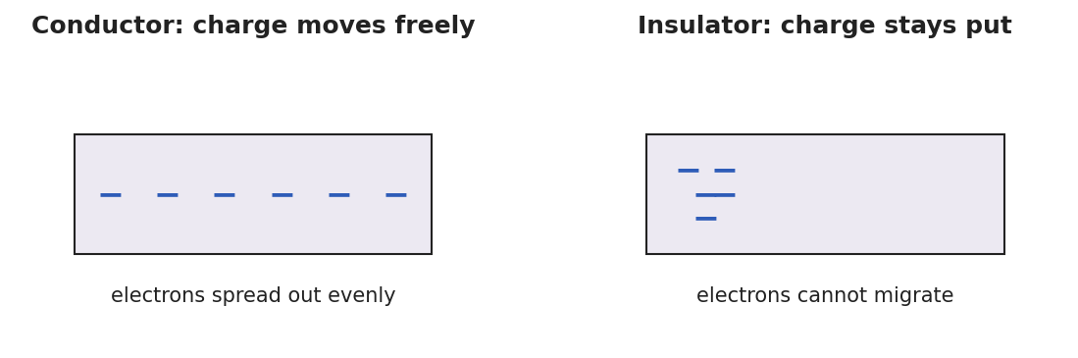
A conductor with charge spread evenly; an insulator with charge stuck in one place.

Worked Example
Problem. A rod carrying a charge of −10 units is touched to an identical neutral metal sphere. The charge shares equally between the two metals. What charge ends up on the sphere, and what sign is it?
Solution. 1. The rod is a conductor and the sphere is a conductor, so charge can __________ between them. 2. Total charge = −10 units, shared __________ between two identical metals → −5 units each. 3. The sphere ends up with __________ units — the __________ sign as the rod (conduction shares charge, it does not reverse it).

Summary
Finish the sentence (Because / But / So):
A charged rod shares its charge with a metal sphere on contact because __________________________________________, but it will not share with a rubber block __________________________________________, so __________________________________________.

