Conductors, Insulators, and Charging by Conduction — Student Worksheet
Unit: Electrostatics — Lesson 02 Name: _______________________ Date: __________ Period: ____

Phenomenon
Your teacher touches a charged rod to the metal knob of an electroscope. The thin metal leaves at the bottom spring apart — and stay apart even after the rod is taken away. A touch of a finger makes them collapse.
Driving question: What decides whether charge spreads through an object or stays stuck in one spot?

Notice & Wonder
I notice… | I wonder…
Turn & Talk #1: The rod touched only the top knob, but the bottom leaves moved. How did the charge get all the way down?

Initial Model
Draw the electroscope. Show where the charge is right after the rod touches the knob, and which way it moves. Predict: would a wooden ruler touched to the knob do the same thing?

My prediction: _______________________________

Investigation
In a conductor, charge spreads out freely; in an insulator, it stays where you put it.
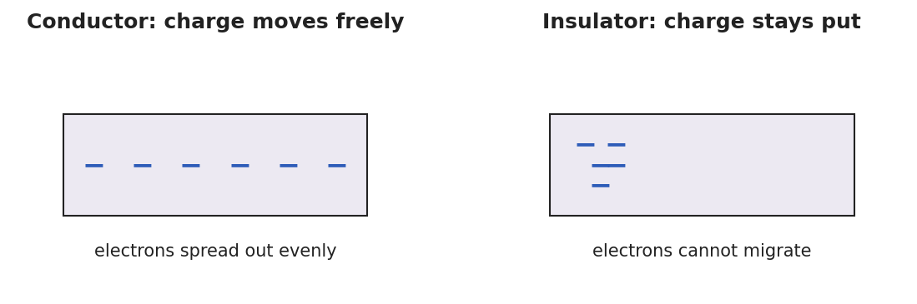
Two panels: a conductor with charge spread evenly across it, and an insulator with charge clustered in one spot.
Predict first, then test. Sort each sample before touching it to the electroscope.
Sample | My prediction (moves / stays) | What happened | Conductor or insulator?
Copper wire
Wooden ruler
Aluminum foil
Rubber band
Glass rod
Key question: What do all your “charge moves” samples have in common?

Make It Make Sense
- A negatively charged rod is touched to a neutral metal sphere. What sign is the sphere afterward, and what is this charging method called?
- Why does touching a charged metal object with your bare hand make its charge disappear?
- A charged balloon (an insulator) is pressed against a wooden block. Will the block become charged all over? Why or why not?

Vocabulary in Action
Use each term in a sentence about today’s phenomenon.
- conductor: _______________________________________________
- insulator: _______________________________________________
- charging by conduction: _______________________________________________

Revise Your Model
Return to your Initial Model. Re-label the electroscope: is the metal a conductor or insulator? Using conduction, write one sentence explaining why the leaves stayed spread after the rod was removed.

Exit Ticket
- Classify each as a conductor or insulator: copper wire, rubber band, aluminum foil, glass rod.
- A negatively charged rod is touched directly to a neutral metal sphere. What sign is the sphere afterward? Name the charging method.
- Explain in one sentence why a charged comb shares its charge with a metal doorknob, but not with a dry plastic cup.

