Charging by Induction and Polarization — Student Notes
Unit: Electrostatics — Lesson 03 Name: _______________________ Date: __________ Period: ____

Learning Targets
By the end of today’s 42 minutes I can:
- Explain polarization and why a charged object attracts a neutral one.
- Describe the four steps of charging by induction.
- Contrast induction (opposite sign, no contact) with conduction (same sign, contact).

Key Vocabulary
- polarization — _______________________________________________
- induction — _______________________________________________
- grounding — _______________________________________________

Guided Notes
Polarization (in a neutral object):
- A charged object brought near makes the neutral object’s charges __________.
- The near side becomes __________ (opposite to the rod); the far side becomes __________.
- The object is overall still __________, but its near side is attracted.
Charging by induction (with a negative rod, no contact):
- Bring the negative rod __________ the neutral metal sphere → it polarizes.
- __________ the far side; electrons (repelled by the rod) flee to the __________.
- Remove the __________ first, while the rod is still near.
- Remove the __________; the sphere is left with the __________ sign (positive).
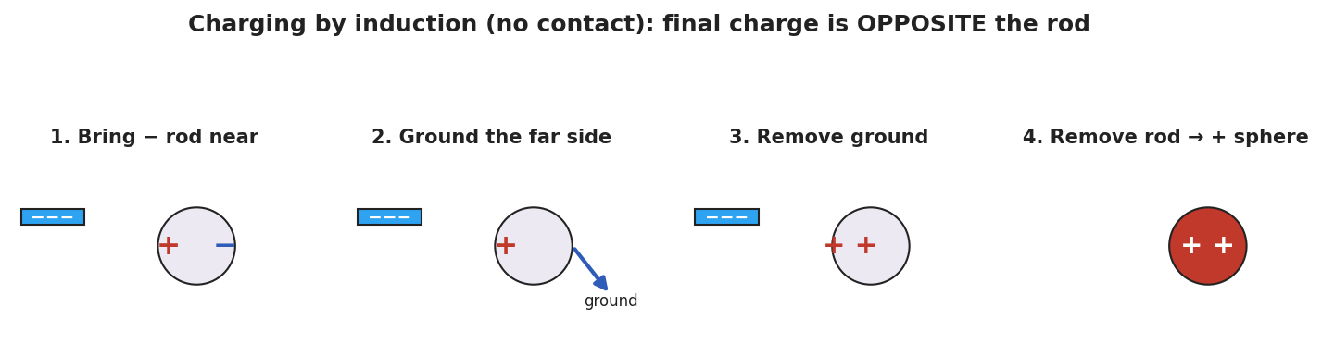
Four panels of induction: polarize, ground, remove ground, remove rod → positive sphere.
Why a neutral object is attracted (polarization):
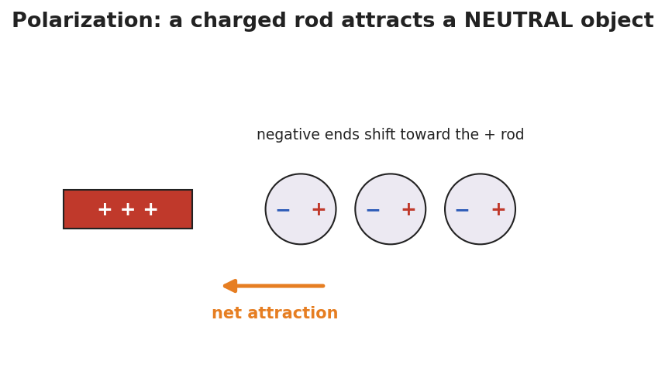
A + rod near neutral atoms whose negative ends have shifted toward the rod, so the object is pulled toward it.
Induction vs. conduction:
 | Contact? | Final sign vs. rod
Conduction | __________ | __________
Induction | __________ | __________

Worked Example
Problem. A metal sphere is charged by induction using a rod that is +8 units. After the procedure, what sign is the sphere’s net charge, and why?
Solution. 1. The + rod is brought near; it __________ the sphere (− on the near side, + on the far side). 2. Grounding lets the rod-repelled charge (the __________ charges) escape to the ground. 3. Remove the ground, then the rod → the sphere keeps the charge __________ to the rod. 4. The rod was +, so the sphere ends up __________ — opposite, with no contact.

Summary
Finish the sentence (Because / But / So):
A charged rod can attract a neutral object because __________________________________________, but to leave the object permanently charged without touching it __________________________________________, so __________________________________________.

