Charging by Induction and Polarization — Student Worksheet
Unit: Electrostatics — Lesson 03 Name: _______________________ Date: __________ Period: ____

Phenomenon
Your teacher holds a charged rod near a thin stream of water — the stream bends toward it. The rod never touches the water, and the water started out neutral. Held over tiny scraps of neutral paper, the rod makes them jump up to meet it.
Driving question: How can a charged object pull on a neutral object it never even touches?

Notice & Wonder
I notice… | I wonder…
Turn & Talk #1: The paper is neutral, yet it’s attracted. What could the charged rod be doing to the inside of the paper?

Initial Model
Draw a scrap of neutral paper with a charged rod held above it. Show what you think happens to the charges inside the paper. Predict whether the paper is pulled up, pushed down, or unaffected.

My prediction: _______________________________

Investigation
BTC thin-slice task (vertical whiteboard, groups of 3):
You have a neutral metal sphere on an insulating stand and a negative rod you may not touch to the sphere. Find a sequence of moves — bring the rod near, touch the sphere with a finger (ground), step away — that leaves the sphere with a lasting positive charge. Draw each step and show where the charges are.
Check your sequence against this model:
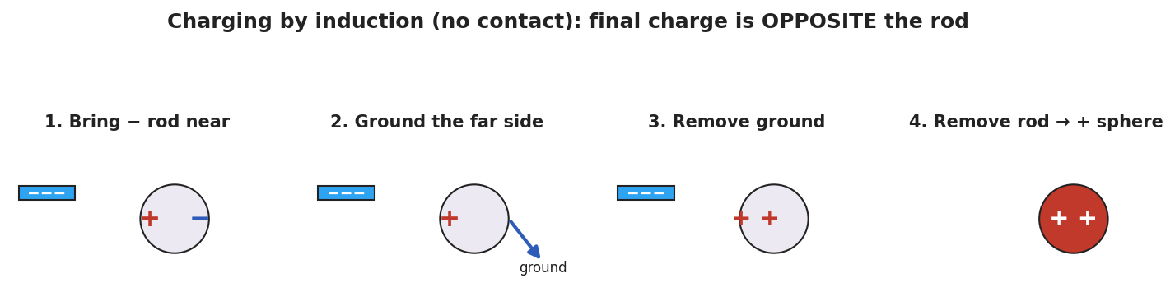
Four panels of charging a metal sphere by induction with a negative rod: polarize, ground the far side, remove the ground, then remove the rod, leaving the sphere positive.
Step | What I do | Where the charges are
1
2
3
4
Key question: Why must you remove the ground before you remove the rod?

Make It Make Sense
- A charged rod attracts a neutral piece of paper. Explain what happens to the paper’s charges (use the word polarization).
- A negative rod is used to charge a metal sphere by induction. What sign does the sphere end up with, and why?
- A student lets the rod touch the sphere instead. Now what charging method is it, and what sign does the sphere get?

Vocabulary in Action
Use each term in a sentence about today’s phenomenon.
- polarization: _______________________________________________
- induction: _______________________________________________
- grounding: _______________________________________________

Revise Your Model
Return to your Initial Model. Re-label it using polarization: which side of the paper is attracted, and why? Then write one sentence stating the final sign if you charged a metal sphere by induction with a positive rod.

Exit Ticket
A positive rod is brought near (not touching) a neutral metal sphere on an insulating stand.
- Sketch where the + and − charges sit on the sphere while the rod is near. What is this called?
- You ground the sphere, remove the ground, then remove the rod. What sign is the sphere’s net charge? Name the method.
- In one sentence, state the key difference between charging by induction and charging by conduction.

