Charging by Induction and Polarization — Teacher Guide

Cover
Unit: Electrostatics — Lesson 03: Charging by Induction and Polarization East Meadow Schools × Valley Stream Central High School District Strategy chips: BTC

Curated Resources (from East Meadow Scope & Sequence)

NYSSLS Standards
This lesson develops HS-PS3-5: “Develop and use a model of two objects interacting through electric or magnetic fields to illustrate the forces between objects and the changes in energy of the objects due to the interaction. (Cause and Effect).” Induction and polarization are the clearest cases of objects interacting at a distance — the charged rod rearranges charge in a neutral object it never touches, which is exactly the field-mediated interaction the next lessons model.

Phenomenon
- A charged rod attracts a thin stream of water / tiny paper bits without touching (Veritasium/standard demo): https://www.youtube.com/watch?v=N2lWX_zk1Q4
- Glass rod rubbed with silk picks up small neutral scraps (Khan Academy, “Triboelectric effect and charge”): https://www.khanacademy.org/science/physics/electric-charge-electric-force-and-voltage

Javalab / Labs
- Electrostatic induction (charge a sphere without contact): https://javalab.org/en/electrostatic_induction_en/
- Electroscope (induction vs. conduction): https://javalab.org/en/electroscope_en/

Assessments
- PhET “Balloons and Static Electricity” — drag the balloon near the neutral wall and watch the wall’s charges shift (polarization): https://phet.colorado.edu/en/simulations/balloons-and-static-electricity. The Exit Ticket below is the formative check.

Lesson Overview
Duration | 42 minutes (1 period)
NYSSLS link | HS-PS3-5 (interaction at a distance — rearranging charge without contact)
CCC focus | Cause and Effect — a charged object causes charge in a neutral object to rearrange, with no contact.
Strategy chips | BTC (Building Thinking Classrooms)
Materials | Charged rods (PVC + acetate) + cloth; metal sphere on an insulating stand (or two touching cans); thin water stream from a tap; paper bits; vertical non-permanent surfaces (whiteboards) + markers; a grounding wire/finger.
Safety | Standard classroom safety. Keep water away from any electrical outlets.
Prior knowledge | Lessons 01–02 — two charges; like repel/unlike attract; conductors let charge move; conduction gives the same sign.
Lesson objectives — students can:
- Explain polarization: a neutral object’s charges shift when a charged object is brought near, so its near side is attracted.
- Describe charging by induction: bring a charge near, ground the far side, remove the ground, then remove the charge — leaving the opposite sign, with no contact.
- Contrast induction (opposite sign, no contact) with conduction (same sign, contact).

Phase 1 · Engage (0 – 10 min)

0–2 min · Opening Connection (SEL)
One-phrase whip-around: “Name a time someone influenced you from a distance — without ever touching or talking to you.” (A role model, a crowd’s mood.) This primes “acting at a distance,” the heart of today’s lesson.

2–7 min · Phenomenon hook — attraction without contact
Teacher actions. Rub a rod and hold it near (not touching) a thin stream of water — the stream bends toward the rod. Then hold it over neutral paper bits — they leap up to it, even though the rod and paper started neutral-to-charged with no contact at all.
Sample teacher language:
“The paper has no charge, the rod never touched it — so how is a neutral scrap of paper being pulled toward something it isn’t even touching?”
Anticipated student responses:
- “The rod pulls the paper like a magnet.” — useful analogy; we’ll sharpen why.
- “The paper must be a little bit charged.” — probe: it was neutral a second ago; what changed?
- “The charges inside the paper moved.” — excellent; this is polarization — hold for Phase 3.

7–10 min · Notice & Wonder + Turn-and-Talk #1
“Turn to your partner: the paper is neutral, yet it’s attracted. What could the charged rod be doing to the inside of the paper?”
Target idea: the rod pushes/pulls the paper’s own charges around. Leave open if unspoken.

Bridge to Phase 2
Each student writes a one-sentence initial model: “The neutral paper is attracted because ______.”

Phase 2 · Explore (10 – 30 min)

BTC launch (random groups, vertical whiteboards)
Form visibly random groups of 3. Each group works at a vertical non-permanent surface. Pose the thin-slice task without front-loading vocabulary:
Thin-slice task: “You have a NEUTRAL metal sphere on an insulating stand and a NEGATIVE rod you may NOT touch to the sphere. Find a sequence of moves — bring the rod near, touch the sphere with a finger (ground), step away — that leaves the sphere with a LASTING positive charge. Draw each step and where the charges are.”
BTC facilitation moves:
“Don’t tell me the answer — show me on the board where the electrons are at each step.” “Your sphere is neutral the whole time the rod is near. So how can it end up positive? What had to leave?”
Mid-task, project the Javalab electrostatic-induction sim so groups can test their proposed sequence. Then reveal the canonical sequence as the model to check against:
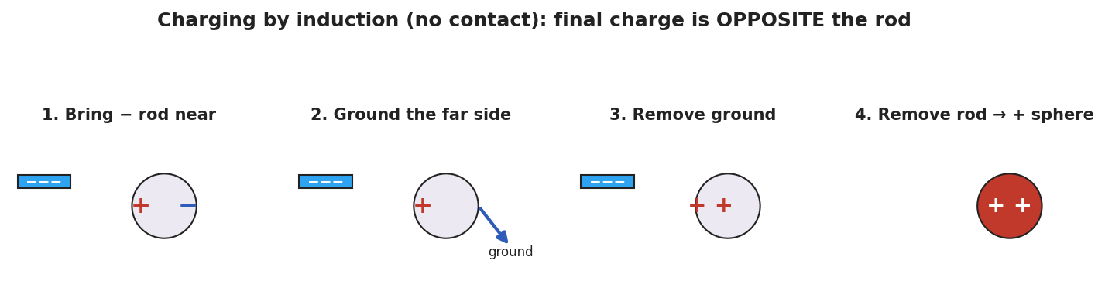
A four-panel sequence of charging a neutral metal sphere by induction with a negative rod: (1) the rod nearby polarizes the sphere with + on the near side and − on the far side; (2) grounding the far side lets electrons flee to the ground; (3) the ground is removed, leaving the sphere net positive; (4) the rod is removed and the positive charge spreads over the sphere.

Teacher facilitation during Explore
- What to look for — groups realizing the ground must be removed before the rod, or the trick fails.
- What to resist — don’t name “induction” until the consolidation; let the sequence emerge on the boards.
- What to redirect — groups who let the rod touch the sphere have done conduction (same sign) — ask them to compare the final sign with the no-touch version.

Phase 3 · Explain (30 – 36 min)

30–34 min · BTC consolidation + class consensus
Tour two or three boards in a deliberate sequence (least-to-most complete). Build the consensus:
“When a charge comes near a neutral object, the object’s own charges shift — near side opposite to the rod, far side same as the rod. That’s polarization, and it explains the attracted paper. If we then connect the far side to the ground, the rod-repelled charge escapes; cut the ground, then remove the rod, and the object is left with the opposite sign — that’s charging by induction, with no contact at all.”

34–36 min · Vocabulary introduction (≤ 3 terms)
Sample teacher language:
“Polarization is the shift of charge within a neutral object. Induction uses that shift, plus a grounding step, to leave an object charged opposite to the rod — without ever touching it.”
Polarization explains the attracted paper:
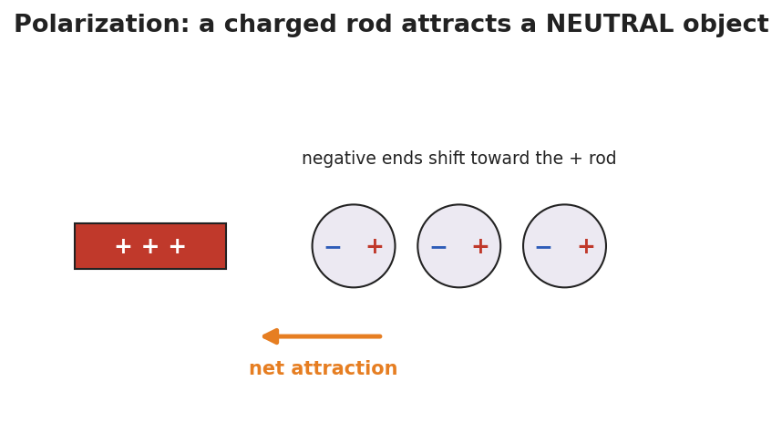
A positive rod near three neutral atoms; in each atom the negative end has shifted toward the rod and the positive end away, so the near side is negative and the whole object is pulled toward the rod.

Discussion prompts to deploy here
- “In induction, why must we remove the ground before the rod?”
  - Sample student response: “If the rod leaves first, the charges just flow back and the object goes neutral again.”
- “A negative rod charges a sphere by induction. What sign is the sphere — and how is that different from conduction?”
  - Sample student response: “Positive — opposite to the rod. Conduction would have made it negative, the same sign, but it needs contact.”

Phase 4 · Elaborate (36 – 40 min)

36–39 min · Revise the model
“Return to your paper-bits drawing. Re-label it using polarization: which side of the paper is attracted, and why? Then write one sentence stating the final sign if you instead charged a metal sphere by induction with a positive rod.”

39–40 min · Return to the phenomenon
“Why does the water stream bend toward either a positive or a negative rod? Answer in one sentence using polarization.”
Target: “Water molecules are polar and rotate so their attracted end faces the rod — so it bends toward a rod of either sign.”

Phase 5 · Evaluate (40 – 42 min)

40–42 min · Exit Ticket + Closing Reflection
“A POSITIVE rod is brought near (not touching) a neutral metal sphere on an insulating stand. (a) Sketch where the + and − charges sit on the sphere while the rod is near. What is this called? (b) You now ground the sphere, remove the ground, then remove the rod. What sign is the sphere’s net charge? Name the method. (c) In one sentence, state the key difference between charging by induction and charging by conduction.”
Expected: (a) negatives gather on the near side, positives on the far side — polarization; (b) the sphere ends up negative (opposite the positive rod), by induction; (c) induction leaves the opposite sign with no contact, while conduction leaves the same sign through direct contact. See Answer_Key.docx.
Closing Reflection (SEL, 30 seconds):
“Which groupmate’s board move helped you see the grounding step? Name one idea you changed your mind about.”

Common Misconceptions
- Misconception: “Induction and conduction give the same result.” → Correction: Induction → opposite sign, no contact; conduction → same sign, with contact.
- Misconception: “A polarized object has gained a net charge.” → Correction: Polarization only shifts existing charge; the object stays overall neutral.
- Misconception: “Order doesn’t matter — remove the rod or the ground first.” → Correction: The ground must be removed before the rod, or the separated charge flows back and the object returns to neutral.

Access & Differentiation
- ELL/ENL supports: Sentence frame: “When the rod comes near, the ___ charges move to the ___ side, so the object becomes ___ (polarized / charged by induction).” Word-choice box: {polarization, induction, grounding, near side, far side, opposite, no contact}. Provide a numbered four-step strip to put in order.
- IEP/SPED supports: Give the four induction panels on cards out of order; students sequence them rather than draw from scratch. Pair the BTC board work with a partner scribe.
- Extensions: Have students design an induction sequence that leaves two spheres oppositely charged at once (the classic two-sphere split), and explain it with grounding.

Strategy Spotlight
BTC (Building Thinking Classrooms). Today uses three BTC pillars: visibly random groups of 3, vertical non-permanent surfaces, and a thin-slice task with the answer withheld. The task (“leave the sphere positive using a negative rod you may not touch”) is deliberately just past what conduction can do, forcing the grounding insight. Consolidate by touring boards least-to-most complete. Keep yourself from naming “induction” until the consolidation — the sequence should be discovered on the boards first.

NYSSLS Observation Checklist Crosswalk
# | Checklist item | Where it appears in this lesson
1 | Local/relatable phenomenon | Phase 1 — bending water/paper bits; water stream in Phase 4
2 | Turn and Talk (2–3×) | Phase 1 (TT#1 — what the rod does inside the paper), Phase 3 (consolidation discussion)
3 | Students develop questions/models/procedures | Phase 1 (initial model), Phase 2 (BTC thin-slice procedure), Phase 4 (revise model)
4 | CCC defined and used | Lesson Overview · Cause and Effect, restated in Phase 2
5 | ENL — ≤ 3 vocab, second half | Phase 3 — vocabulary at 34–36 min (polarization / induction / grounding)
6 | Revisit phenomenon with evidence | Phase 4 — water stream + paper re-labeling
7 | ENL/SPED supports | Access & Differentiation block
8 | Assessment check | Phase 5 — Exit Ticket (induction sequence + induction-vs-conduction contrast)

Companion Materials
- Student_Worksheet.docx — the 5E student investigation (hand out at start of Phase 2)
- Student_Notes.docx — guided note-guide for vocabulary and the worked example
- Answer_Key.docx — answers to “Make It Make Sense” prompts and the Exit Ticket

Key Vocabulary (max 3)
- polarization — the shift of charge within a neutral object when a charged object is brought near; the near side becomes oppositely charged, so the object is attracted (it stays overall neutral)
- induction — charging an object without contact by bringing a charge near, grounding, then removing the ground and the charge; the object is left with the opposite sign
- grounding — connecting an object to the Earth (or a large conductor) so charge can flow off to or from it

