Coulomb’s Law — Student Notes
Unit: Electrostatics — Lesson 04 Name: _______________________ Date: __________ Period: ____
Reference: Fₑ = k·q₁·q₂ / r² · k = 8.99 × 10⁹ N·m²/C² · e = 1.6 × 10⁻¹⁹ C

Learning Targets
By the end of today’s 42 minutes I can:
- State Coulomb’s law in words and symbols and name each quantity’s unit.
- Predict how the force changes when charge or distance changes.
- Calculate the electrostatic force between two charges.

Key Vocabulary
- Coulomb’s law — _______________________________________________
- electrostatic force — _______________________________________________
- inverse-square law — _______________________________________________

Guided Notes
Coulomb’s law: Fₑ = k · q₁ · q₂ / r²
- Fₑ = the __________ force, in newtons (N)
- q₁, q₂ = the two __________, in coulombs (C)
- r = the __________ between the charges, in meters (m)
- k = __________ × 10⁹ N·m²/C² (Coulomb constant)
Patterns:
- Force is __________ to each charge → double a charge, the force __________.
- Force depends on distance __________ (squared) → double r, force becomes __________; triple r, force becomes __________.
- This 1/r² shape is an inverse-square law — the same pattern as __________ (gravitation).
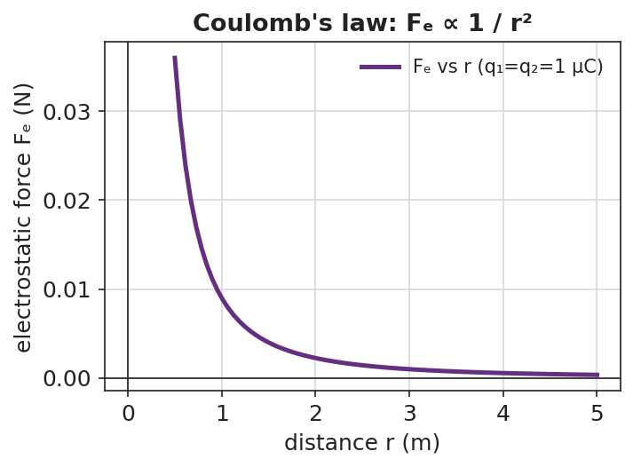
A force-versus-distance curve falling off as 1/r².
The two charges always feel equal and opposite forces (Newton’s third law):
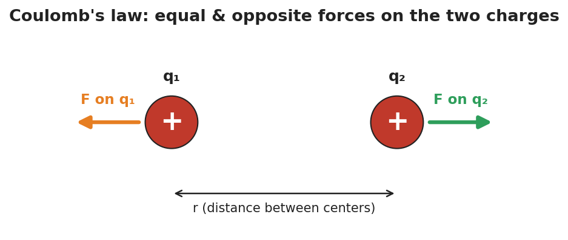
Two charges with equal-length, opposite repulsive force arrows.

Worked Example
Problem. Two charges of +2.0 × 10⁻⁶ C each sit 0.30 m apart. Find the electrostatic force, and state whether it is attractive or repulsive.
Solution. 1. Write the formula: Fₑ = k · q₁ · q₂ / r². 2. Substitute: Fₑ = (8.99 × 10⁹)(2.0 × 10⁻⁶)(2.0 × 10⁻⁶) / (0.30)². 3. Numerator: (8.99 × 10⁹)(4.0 × 10⁻¹²) = __________ ≈ 3.6 × 10⁻² N·m². 4. Divide by r² = (0.30)² = 0.090 m²: Fₑ ≈ __________ ≈ 0.40 N. 5. Both charges are positive, so the force is __________ (repulsive).
Check the pattern: if r doubles to 0.60 m, r² ×4, so Fₑ → 0.40 / 4 = __________ N.

Summary
Finish the sentence (Because / But / So):
The electrostatic force between two charges gets stronger because __________________________________________, but it weakens fast as the charges move apart __________________________________________, so __________________________________________.

