Coulomb’s Law — Student Worksheet
Unit: Electrostatics — Lesson 04 Name: _______________________ Date: __________ Period: ____
Reference: Fₑ = k·q₁·q₂ / r² · k = 8.99 × 10⁹ N·m²/C² · e = 1.6 × 10⁻¹⁹ C

Phenomenon
Your teacher drags two charged spheres in the PhET “Coulomb’s Law” simulation. Doubling one charge doubles the force — no surprise. But halving the distance quadruples the force, and the readout looks just like the gravity behavior from the Forces unit.
Driving question: How exactly does the force between two charges depend on the charges and on the distance between them?

Notice & Wonder
I notice… | I wonder…
Turn & Talk #1: Halving the distance made the force four times bigger, not two. What relationship between force and distance would do that?

Initial Model
Sketch two charges a distance r apart. Predict, in words, what happens to the force if you (a) triple one charge, (b) double the distance.
- Triple one charge: __________________________
- Double the distance: ________________________

Investigation
Test each prediction on PhET, one variable at a time.
Charge sweep (keep r fixed):
q₁ (µC) | 1 | 2 | 3 | 4
Force (record)
Distance sweep (keep charges fixed):
r (units) | 1 | 2 | 3 | 4
Force (record)
The distance data should trace this inverse-square curve:
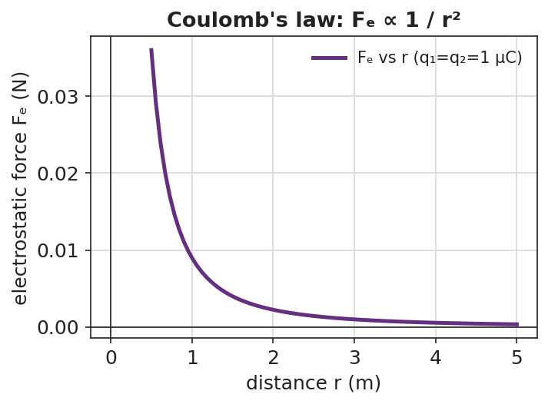
A force-versus-distance curve that drops steeply at small distances and flattens at larger distances — the 1/r² shape.
Key question: When you doubled r, the force became what fraction? At triple r?

Make It Make Sense
- The two charges in PhET have very different sizes. Which one feels the bigger force? Explain. (See the force-pair diagram below.)
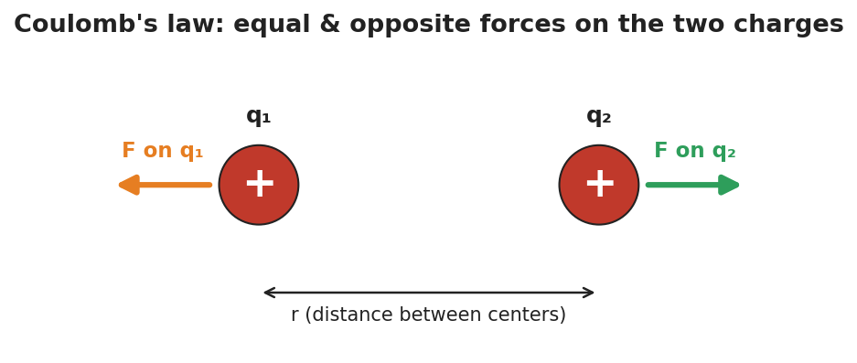
Two like charges with equal, opposite repulsive force arrows, separated by distance r.
- If you triple both charges, what happens to the force? Show your reasoning.
- Coulomb’s law has the same 1/r² shape as which force from the Forces unit? What does that tell you about how nature works?

Vocabulary in Action
Use each term in a sentence about today’s phenomenon.
- Coulomb’s law: _______________________________________________
- electrostatic force: _______________________________________________
- inverse-square law: _______________________________________________

Revise Your Model
Two charges of +2.0 × 10⁻⁶ C each sit 0.30 m apart. Use Fₑ = k·q₁·q₂ / r² to find the force. Then state what happens to it if the distance is doubled.
Fₑ = ____________________ → Fₑ ≈ __________ N If r is doubled, Fₑ becomes __________________

Exit Ticket
Use Fₑ = k·q₁·q₂ / r², with k = 8.99 × 10⁹ N·m²/C².
- Two charges, q₁ = +3.0 × 10⁻⁶ C and q₂ = +3.0 × 10⁻⁶ C, are 0.20 m apart. Calculate the electrostatic force. Is it attractive or repulsive?
- Without recalculating from scratch, state what happens to the force if the distance is tripled.
- Coulomb’s law shares its 1/r² shape with which force from the Forces unit?

