Electric Fields — Student Notes
Unit: Electrostatics — Lesson 05 Name: _______________________ Date: __________ Period: ____
Reference: E = Fₑ / q (units: N/C) · k = 8.99 × 10⁹ N·m²/C²

Learning Targets
By the end of today’s 42 minutes I can:
- Define the electric field as force per unit charge (E = Fₑ / q).
- Explain the test-charge idea and which way the field points.
- Calculate field strength from a force and a charge.

Key Vocabulary
- electric field — _______________________________________________
- test charge — _______________________________________________
- field strength — _______________________________________________

Guided Notes
Big idea: A charge fills the space around it with an electric field — a __________ per unit charge at every point.
- Formula: E = __________ / __________, with units __________ (newtons per coulomb).
- We find its direction with a tiny positive test charge: the field points the way that charge is __________.
- Near a positive charge, the field points __________ (away).
- Near a negative charge, the field points __________ (toward).
- Field strength is __________ near the source and falls off as __________ (inverse-square).
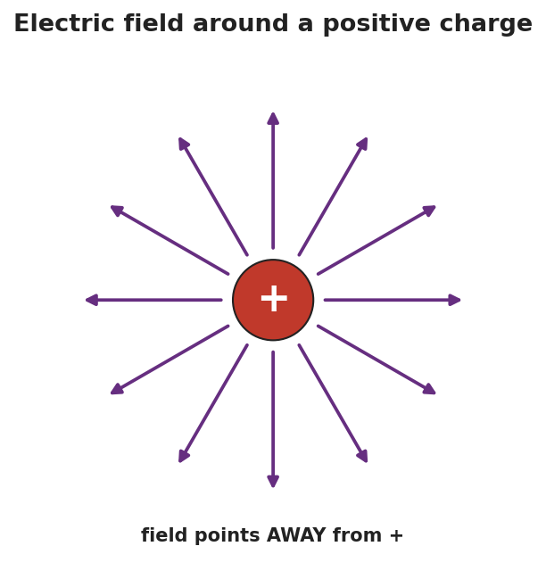
Radial arrows pointing away from a positive charge.
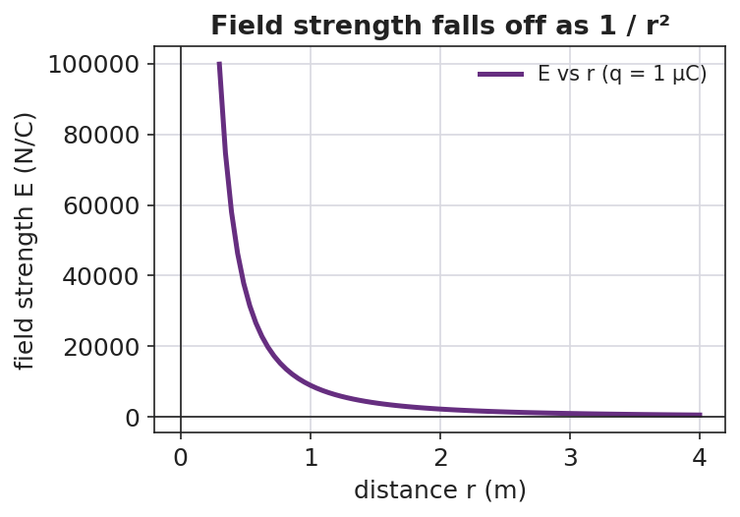
A graph of field strength E versus distance, falling off as 1/r².
Two ways to use E = Fₑ / q:
- Find the field: E = Fₑ / q.
- Find the force on a charge in a field: Fₑ = __________ · __________.

Worked Example
Problem. A field of 500 N/C points east at a point. What force does it exert on a charge of +2.0 × 10⁻⁶ C placed there, and in which direction?
Solution. 1. Rearrange E = Fₑ / q to solve for force: Fₑ = __________ · __________. 2. Substitute: Fₑ = (500 N/C)(2.0 × 10⁻⁶ C) = __________ N. 3. Result: Fₑ ≈ 1.0 × 10⁻³ N. 4. The charge is __________, so it is pushed in the __________ direction the field points → east.

Summary
Finish the sentence (Because / But / So):
A charge fills the space around it with an electric field because __________________________________________, but you only feel a force when another charge sits in that field __________________________________________, so __________________________________________.

