Electric Fields — Student Worksheet
Unit: Electrostatics — Lesson 05 Name: _______________________ Date: __________ Period: ____
Reference: E = Fₑ / q (units: N/C) · k = 8.99 × 10⁹ N·m²/C²

Phenomenon
Your teacher holds a fluorescent tube near a plasma ball — it glows, even though it isn’t plugged in or touching the ball. Move it away and it dims. Something is filling the space around the ball.
Driving question: What is in the space around a charge, and how can we describe its direction and strength?

Notice & Wonder
I notice… | I wonder…
Turn & Talk #1: The effect on the bulb got weaker as it moved away. What does that tell you about whatever surrounds the ball?

Initial Model
Draw the plasma ball. Around it, draw arrows showing how it would push or pull on a small positive test charge placed at several spots. Mark where the push would be strongest.

Strongest at: _________________________________

Investigation
Human field map. Stand at your assigned spot holding a + test-charge card near the floor “+” source.
My spot | Direction my + card is pushed | Near or far from source? | Strong or weak field?
Round 1 (+ source)
Round 2 (− source)
Compare your map to the field around a single positive charge:
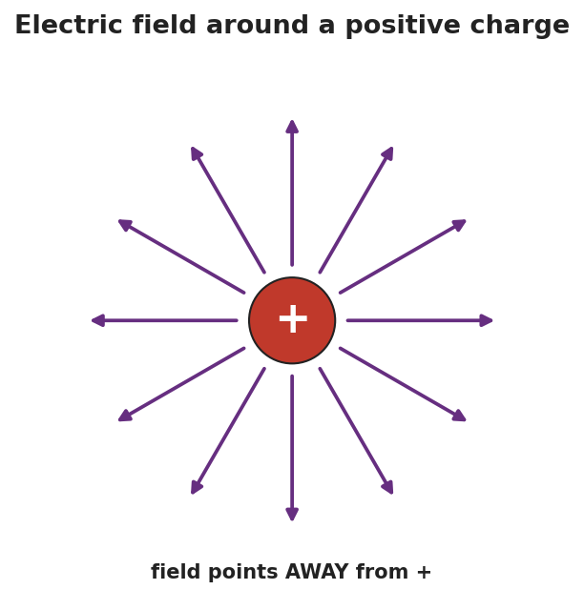
Arrows radiating outward in all directions from a single positive charge.
Key question: Which way does the field point near a positive source? Near a negative source?

Make It Make Sense
- A 2.0 N force acts on a +0.5 C charge placed at a point. What is the electric field strength there? Show E = Fₑ/q.
- The field strength drops as you move away from the source (see the graph). What shape is that fall-off, and where have you seen it before?
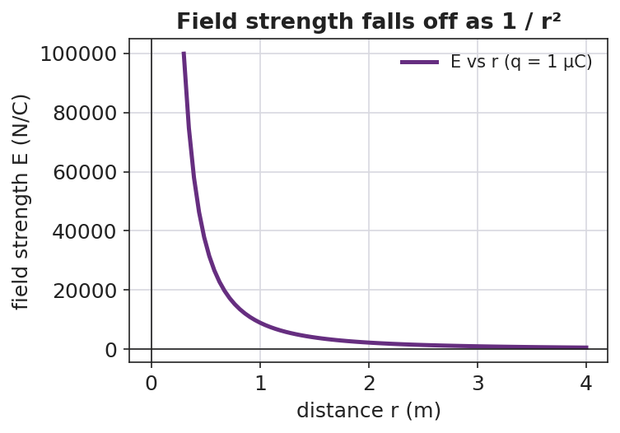
A graph of field strength E versus distance r, falling off as 1/r².
- Why do we use a positive test charge (and a small one) to define the field’s direction?

Vocabulary in Action
Use each term in a sentence about today’s phenomenon.
- electric field: _______________________________________________
- test charge: _______________________________________________
- field strength: _______________________________________________

Revise Your Model
A field of 500 N/C exists at a point, pointing east. (a) What force would it exert on a +2.0 × 10⁻⁶ C charge placed there? (b) Which direction?
Fₑ = E·q = ____________________ ≈ __________ N Direction: ____________________

Exit Ticket
Use E = Fₑ / q.
- A charge of +4.0 × 10⁻⁶ C feels a force of 0.012 N at a point. Calculate the electric field strength there, with units.
- Draw the field around a single negative charge. Which way do the arrows point?
- In one sentence, explain what a “test charge” is and why it must be small.

