Electric Field Lines — Student Notes
Unit: Electrostatics — Lesson 06 Name: _______________________ Date: __________ Period: ____

Learning Targets
By the end of today’s 42 minutes I can:
- State and apply the four rules for drawing field lines.
- Draw the field for a single charge, a dipole, and parallel plates.
- Read field strength from line spacing.

Key Vocabulary
- field line — _______________________________________________
- dipole — _______________________________________________
- uniform field — _______________________________________________

Guided Notes
The four rules for field lines:
- Lines start on __________ charges and end on __________ charges.
- They point the way a __________ test charge would move.
- Field lines never __________.
- Where lines are __________ together, the field is __________ (density shows strength).
Three key patterns:
- Single charge: lines go straight __________ (for +) and weaken with distance.
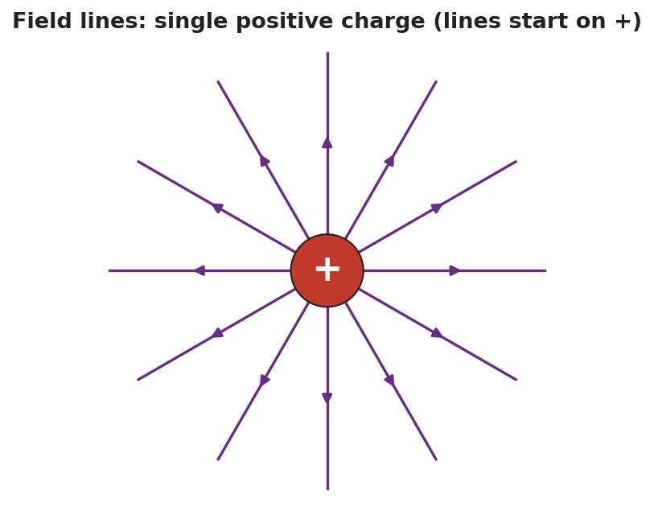
Field lines radiating from a single positive charge.
- Dipole (+ and −): lines curve from the __________ to the __________, never crossing.
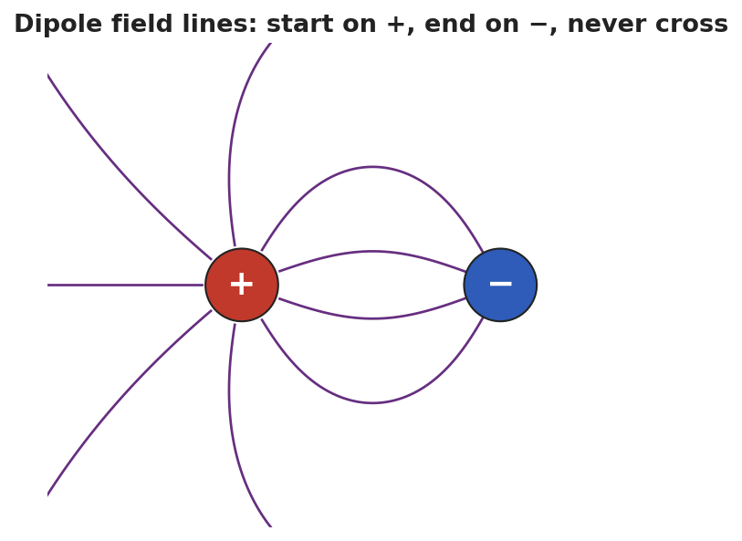
Dipole field lines from + to −.
- Parallel plates: straight, __________ spaced lines → a __________ field (same strength everywhere).
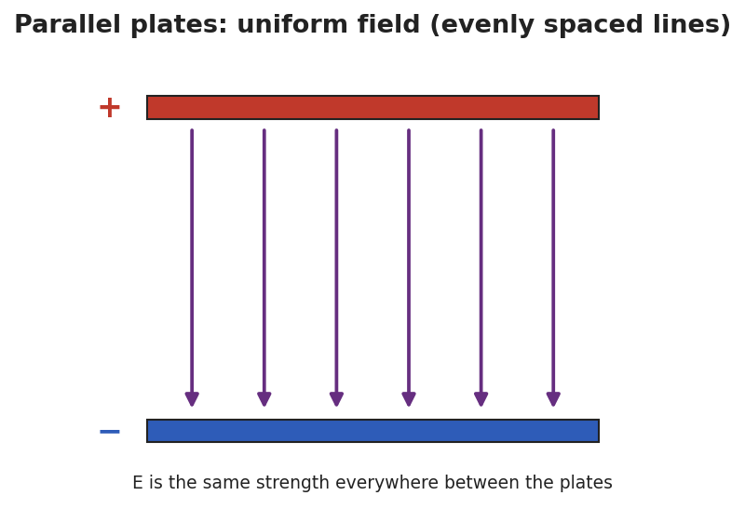
Parallel plates with a uniform field.

Worked Example
Problem. Two field-line diagrams are drawn to the same scale. In Diagram A the lines are spaced 2 mm apart; in Diagram B they are spaced 8 mm apart. In which diagram is the electric field stronger, and how do you know?
Solution. 1. Rule 4: line __________ shows field strength. 2. Closer lines mean a __________ field; lines farther apart mean a __________ field. 3. Diagram A has lines only __________ mm apart (closer), so Diagram A has the stronger field.

Summary
Finish the sentence (Because / But / So):
Field lines that are close together show a strong field because __________________________________________, but far from a charge the lines spread out __________________________________________, so __________________________________________.

