Electric Field Lines — Student Worksheet
Unit: Electrostatics — Lesson 06 Name: _______________________ Date: __________ Period: ____

Phenomenon
Your teacher switches on two electrodes in a dish of semolina grains in oil. The grains snap into curved chains running between the electrodes — an invisible field suddenly made visible.
Driving question: What rules do field lines follow, and how do they show us the direction and strength of an electric field?

Notice & Wonder
I notice… | I wonder…
Turn & Talk #1: From the semolina chains, write two rules the field lines seem to obey.
Rule 1: __________________________________________ Rule 2: __________________________________________

Initial Model
Draw a single + charge and sketch how you think the field lines leave it. Then draw a + and a − near each other and sketch the lines between them.

Investigation
Use the Javalab field-line sim to build three patterns. Record what you notice.
Setup | Where lines start / end | Spacing (even? bunched?) | Field strongest where?
1. Single + charge
2. Dipole (+ and −)
3. Parallel plates
Confirm each against these diagrams:
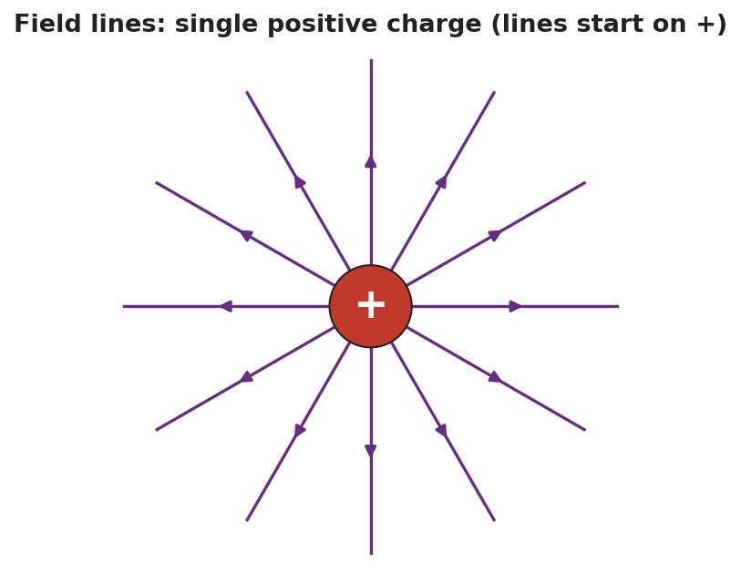
Field lines radiating outward from a single positive charge.
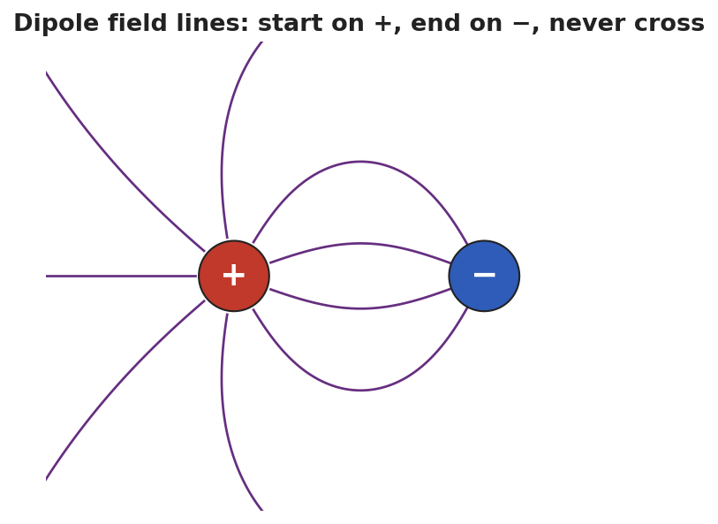
Dipole field lines curving from + to −, never crossing.
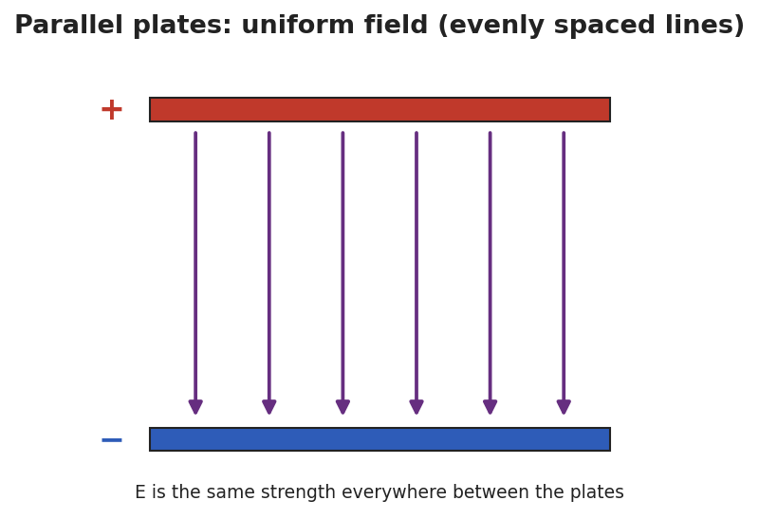
Parallel plates with straight, evenly spaced field lines — a uniform field.
Key question: Why can’t two field lines ever cross?

Make It Make Sense
- List the four rules for drawing electric field lines.
- Two diagrams show field lines: in Diagram A the lines are close together; in Diagram B they are far apart. Where is the field stronger, and how do you know?
- How is the field between parallel plates different from the field around a single charge?

Vocabulary in Action
Use each term in a sentence about today’s phenomenon.
- field line: _______________________________________________
- dipole: _______________________________________________
- uniform field: _______________________________________________

Revise Your Model
Return to your dipole sketch. Re-draw it to obey all four rules: lines start on +, end on −, never cross, and crowd where the field is strong. Label where the field is strongest.

Exit Ticket
- State two rules for drawing electric field lines.
- Two diagrams show field lines: in Diagram A the lines are close together; in Diagram B they are spread far apart. Where is the field stronger, and how do you know?
- Sketch the field lines for a single negative charge. Which way do the arrows point, and where do they end?

