Electric Field Lines — Teacher Guide

Cover
Unit: Electrostatics — Lesson 06: Electric Field Lines East Meadow Schools × Valley Stream Central High School District Strategy chips: HOCHMAN

Curated Resources (from East Meadow Scope & Sequence)

NYSSLS Standards
This lesson completes the field model of HS-PS3-5: “Develop and use a model of two objects interacting through electric or magnetic fields to illustrate the forces between objects and the changes in energy of the objects due to the interaction. (Cause and Effect).” Field lines are the visual representation students use to illustrate the forces between charges — for a single charge, a dipole, and parallel plates.

Phenomenon
- Semolina grains (or grass seed) in oil line up along the field of charged electrodes (classic field-mapping demo): https://www.youtube.com/watch?v=field+lines+semolina+oil
- Iron-filings analogy for visualizing an invisible field (Veritasium): https://www.youtube.com/watch?v=field+lines+visualization

Javalab / Labs
- Electric field line (single charge, dipole, plates): https://javalab.org/en/electric_field_line_en/
- Electric field of point charges (Javalab): https://javalab.org/en/electric_field_en/

Assessments
- Reference Table relationship: E = Fₑ / q (line density ↔ field strength). The Exit Ticket below is the formative check.

Lesson Overview
Duration | 42 minutes (1 period)
NYSSLS link | HS-PS3-5 (using a model — field lines — to illustrate the forces between charges)
CCC focus | Cause and Effect — line direction shows the force direction; line density shows the field strength.
Strategy chips | HOCHMAN (literacy)
Materials | Javalab field-line sim; (optional) semolina-in-oil dish with electrodes; rulers; sentence-expansion strips (appositive / Because-But-So); whiteboards/markers.
Safety | If running the semolina/oil dish with electrodes, keep the high-voltage supply away from students and observe its limits.
Prior knowledge | Lesson 05 — the electric field (E = Fₑ/q); field points away from + and toward −; strength falls off with distance.
Lesson objectives — students can:
- State and apply the rules for drawing field lines: start on +, end on −, never cross, line density shows strength.
- Draw the field-line pattern for a single charge, a dipole, and parallel plates (a uniform field).
- Read field strength from line spacing (closer lines = stronger field).

Phase 1 · Engage (0 – 10 min)

0–2 min · Opening Connection (SEL)
One-phrase whip-around: “Name a map or diagram you read where the lines tell you something — a subway map, a weather chart, a contour line.” This primes the idea that lines on a page carry meaning.

2–7 min · Phenomenon hook — semolina reveals the field
Teacher actions. Show the semolina-in-oil dish (or the video): switch on the electrodes and the grains snap into curved chains running between them — the invisible field made visible. Or run the Javalab sim and drop test points that trace lines.
Sample teacher language:
“Each grain just lined itself up along something it can’t see. Those chains are a picture of the field. What rules do they seem to follow — where do the chains start, end, and how do they bunch up?”
Anticipated student responses:
- “They go from one electrode to the other.” — capture: lines connect + to −.
- “They’re closer together near the points.” — gold: density shows strength.
- “They never seem to cross.” — excellent; this is one of the core rules.

7–10 min · Notice & Wonder + Turn-and-Talk #1
“Turn to your partner: from the semolina chains, write two ‘rules’ the field lines seem to obey.”
Target ideas: lines run from one charge to the other; they bunch up where the field is strong; they don’t cross. Leave open if unspoken.

Bridge to Phase 2
Each student writes a one-sentence initial model: “The chains run from ______ to ______, and they are closest together where ______.”

Phase 2 · Explore (10 – 28 min)

10–14 min · Initial Model (silent / individual)
“Draw a single + charge and sketch how you think the field lines leave it. Then draw a + and a − near each other and sketch the lines between them.”

14–28 min · Investigation — discover the rules (Javalab)
Pairs use the Javalab field-line sim to build three patterns and record what they notice:
- Single + charge — lines leave straight out in all directions; density falls with distance.
- Dipole (+ and −) — lines curve from the + to the −, never crossing.
- Parallel plates (+ and −) — lines run straight, evenly spaced → a uniform field.
Use the reference diagrams below to confirm each pattern.
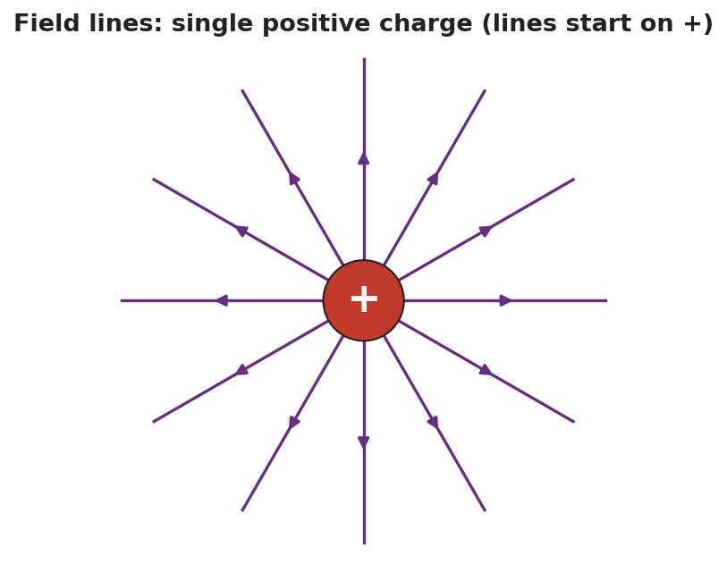
Field lines for a single positive charge: straight lines radiating outward in all directions, each with an arrow pointing away from the charge.
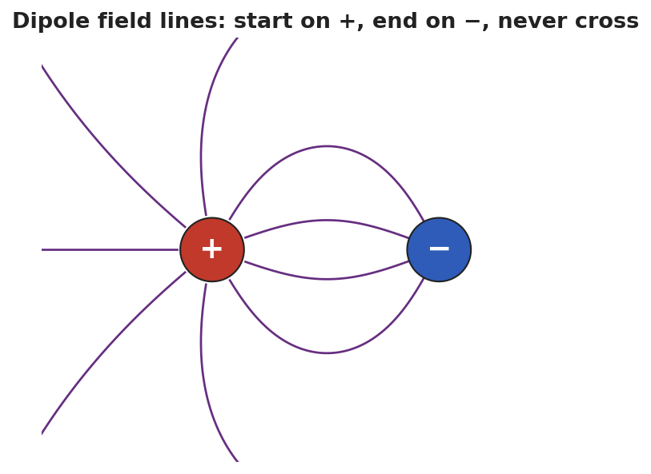
Dipole field lines: curved lines that start on the positive charge and end on the negative charge, none of them crossing.
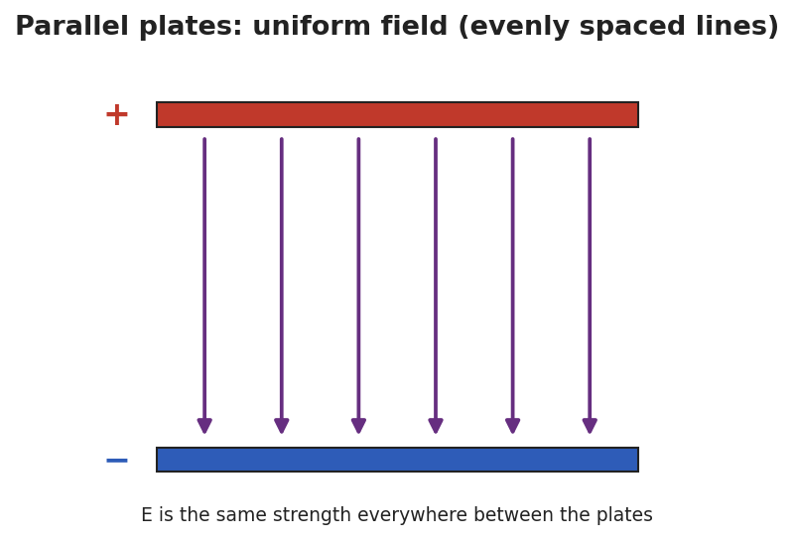
Parallel-plate field: a positive top plate and a negative bottom plate with straight, evenly spaced field lines running from + to −, representing a uniform field of constant strength.
Teacher facilitation language:
“Where do every one of your lines begin, and where do they end?” “Between the plates, are the lines bunching up anywhere, or evenly spaced? What does even spacing tell you about the field’s strength?”

Teacher facilitation during Explore
- What to look for — pairs articulating start-on-+, end-on-−, never-cross, and density-shows-strength from the sim.
- What to resist — don’t list the rules first; let the three patterns reveal them.
- What to redirect — pairs who draw crossing lines should be asked: “if two lines crossed, the field would point two ways at once — can it?”

Phase 3 · Explain (28 – 36 min)

28–31 min · Turn-and-Talk #2 + class consensus
“State the four rules for drawing electric field lines, in your own words.”
Target consensus (the four rules):
“1) Lines start on positive charges and end on negative ones. 2) They point the way a positive test charge would move. 3) They never cross. 4) Where lines are closer together, the field is stronger.”

31–33 min · Vocabulary introduction (≤ 3 terms)
Sample teacher language:
“These are field lines. A + and a − charge close together form a dipole, with lines curving from + to −. Between parallel plates the lines are straight and evenly spaced — a uniform field, the same strength everywhere.”

33–36 min · HOCHMAN sentence work
Run an appositive drill naming the dipole inside a sentence:
“A dipole, a pair of equal and opposite charges set close together, produces field lines that curve from the + to the −.”
Then a Because/But/So expansion of the density rule:
Stem: “Field lines that are close together…” - because … (a strong field is drawn with crowded lines) - but … (far from a charge the lines spread out) - so … (you can read the field’s strength straight off the spacing)

Discussion prompts to deploy here
- “Why can’t two field lines ever cross?”
  - Sample student response: “A crossing point would have the field pointing two directions at once, which is impossible.”
- “How is the field between parallel plates different from the field around a single charge?”
  - Sample student response: “The plates give a uniform field — straight, evenly spaced lines; a single charge’s field spreads out and weakens with distance.”

Phase 4 · Elaborate (36 – 40 min)

36–39 min · Revise the model
“Return to your dipole sketch. Re-draw it to obey all four rules: lines start on +, end on −, don’t cross, and crowd where the field is strong. Label where the field is strongest.”

39–40 min · Return to the phenomenon
“Why did the semolina grains line up exactly along the field lines? Answer in one sentence.”
Target: “Each grain became polarized and lined up end-to-end along the field’s direction, tracing the lines we’d draw.”

Phase 5 · Evaluate (40 – 42 min)

40–42 min · Exit Ticket + Closing Reflection
“(a) State two rules for drawing electric field lines. (b) Two diagrams show field lines: in Diagram A the lines are close together; in Diagram B they are spread far apart. Where is the field stronger, and how do you know? (c) Sketch the field lines for a single negative charge — which way do the arrows point, and where do they end?”
Expected: (a) any two of: start on +, end on −; never cross; point the way a + test charge moves; density shows strength; (b) Diagram A — closely spaced lines mean a stronger field; (c) straight lines pointing inward toward the negative charge (lines end on negative charges). See Answer_Key.docx.
Closing Reflection (SEL, 30 seconds):
“Which Hochman sentence (the appositive or a Because/But/So) best captured a rule for you today?”

Common Misconceptions
- Misconception: “Field lines can cross.” → Correction: They never cross — a crossing would mean the field points two ways at one point.
- Misconception: “Field lines are real, physical wires.” → Correction: They are a model — a way to picture the field’s direction and strength; the field itself is continuous.
- Misconception: “Evenly spaced or not, spacing doesn’t matter.” → Correction: Line density encodes strength: crowded = strong, spread out = weak; uniform spacing means a uniform field.

Access & Differentiation
- ELL/ENL supports: Sentence frame: “Field lines start on the ___ charge and end on the ___ charge; where they are ___ (close/far), the field is ___ (strong/weak).” Word-choice box: {field line, dipole, uniform field, start, end, never cross, density}. Provide pre-printed +, −, and plate templates to draw onto.
- IEP/SPED supports: Give partially drawn patterns (single charge, dipole, plates) with a few lines complete; students add the rest following the rules. Offer the Javalab sim as the primary tool over freehand drawing.
- Extensions: Have students draw the field for two like charges (both +) and explain the “no-man’s-land” point between them where the field is zero (no lines).

Strategy Spotlight
HOCHMAN (literacy). The four field-line rules are consolidated as sentences, not a bullet list: an appositive that defines a dipole inside a working sentence, and a Because/But/So expansion of the density rule. This pushes students to encode each rule in precise prose, supporting transfer to constructed-response items. Keep each strip to one clause and read several aloud; the goal is sentence fluency with the rule, not length.

NYSSLS Observation Checklist Crosswalk
# | Checklist item | Where it appears in this lesson
1 | Local/relatable phenomenon | Phase 1 — semolina-in-oil field reveal; grains lining up in Phase 4
2 | Turn and Talk (2–3×) | Phase 1 (TT#1 — two rules from the chains), Phase 3 (TT#2 — state the four rules)
3 | Students develop questions/models/procedures | Phase 1 (initial model), Phase 2 (Javalab pattern-building), Phase 4 (revise dipole)
4 | CCC defined and used | Lesson Overview · Cause and Effect (direction + density), restated in Phase 2
5 | ENL — ≤ 3 vocab, second half | Phase 3 — vocabulary at 31–33 min (field line / dipole / uniform field)
6 | Revisit phenomenon with evidence | Phase 4 — semolina explanation + dipole re-draw
7 | ENL/SPED supports | Access & Differentiation block
8 | Assessment check | Phase 5 — Exit Ticket (rules; density→strength; single-negative sketch)

Companion Materials
- Student_Worksheet.docx — the 5E student investigation (hand out at start of Phase 2)
- Student_Notes.docx — guided note-guide for the rules and the worked example
- Answer_Key.docx — answers to “Make It Make Sense” prompts and the Exit Ticket

Key Vocabulary (max 3)
- field line — a line drawn to represent an electric field: it starts on a positive charge, ends on a negative charge, never crosses another, and shows the field’s strength by how closely spaced it is
- dipole — a pair of equal and opposite charges set close together; its field lines curve from the + charge to the − charge
- uniform field — a field of constant strength and direction, shown by straight, evenly spaced field lines (as between parallel plates)

