Electric Current and Ohm’s Law — Student Notes
Unit: Current Electricity — Lesson 01 Name: _______________________ Date: __________ Period: ____

Learning Targets
By the end of today’s 42 minutes I can:
- Define current (charge ÷ time) and voltage (the push that drives charge).
- Use V = I·R to solve for V, I, or R.
- Read a V-vs-I graph and explain that its slope is the resistance.

Key Vocabulary
- current — _______________________________________________
- voltage — _______________________________________________
- resistance — _______________________________________________

Guided Notes
What flows, and what pushes it.
- Current (I) is the flow of electric __________ through a wire. It equals charge ÷ __________, and is measured in __________ (A).
- Voltage (V), also called potential difference, is the __________ that drives the charge around the loop. It is measured in __________ (V).
- Resistance (R) is how much a material __________ the flow. It is measured in __________ (Ω).
- Charge needs a __________ (closed) loop to flow — break the loop and the current __________.
Ohm’s Law.
V = I · R (voltage = current × resistance)
Rearranged: I = V ÷ __________ and R = V ÷ __________.
Reading the V-vs-I graph. When you plot V (up) against I (across) for one resistor, the points form a straight __________ through the origin. The __________ of that line equals the __________.
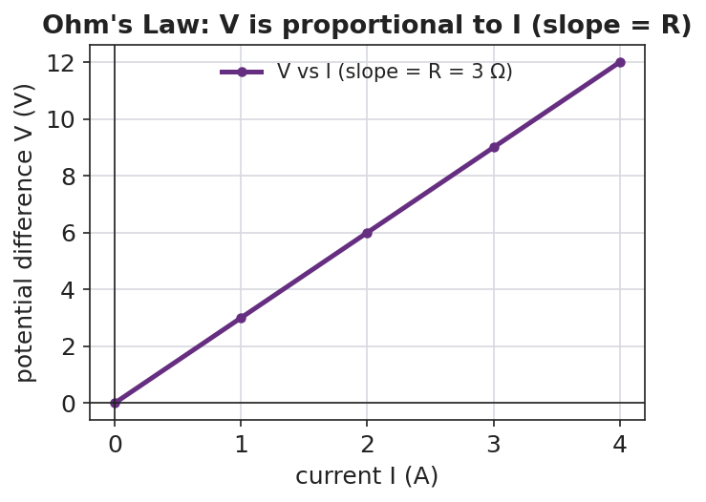
Graph of voltage versus current: a straight line through the origin whose slope equals the resistance R.
Power (extension). The electrical power delivered is P = V·I = I²·R, measured in watts (W).

Worked Example
Problem. A resistor has 9 V across it and a current of 3 A flowing through it. (a) Find its resistance. (b) If the voltage is raised to 18 V, find the new current.
Solution. 1. Write Ohm’s Law: V = I·R, so R = V ÷ I = 9 V ÷ 3 A = __________ Ω. 2. Same resistor, new voltage: I = V ÷ R = 18 V ÷ __________ Ω = __________ A. 3. Doubling the voltage __________ the current, because R stayed the same.

Summary
Finish the sentence (Because / But / So):
Current increases when the voltage increases because __________________________________________, but __________________________________________, so __________________________________________.

