Electric Current and Ohm’s Law — Student Worksheet
Unit: Current Electricity — Lesson 01 Name: _______________________ Date: __________ Period: ____

Phenomenon
Your teacher holds an “energy stick.” Nothing happens — until two people grab the metal ends and complete the loop with their hands. Then it lights up and buzzes. Break the loop, and it goes dark again.
Driving question: What has to be true for electric charge to flow, and what controls how much flows?

Notice & Wonder
I notice… | I wonder…
Turn & Talk #1: What has to be true for the charge to flow? Use the word path in your answer.

Initial Model
Draw the energy-stick loop with two people holding hands. Mark where the push comes from and draw arrows for which way the charge moves. Then predict: what would make the light brighter?

My prediction: _______________________________

Investigation
In PhET Circuit Construction Kit: DC, build one battery connected to one resistor. Add an ammeter (reads current I in amperes) in the loop and a voltmeter (reads voltage V in volts) across the resistor.
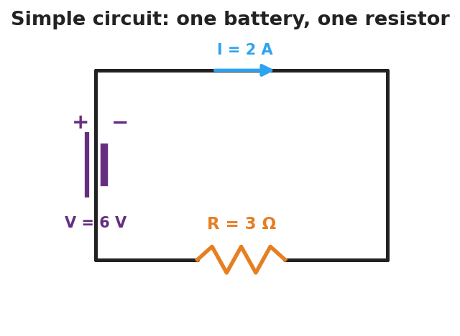
Schematic of a simple circuit: a battery on the left drives current I around a single loop through one resistor R on the bottom wire.
Part A — Same resistor, change the voltage. Set the resistor to a fixed value. Record current at three battery voltages.
Battery voltage V (V) | Current I (A) | V ÷ I (Ω)
9
18
27
Plot your three points with I on the x-axis and V on the y-axis. Draw the best-fit line.
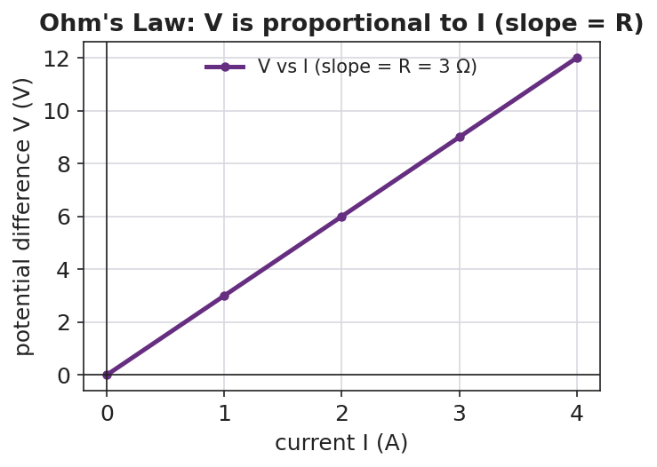
Graph of voltage V versus current I showing a straight line through the origin whose slope equals the resistance R.
Part B — Same voltage, change the resistor. Keep the battery fixed and increase the resistance. What happens to the current?

Key question: What number do you get every time you compute V ÷ I for the same resistor? What is that number called?

Make It Make Sense
- A resistor has 12 V across it and 3 A flowing through it. Use V = I·R to find its resistance.
- A 4 Ω resistor is connected to a 24 V battery. How much current flows?
- The slope of your V-vs-I line was 3. What physical quantity does that slope represent, and what are its units?

Vocabulary in Action
Use each term in a sentence about today’s phenomenon.
- current: _______________________________________________
- voltage: _______________________________________________
- resistance: _______________________________________________

Revise Your Model
Return to your Initial Model. Add the energy-stick hand-chain. Explain, using resistance and current, why adding more people makes the stick harder to light.

Exit Ticket
A resistor has 6 V across it and carries 2 A of current.
- What is its resistance? Show V = I·R.
- The voltage is raised to 12 V with the same resistor. What is the new current?
- In one sentence, what does the slope of a V-vs-I graph represent?

