Electric Current and Ohm’s Law — Teacher Guide

Cover
Unit: Current Electricity — Lesson 01: Electric Current and Ohm’s Law East Meadow Schools × Valley Stream Central High School District Strategy chips: HOCHMAN

Curated Resources (from East Meadow Scope & Sequence)

NYSSLS Standards
This lesson is the anchor for HS-PS3-6: “Analyze data to support the claim that Ohm’s Law describes the mathematical relationship among the potential difference, current, and resistance of an electric circuit.” Students collect (or read) V–I data, see the straight-line pattern, and name the slope as resistance. It builds on the energy ideas of HS-PS3 (energy transfer in a system) and sets up the series/parallel analysis in Lessons 03–04.

Phenomenon
- Energy-stick / human-circuit toy that lights and buzzes only when two people complete the loop by holding hands: https://www.youtube.com/results?search_query=energy+stick+human+circuit
- Why a dimmer knob changes brightness — changing resistance changes current (Khan Academy, “Ohm’s law”): https://www.khanacademy.org/science/physics/circuits-topic/circuits-resistance/a/ee-voltage-and-current

Javalab / Labs
- PhET Circuit Construction Kit: DC — build a battery + resistor loop, read the ammeter and voltmeter: https://phet.colorado.edu/en/simulations/circuit-construction-kit-dc
- Javalab — Electric current (charge flowing through a conductor): https://javalab.org/en/electric_current_en/

Assessments
- PhET CCK-DC guided data table (V vs I) — formative during Explore.
- Exit ticket below (numeric Ohm’s-law problem) is the formative check; full key in Answer_Key.docx.

Lesson Overview
Duration | 42 minutes (1 period)
NYSSLS link | HS-PS3-6 (core — V, I, R relationship)
CCC focus | Patterns — V plotted against I forms a straight line whose slope is the resistance.
Strategy chips | HOCHMAN (Because/But/So on the V–I relationship)
Materials | Energy stick (or a simple battery–bulb kit); devices/Chromebooks for PhET CCK-DC; whiteboards/markers; calculators.
Safety | Low-voltage kits only (≤ 6 V). No wall outlets. Do not short a battery directly across its terminals — always include a bulb or resistor.
Prior knowledge | Charge (positive/negative), conservation of charge, and energy as the capacity to do work.
Lesson objectives — students can:
- Define current as charge per unit time (amperes) and voltage as the push that drives charge around a circuit.
- Use Ohm’s Law, V = I·R, to solve for any one of V, I, or R given the other two.
- Interpret a V-vs-I graph: a straight line through the origin whose slope equals the resistance.

Phase 1 · Engage (0 – 10 min)

0–2 min · Opening Connection (SEL)
Quick whip-around (one sentence each, pass allowed): “Name one thing in your home that needs to be ‘plugged in’ or charged to work.” Capture two or three answers; you’ll return to the idea that all of these move electric charge.

2–7 min · Phenomenon hook — the energy stick
Teacher actions. Hold the energy stick by one metal end. Nothing happens. Grab the other end with your free hand — it lights and buzzes. Break contact — it stops. Then form a chain of students holding hands; the stick lights only when the loop is closed.
Sample teacher language:
“Watch — when the loop is open, nothing. The moment we close the loop with our hands, charge can flow all the way around and the light comes on. What’s our skin doing in this circuit?”
Anticipated student responses:
- “We’re the wire.” — capture this; skin is a (poor) conductor completing the path.
- “Electricity needs a complete circle.” — exactly; name it closed loop / complete circuit.
- “More people should make it brighter/dimmer.” — flag it; we’ll connect more people = more resistance later.

7–10 min · Notice & Wonder + Turn-and-Talk #1
Two columns on the board. Then:
“Turn to your partner: what has to be true for the charge to flow? Use the word path in your answer.”
Target insight: charge needs a complete, closed path and a push (the battery) to keep it moving.

Bridge to Phase 2
Each student writes a one-sentence initial model: “The stick lights up because ______.”

Phase 2 · Explore (10 – 30 min)

10–14 min · Initial Model (silent / individual)
Prompt on the board:
“Draw the energy-stick loop with two people holding hands. Mark where the push comes from and draw arrows showing which way the charge moves around the loop. Predict: what would make the light brighter?”

14–30 min · Investigation — PhET Circuit Construction Kit DC
Students build a single battery + resistor loop, add an ammeter (current, A) in the loop and a voltmeter (voltage, V) across the resistor.
- Same resistor, change the battery voltage. Record V and I for 9 V, 18 V, 27 V across a fixed resistor. Plot V (y) vs I (x).
- Same battery, change the resistor. Watch the current drop as resistance rises.
Teacher facilitation language:
“When you double the battery voltage, what happens to the current? Is it exactly double?” “Your V-vs-I points — are they making a line? What does the steepness of that line tell you?” “Which resistor let the most current through for the same push?”
Use the V-vs-I graph below to make the linear pattern (slope = R) visible once a group has three data points.
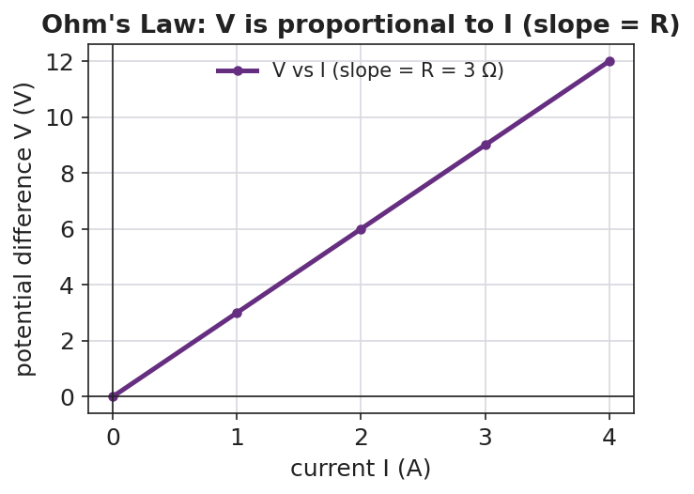
Graph of potential difference V on the vertical axis versus current I on the horizontal axis: the points fall on a straight line through the origin, and the slope of the line equals the resistance R.
The single-loop schematic students are building:
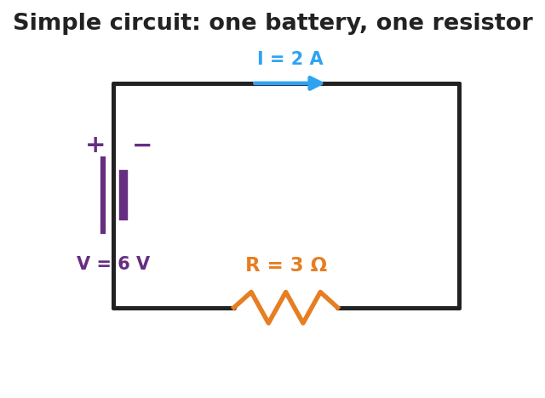
Schematic of a simple circuit: a battery labeled V equals 6 volts on the left side drives a current I equals 2 amperes clockwise through a single resistor labeled R equals 3 ohms on the bottom wire.

Teacher facilitation during Explore
- What to look for — groups noticing that V ÷ I gives the same number every time for one resistor (that number is R).
- What to resist — don’t hand them “V = IR” yet; let the straight line emerge from the data.
- What to redirect — students who say “more voltage means more resistance” should re-check: more voltage means more current; resistance is the slope, set by the resistor.

Phase 3 · Explain (30 – 36 min)

30–33 min · Turn-and-Talk #2 + class consensus
“Across your data, how did current respond when you increased the voltage but kept the same resistor?”
Target consensus:
“Current grows in proportion to voltage. For one resistor, V divided by I is always the same number — that constant is the resistance.”

33–36 min · Vocabulary introduction (≤ 3 terms)
Sample teacher language:
“The flow of charge is current — charge per second, measured in amperes. The push that drives it is the voltage (potential difference), in volts. What slows the flow is the resistance, in ohms. Put them together and you get Ohm’s Law: V = I·R — voltage equals current times resistance. On your graph, the slope is R.”
Reference relationships to post: V = I·R; power P = V·I = I²·R.

Discussion prompts to deploy here
- “A 12 V battery drives 3 A through a resistor. What is the resistance?”
  - Sample response: “R = V/I = 12/3 = 4 Ω.”
- “If you keep the resistor the same but double the voltage, what happens to the current?”
  - Sample response: “It doubles, because I = V/R and R didn’t change.”

Phase 4 · Elaborate (36 – 40 min)

36–38 min · Hochman Because/But/So
Students complete a Because/But/So sentence on the core relationship:
“Current increases when voltage increases because ____, but ____, so ____.”
Target: …because voltage is the push that drives charge, but the resistance limits how much charge gets through, so the current is set by both together (I = V/R).

38–40 min · Return to the phenomenon
“On the energy stick, why does adding more people in the hand-chain make it harder to light? Answer in one sentence using resistance and current.”
Target: “Each person adds resistance, so for the same small voltage the current drops below what the stick needs to light.”

Phase 5 · Evaluate (40 – 42 min)

40–42 min · Exit Ticket + Closing Reflection
“A resistor has 6 V across it and carries 2 A of current. (a) What is its resistance? Show V = I·R. (b) The voltage is raised to 12 V with the same resistor. What is the new current? (c) In one sentence, what does the slope of a V-vs-I graph represent?”
Expected: (a) R = V/I = 6/2 = 3 Ω; (b) I = V/R = 12/3 = 4 A; (c) the slope equals the resistance. See Answer_Key.docx.
Closing Reflection (SEL, 30 seconds):
“What is one thing about electricity you understand now that you didn’t this morning?”

Common Misconceptions
- Misconception: “Current gets used up as it goes around the loop.” → Correction: Charge is conserved; the same current flows all the way around a single loop. Energy is transferred, not the charge itself.
- Misconception: “Voltage flows through the wire.” → Correction: Current (charge) flows; voltage is the difference in electric potential between two points — the push, not the stuff that moves.
- Misconception: “More resistance means more current.” → Correction: For a fixed voltage, more resistance means less current (I = V/R).

Access & Differentiation
- ELL/ENL supports: Sentence frame: “Current is the ___ of charge; voltage is the ___ that drives it; resistance ___ the flow.” Word box: {flow, push, opposes, amperes, volts, ohms}. Pair current with a hand-sweeping gesture (flow) and resistance with a hand-blocking gesture.
- IEP/SPED supports: Provide the V-vs-I axes pre-drawn and a partly filled data table; students plot two given points and read the slope. Offer a triangle “V over I·R” cover-up card for solving Ohm’s Law.
- Extensions: Have students compute the power delivered to the resistor in the exit ticket (P = V·I) and explain why a higher-resistance wire of the same length runs hotter for the same voltage (P = V²/R reasoning).

Strategy Spotlight
HOCHMAN (sentence-level literacy). The Elaborate phase uses a Because/But/So expansion on a single physics relationship (voltage up → current up, limited by resistance). Insist on one complete sentence with all three conjunctions; the “but” clause is where the resistance idea must appear, which is exactly the conceptual hinge of Ohm’s Law. Read two or three aloud and revise one together so students hear how the “but” sharpens the claim.

NYSSLS Observation Checklist Crosswalk
# | Checklist item | Where it appears in this lesson
1 | Local/relatable phenomenon | Phase 1 — energy-stick human circuit; dimmer callback
2 | Turn and Talk (2–3×) | Phase 1 (TT#1 — what makes charge flow), Phase 3 (TT#2 — current vs. voltage)
3 | Students develop questions/models/procedures | Phase 1 (initial model), Phase 2 (PhET data + graph), Phase 4 (revise)
4 | CCC defined and used | Lesson Overview · Patterns (linear V–I), used in Phase 2 graph
5 | ENL — ≤ 3 vocab, second half | Phase 3 — current / voltage / resistance at 33–36 min
6 | Revisit phenomenon with evidence | Phase 4 — why more people dims the stick
7 | ENL/SPED supports | Access & Differentiation block
8 | Assessment check | Phase 5 — numeric Ohm’s-law exit ticket

Companion Materials
- Student_Worksheet.docx — the 5E student investigation (hand out at start of Phase 2)
- Student_Notes.docx — guided note-guide for vocabulary and the worked example
- Answer_Key.docx — answers to “Make It Make Sense” prompts and the Exit Ticket

Key Vocabulary (max 3)
- current — the rate of flow of electric charge through a conductor, equal to charge ÷ time, measured in amperes (A)
- voltage — the potential difference (electrical “push”) between two points that drives current around a circuit, measured in volts (V)
- resistance — the opposition a material offers to the flow of charge; the slope of a V-vs-I graph, measured in ohms (Ω)

