Resistance in a Wire — Student Notes
Unit: Current Electricity — Lesson 02 Name: _______________________ Date: __________ Period: ____

Learning Targets
By the end of today’s 42 minutes I can:
- Predict how a wire’s resistance changes with its length and its cross-sectional area.
- Explain how the material’s resistivity and temperature affect resistance.
- Analyze R-vs-L and R-vs-A data to state the proportional relationships.

Key Vocabulary
- resistance — _______________________________________________
- resistivity — _______________________________________________
- cross-sectional area — _______________________________________________

Guided Notes
What sets a wire’s resistance? Four things:
- Length L — a longer wire has __________ resistance. R is __________ to length (R ∝ L).
- Cross-sectional area A — a thicker wire has __________ resistance. R is __________ to area (R ∝ 1/A).
- Material (resistivity ρ) — a higher-ρ material like nichrome has __________ resistance than a low-ρ material like __________.
- Temperature — for most metals, heating the wire __________ its resistance.
The two key patterns:
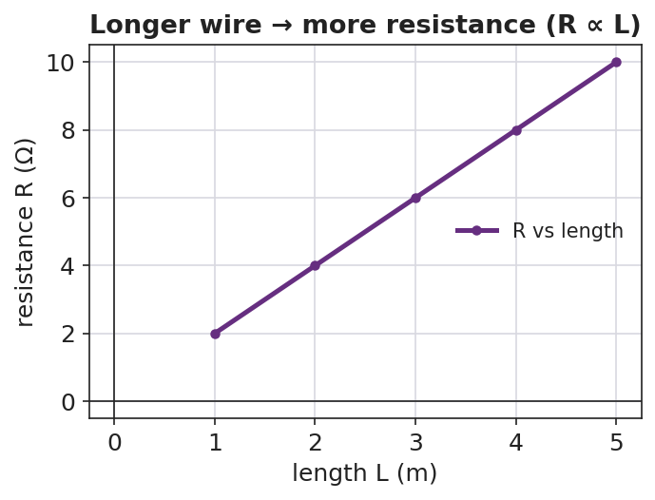
Line graph of resistance versus length: a rising straight line showing R is proportional to length.
When length doubles, resistance __________.
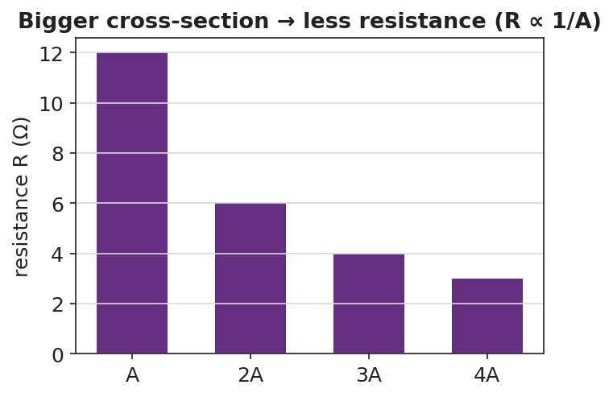
Bar chart of resistance versus cross-sectional area: bars shrink as area grows, showing R is inversely proportional to area.
When area doubles, resistance __________.
Connection to Ohm’s Law. Resistance is the R in V = I·R. If a wire’s resistance is high, then for the same voltage the current is __________.

Worked Example
Problem. Wire A and Wire B are the same copper, same thickness, but Wire B is three times as long as Wire A. Wire A has resistance 2 Ω. (a) Find Wire B’s resistance. (b) If both are connected to the same 12 V battery, which carries more current?
Solution. 1. Resistance is proportional to length, so tripling the length __________ the resistance: R_B = 3 × 2 Ω = __________ Ω. 2. Using I = V ÷ R: Wire A carries 12 ÷ 2 = __________ A; Wire B carries 12 ÷ 6 = __________ A. 3. Wire A carries more current because it has the __________ resistance.

Summary
Finish the sentence (Because / But / So):
A long, thin wire dims the bulb because __________________________________________, but __________________________________________, so __________________________________________.

