Resistance in a Wire — Student Worksheet
Unit: Current Electricity — Lesson 02 Name: _______________________ Date: __________ Period: ____

Phenomenon
The same battery and the same bulb are connected first with a long, thin wire — the bulb glows dim. Then they’re connected with a short, thick wire — the bulb glows bright. The only thing that changed was the wire.
Driving question: What properties of a wire decide how much it resists the flow of charge?

Notice & Wonder
I notice… | I wonder…
Turn & Talk #1: List every property of the wire that could change the brightness. Use the word resistance.

Initial Model
At your group’s board, predict before you touch the simulation:
- If you make a wire twice as long (same thickness), what happens to its resistance R?
- If you make a wire twice as thick (double the cross-sectional area, same length), what happens to R?
Length prediction: __________________________ Area prediction: ____________________________

Investigation
Open PhET Resistance in a Wire. Change one slider at a time.
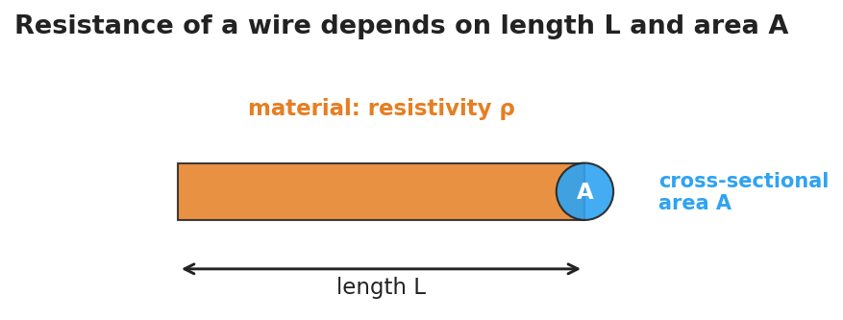
Diagram of a wire labeled with its length L, its circular end cap as cross-sectional area A, and the material’s resistivity rho.
Part A — Vary length L (keep ρ and A fixed):
Length L (m) | Resistance R (Ω)
1
2
3
4
5
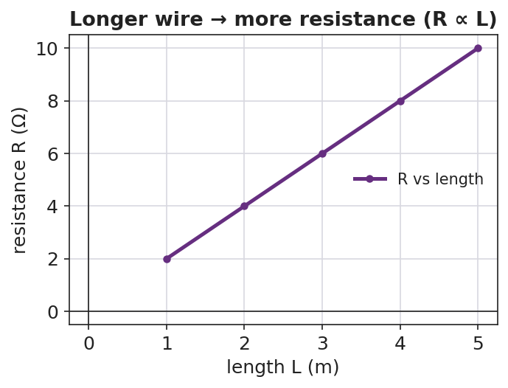
Line graph of resistance versus length showing a rising straight line: resistance is proportional to length.
Part B — Vary area A (keep ρ and L fixed). As area gets bigger, what happens to R?

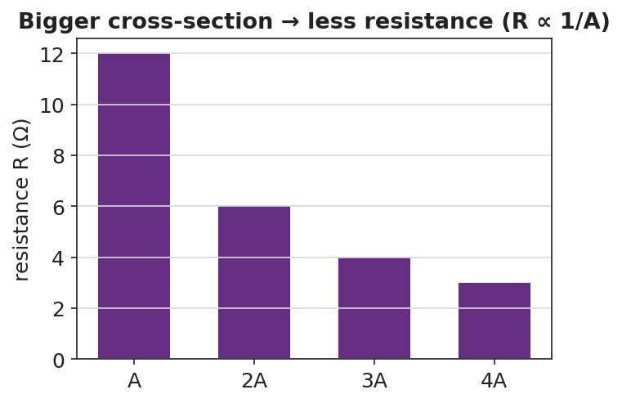
Bar chart of resistance versus cross-sectional area showing the bars get shorter as area increases.
Part C — Material. Increase the resistivity ρ slider. Does R go up or down?

Key question: Complete each pattern. R is proportional to __________ and inversely proportional to __________.

Make It Make Sense
- A wire is made twice as long with the same thickness. By what factor does its resistance change?
- A wire is made twice as thick (double the area) with the same length. By what factor does its resistance change?
- Copper has a low resistivity and nichrome has a high resistivity. Which makes a better connecting wire, and why?

Vocabulary in Action
Use each term in a sentence about today’s phenomenon.
- resistance: _______________________________________________
- resistivity: _______________________________________________
- cross-sectional area: _______________________________________________

Revise Your Model
Return to your Initial Model. Rewrite your explanation for why the long, thin wire dimmed the bulb, using length, cross-sectional area, and resistance.

Exit Ticket
Two wires are made of the same material.
- Wire B is twice as long as Wire A (same thickness). How does B’s resistance compare to A’s?
- Wire C is twice as thick as Wire A (same length, double the cross-sectional area). How does C’s resistance compare to A’s?
- Name one property of the material itself that affects resistance.

