Resistance in a Wire — Teacher Guide

Cover
Unit: Current Electricity — Lesson 02: Resistance in a Wire East Meadow Schools × Valley Stream Central High School District Strategy chips: BTC

Curated Resources (from East Meadow Scope & Sequence)

NYSSLS Standards
This lesson supports HS-PS3-6: “Analyze data to support the claim that Ohm’s Law describes the mathematical relationship among the potential difference, current, and resistance of an electric circuit.” Here students analyze how the resistance term in Ohm’s Law is itself determined — by the wire’s length, cross-sectional area, material (resistivity), and temperature. It deepens Lesson 01’s V = I·R by explaining where R comes from.

Phenomenon
- A circuit built with a thin/long wire glows dim; the same circuit with a thick/short wire glows bright (extension-cord and filament demos): https://www.youtube.com/results?search_query=wire+thickness+resistance+demonstration
- Why long, thin extension cords drop voltage and run warm (Khan Academy, “Resistivity and conductivity”): https://www.khanacademy.org/science/physics/circuits-topic/circuits-resistance/a/resistivity-and-conductivity

Javalab / Labs
- PhET — Resistance in a Wire: drag sliders for resistivity ρ, length L, and area A, and watch R change: https://phet.colorado.edu/en/simulations/resistance-in-a-wire
- PhET Circuit Construction Kit: DC — substitute wires of different length to see current change: https://phet.colorado.edu/en/simulations/circuit-construction-kit-dc

Assessments
- PhET Resistance-in-a-Wire data table (R vs L, R vs A) — formative during Explore.
- Exit ticket below; full key in Answer_Key.docx.

Lesson Overview
Duration | 42 minutes (1 period)
NYSSLS link | HS-PS3-6 (supports — origin of the R term)
CCC focus | Patterns / Scale — R rises in proportion to length and falls in proportion to cross-sectional area.
Strategy chips | BTC (Building Thinking Classrooms — random groups, vertical surfaces)
Materials | Devices for PhET Resistance in a Wire; whiteboards / vertical non-permanent surfaces; markers; (optional) nichrome vs. copper wire samples, thick vs. thin.
Safety | If running a real filament demo, use a low-voltage supply; wire can get hot — do not touch a powered nichrome coil.
Prior knowledge | Lesson 01 — current, voltage, resistance, and Ohm’s Law V = I·R.
Lesson objectives — students can:
- Predict how the resistance of a wire changes when its length or cross-sectional area changes.
- Explain the role of the material’s resistivity and of temperature in setting a wire’s resistance.
- Analyze R-vs-L and R-vs-A data to state the proportional relationships (R ∝ L, R ∝ 1/A).

Phase 1 · Engage (0 – 10 min)

0–2 min · Opening Connection (SEL)
One-sentence whip-around: “Describe a time you used a really long extension cord — did anything seem off about the device on the end?” Surface “it was dimmer / charged slower”; you’ll explain why by the end.

2–7 min · Phenomenon hook — thin vs. thick, long vs. short
Teacher actions. Show (live or on video) the same battery + bulb circuit wired first with a long, thin wire, then a short, thick wire. The bulb is noticeably brighter with the short, thick wire.
Sample teacher language:
“Same battery, same bulb — the only thing I changed was the wire connecting them. Why would the wire itself change how bright the bulb is?”
Anticipated student responses:
- “The thin wire blocks the electricity.” — capture “blocks”; we’ll sharpen to more resistance.
- “Longer means it has farther to travel.” — useful intuition; longer wire = more resistance.
- “Different metal?” — flag it; material (resistivity) matters too.

7–10 min · Notice & Wonder + Turn-and-Talk #1
“Turn to your partner: list every property of the wire that you think could change the brightness. Use the word resistance.”
Target list: length, thickness (area), material, maybe temperature.

Bridge to Phase 2
Each student writes a one-sentence initial model: “A thin, long wire dims the bulb because ______.”

Phase 2 · Explore (10 – 30 min)

10–14 min · Initial Model (BTC — random groups to vertical surfaces)
Form visibly random groups of three and send them to vertical non-permanent surfaces. Prompt:
“At your board, predict: if you make a wire twice as long, what happens to R? If you make it twice as thick (double the area), what happens to R? Write a prediction before you touch the sim.”

14–30 min · Investigation — PhET Resistance in a Wire
Groups drag the sliders one variable at a time and record R.
- Vary length L (hold ρ and A fixed). Record R at L = 1, 2, 3, 4, 5.
- Vary area A (hold ρ and L fixed). Record R as A doubles, triples, quadruples.
- Change material/resistivity ρ qualitatively — does a higher ρ raise or lower R?
Teacher facilitation language (circulating at the boards):
“When you doubled the length, exactly how did R change? Is that a straight-line pattern?” “When you doubled the area, did R double — or do something else?” “Convince your group: is area in the top or the bottom of the resistance relationship?”
Use the R-vs-length graph and the R-vs-area bar chart to consolidate the two patterns:
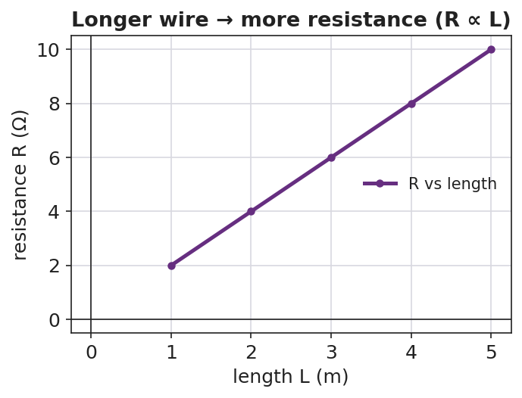
Line graph of resistance R versus wire length L: the points rise on a straight line, showing resistance is proportional to length.
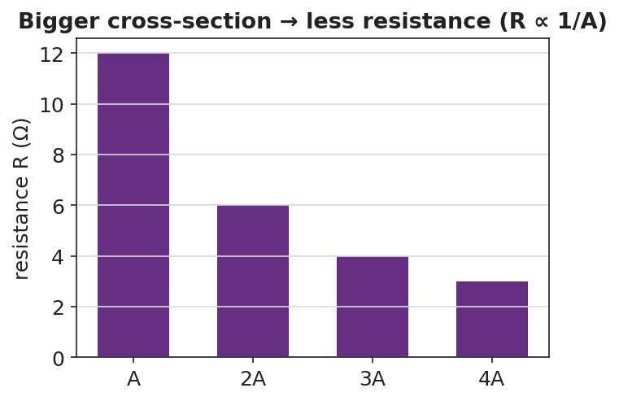
Bar chart of resistance versus cross-sectional area for areas A, 2A, 3A, and 4A: the bars fall as area increases, showing resistance is inversely proportional to area.
The wire model students are reasoning about — length L, cross-sectional area A, material resistivity ρ:
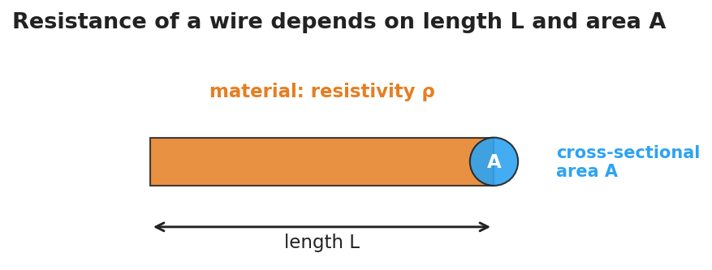
Diagram of a wire showing its length L along the long dimension, a circular end cap labeled cross-sectional area A, and a label for the material’s resistivity rho.

Teacher facilitation during Explore
- What to look for — groups stating “R doubles when L doubles” (direct) and “R halves when A doubles” (inverse).
- What to resist — handing them ρ·L/A; let the sim’s sliders reveal direct vs. inverse first.
- What to redirect — groups who change two sliders at once: insist on one variable at a time (control of variables).

Phase 3 · Explain (30 – 36 min)

30–33 min · Group consensus + Turn-and-Talk #2
“At your board, write one sentence each for length and for area: ’When ___ increases, R ___ because ___.’”
Target consensus:
“Resistance goes up with length and down with cross-sectional area. A wider wire gives charge more room to flow; a longer wire makes it fight resistance over a greater distance.”

33–36 min · Vocabulary introduction (≤ 3 terms)
Sample teacher language:
“We already met resistance. The property of the material itself is its resistivity — symbol ρ. Copper has low ρ (good conductor); nichrome has high ρ. And the wire’s thickness is its cross-sectional area, A. Put it together: R grows with length and resistivity, and shrinks with area. (Heating the wire also raises R for most metals.)”
Reference relationship to post: resistance ties back to Ohm’s Law V = I·R — change R, and the current changes.

Discussion prompts to deploy here
- “You have two copper wires, same thickness, but one is twice as long. Which has more resistance, and by how much?”
  - Sample response: “The long one — twice the resistance, because R is proportional to length.”
- “Why are thick wires used for high-current appliances?”
  - Sample response: “More cross-sectional area means less resistance, so less heat and voltage loss.”

Phase 4 · Elaborate (36 – 40 min)

36–38 min · Apply to the extension cord
“Explain why a long, thin extension cord makes a power tool run weaker than a short, thick one. Use length, area, and resistance in your answer.”
Target: the long, thin cord has high resistance, so more voltage is lost in the cord and less reaches the tool.

38–40 min · Return to the phenomenon
“Back to our two wires and the bulb: in one sentence, why did the short, thick wire make the bulb brighter?”
Target: “The short, thick wire has lower resistance, so more current reaches the bulb (I = V/R).”

Phase 5 · Evaluate (40 – 42 min)

40–42 min · Exit Ticket + Closing Reflection
“Two wires are made of the same material. (a) Wire B is twice as long as Wire A (same thickness). How does B’s resistance compare to A’s? (b) Wire C is twice as thick as Wire A (same length, so double the cross-sectional area). How does C’s resistance compare to A’s? (c) Name one property of the material itself that affects resistance.”
Expected: (a) twice the resistance; (b) half the resistance; (c) resistivity (ρ) — also accept temperature. See Answer_Key.docx.
Closing Reflection (SEL, 30 seconds):
“Whose explanation at the boards today helped you see the area pattern? Name them.”

Common Misconceptions
- Misconception: “A thicker wire has more resistance because there’s more metal.” → Correction: More cross-sectional area gives charge more parallel room to flow, so resistance decreases (R ∝ 1/A).
- Misconception: “Resistance only depends on the material.” → Correction: It depends on material (ρ) and geometry (length and area) and temperature.
- Misconception: “Longer wires carry more current because they’re bigger.” → Correction: Longer wires have more resistance, so for the same voltage they carry less current.

Access & Differentiation
- ELL/ENL supports: Sentence frames at the board: *“When length increases, resistance ___.”* / *“When area increases, resistance ___.”* Word box: {increases, decreases, longer, wider, resistivity, material}. Pair resistivity with sample wires labeled “easy flow” (copper) and “hard flow” (nichrome).
- IEP/SPED supports: Pre-filled data tables for the sim; students circle “up” or “down” rather than recording raw numbers. Provide the R-vs-L and R-vs-A figures with the patterns pre-drawn for annotation.
- Extensions: Introduce the full relationship R = ρ·L / A and have students compute R for a copper wire (ρ ≈ 1.7 × 10⁻⁸ Ω·m) of a given length and area; predict the effect of heating the wire.

Strategy Spotlight
BTC (Building Thinking Classrooms). Use visibly random groups of three and vertical non-permanent surfaces (whiteboards or windows). Give the thin-slice task verbally, not on a handout, and keep students standing. Circulate with the facilitation questions above rather than answers; when one group lands the “R halves when A doubles” insight, route other groups to go read that board. The vertical surfaces make every group’s thinking public, which is the point.

NYSSLS Observation Checklist Crosswalk
# | Checklist item | Where it appears in this lesson
1 | Local/relatable phenomenon | Phase 1 — thin/thick wire bulb; extension cord
2 | Turn and Talk (2–3×) | Phase 1 (TT#1 — wire properties), Phase 3 (TT#2 — length/area sentences)
3 | Students develop questions/models/procedures | Phase 1 (initial model), Phase 2 (sim, control of variables), Phase 4 (revise)
4 | CCC defined and used | Lesson Overview · Patterns/Scale, used in Phase 2 graphs
5 | ENL — ≤ 3 vocab, second half | Phase 3 — resistance / resistivity / cross-sectional area at 33–36 min
6 | Revisit phenomenon with evidence | Phase 4 — why the short, thick wire is brighter
7 | ENL/SPED supports | Access & Differentiation block
8 | Assessment check | Phase 5 — R-vs-length/area exit ticket

Companion Materials
- Student_Worksheet.docx — the 5E student investigation (hand out at start of Phase 2)
- Student_Notes.docx — guided note-guide for vocabulary and the worked example
- Answer_Key.docx — answers to “Make It Make Sense” prompts and the Exit Ticket

Key Vocabulary (max 3)
- resistance — the opposition a wire offers to the flow of charge, set by its length, area, material, and temperature, measured in ohms (Ω)
- resistivity — a property of the material itself (symbol ρ) describing how strongly it opposes current; copper is low, nichrome is high
- cross-sectional area — the area of the wire’s circular end face (A); a larger area gives charge more room to flow, lowering resistance

