Series Circuits — Student Notes
Unit: Current Electricity — Lesson 03 Name: _______________________ Date: __________ Period: ____

Learning Targets
By the end of today’s 42 minutes I can:
- Identify a series circuit and explain why the current is the same everywhere in it.
- Compute the equivalent resistance in series (R_total = R₁ + R₂ + …) and find the current.
- Explain why the voltage drops add up to the source voltage.

Key Vocabulary
- series circuit — _______________________________________________
- equivalent resistance — _______________________________________________
- current — _______________________________________________

Guided Notes
A series circuit has a single __________ for charge. Because there is only one path:
- The current is the __________ at every point in the loop.
- The total (equivalent) resistance is the __________ of the resistors: > R_total = R₁ + R₂ + R₃ + …
- The voltage drops across the resistors __________ up to the source voltage.
- One break anywhere stops the current __________.
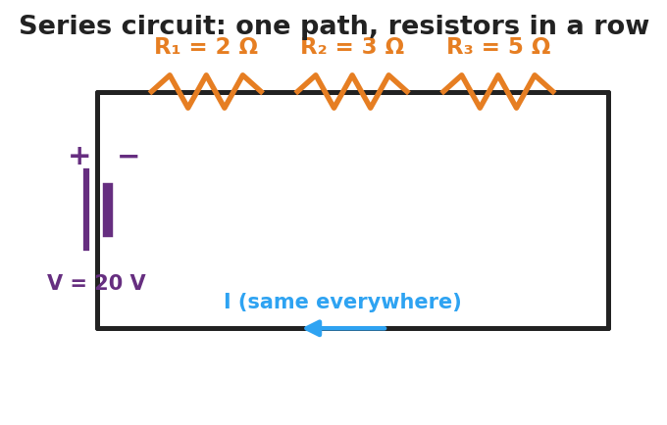
Schematic of a series circuit: one battery drives a single current through three resistors in a row; the current is the same everywhere.
Finding the current. Once you have R_total, use Ohm’s Law: > I = V ÷ R_total (this same I flows through every resistor)
Voltage drops add to the source:
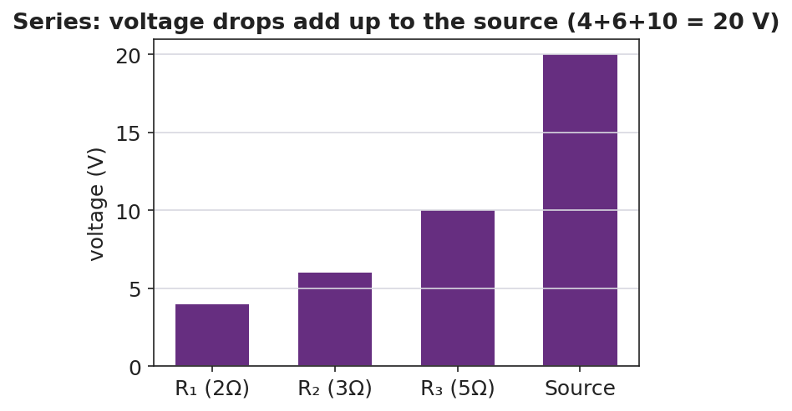
Bar chart of voltage drops in a series circuit summing to the source voltage.
Reference: V = I·R · series R_total = R₁ + R₂ + … · power P = V·I = I²·R

Worked Example
Problem. A 20 V battery is in series with R₁ = 2 Ω, R₂ = 3 Ω, and R₃ = 5 Ω. (a) Find R_total. (b) Find the current. (c) Find the voltage drop across R₃.
Solution. 1. R_total = R₁ + R₂ + R₃ = 2 + 3 + 5 = __________ Ω. 2. I = V ÷ R_total = 20 ÷ 10 = __________ A (this current flows through every resistor). 3. Voltage across R₃: V₃ = I·R₃ = 2 × 5 = __________ V. (Check: drops are 4 V + 6 V + 10 V = __________ V = the source.)

Summary
Finish the sentence (Because / But / So):
In a series circuit the current is the same everywhere because __________________________________________, but __________________________________________, so __________________________________________.

