Series Circuits — Student Worksheet
Unit: Current Electricity — Lesson 03 Name: _______________________ Date: __________ Period: ____

Phenomenon
An old string of holiday lights has fifty bulbs. You remove just one bulb — and the entire string goes dark. On a newer string, removing one bulb leaves the rest glowing.
Driving question: Why can a single missing bulb shut down an entire string of lights?

Notice & Wonder
I notice… | I wonder…
Turn & Talk #1: In a single-loop circuit, if you removed one resistor, what happens to the current everywhere else? Use the word path.

Initial Model
Sketch three bulbs wired in a single loop with a battery. Draw one arrow for the current. Predict: is the current the same at every bulb, or does it shrink as it passes each one?

My prediction: _______________________________

Investigation
Open PhET Circuit Construction Kit: DC. Build a 20 V battery with three resistors in one loop: R₁ = 2 Ω, R₂ = 3 Ω, R₃ = 5 Ω.
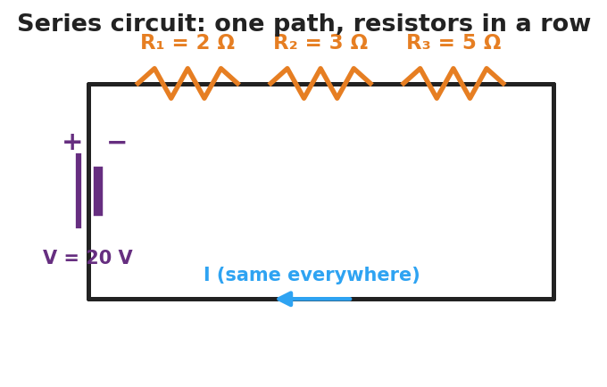
Schematic of a series circuit: a 20-volt battery drives one current through three resistors in a row, R-one 2 ohms, R-two 3 ohms, R-three 5 ohms; the current is the same everywhere.
Part A — Current. Measure the current at three points.
Point | Current I (A)
Before R₁
Between R₂ and R₃
After R₃
What do you notice about the three readings?

Part B — Voltage drops. Measure the voltage across each resistor and add them.
Resistor | Voltage drop (V)
R₁ (2 Ω)
R₂ (3 Ω)
R₃ (5 Ω)
Sum
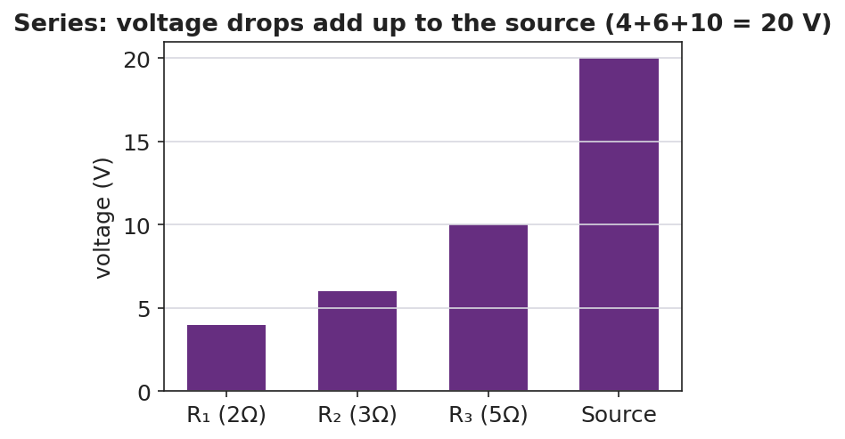
Bar chart of series voltage drops: 4 V, 6 V, and 10 V across the three resistors, summing to the 20 V source.
Part C — Break it. Remove one resistor (open the loop). What happens to the current everywhere?

Key question: How does R₁ + R₂ + R₃ compare to the total resistance you’d compute from I = V ÷ R_total?

Make It Make Sense
- Three resistors (1 Ω, 2 Ω, 3 Ω) are in series with a 12 V battery. Find the equivalent resistance and the current.
- In a series circuit the current is 2 A everywhere. The resistors are 3 Ω and 5 Ω. Find the voltage drop across each.
- You add a fourth resistor in series. Does the current go up or down? Why?

Vocabulary in Action
Use each term in a sentence about today’s phenomenon.
- series circuit: _______________________________________________
- equivalent resistance: _______________________________________________
- current: _______________________________________________

Revise Your Model
Return to your Initial Model. Was the current actually the same at every bulb? Rewrite your explanation for why one missing bulb kills the whole old string, using series and path.

Exit Ticket
A 24 V battery is connected in series to a 4 Ω resistor and an 8 Ω resistor.
- Find the equivalent (total) resistance.
- Find the current in the circuit.
- Find the voltage drop across the 8 Ω resistor, and check that the two drops add to 24 V.

