Parallel Circuits — Student Notes
Unit: Current Electricity — Lesson 04 Name: _______________________ Date: __________ Period: ____

Learning Targets
By the end of today’s 42 minutes I can:
- Identify a parallel circuit and explain why each branch has the same voltage.
- Explain why branch currents add to the total and why one branch can fail while others stay on.
- Compute the equivalent resistance in parallel (1/R_total = 1/R₁ + 1/R₂ + …) and find branch currents.

Key Vocabulary
- parallel circuit — _______________________________________________
- branch — _______________________________________________
- equivalent resistance — _______________________________________________

Guided Notes
A parallel circuit has more than one __________ for charge. Because each branch connects to the same two points:
- The voltage across every branch is the __________ (the full source voltage).
- The branch currents __________ up to the total current in the main wire.
- The equivalent resistance combines as reciprocals: > 1 / R_total = 1/R₁ + 1/R₂ + 1/R₃ + …
- R_total comes out __________ than any single branch (more paths = easier flow).
- Opening one branch leaves the other branches __________.
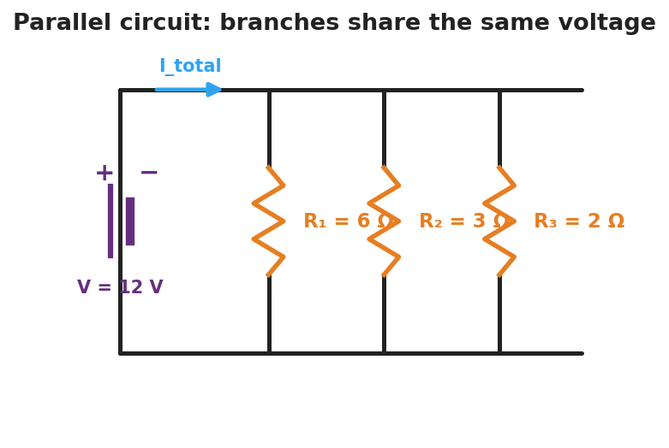
Schematic of a parallel circuit: a battery connected to three resistor branches that each see the full source voltage.
Finding branch currents. Each branch follows Ohm’s Law with the full voltage: > I_branch = V ÷ R_branch then add them for the total.
Branch currents add to the total:
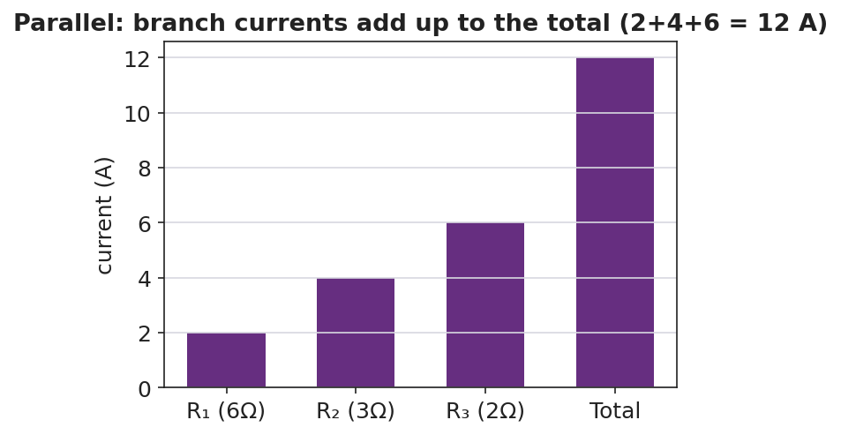
Bar chart of branch currents adding up to the total current in a parallel circuit.
Reference: V = I·R · parallel 1/R_total = 1/R₁ + 1/R₂ + … · power P = V·I = I²·R

Worked Example
Problem. A 12 V battery has three parallel branches: R₁ = 6 Ω, R₂ = 3 Ω, R₃ = 2 Ω. (a) Voltage across each branch? (b) Current in each branch? (c) Total current and equivalent resistance.
Solution. 1. Each branch has the full __________ V across it. 2. Branch currents (I = V/R): I₁ = 12/6 = __________ A; I₂ = 12/3 = __________ A; I₃ = 12/2 = __________ A. 3. Total current = 2 + 4 + 6 = __________ A. Equivalent resistance: R_total = V ÷ I_total = 12 ÷ 12 = __________ Ω — note it’s smaller than the 2 Ω branch.

Summary
Finish the sentence (Because / But / So):
Unplugging one lamp leaves the others lit because __________________________________________, but __________________________________________, so __________________________________________.

