Parallel Circuits — Student Worksheet
Unit: Current Electricity — Lesson 04 Name: _______________________ Date: __________ Period: ____

Phenomenon
Three lamps are plugged into a power strip — all lit. You unplug one, and the other two stay bright. Yesterday, removing one bulb from a series string killed the whole string. Something is wired differently here.
Driving question: How can one lamp turn off while the others stay on?

Notice & Wonder
I notice… | I wonder…
Turn & Talk #1: If each lamp has its own path to the source, what must be true about the voltage each lamp gets? Use the word branch.

Initial Model
Sketch three lamps each wired directly across the same battery (three branches). Predict: does each lamp get the full battery voltage or a share of it? Does the same current go through all three?

My prediction: _______________________________

Investigation
Open PhET Circuit Construction Kit: DC. Build a 12 V battery with three parallel resistor branches: R₁ = 6 Ω, R₂ = 3 Ω, R₃ = 2 Ω.
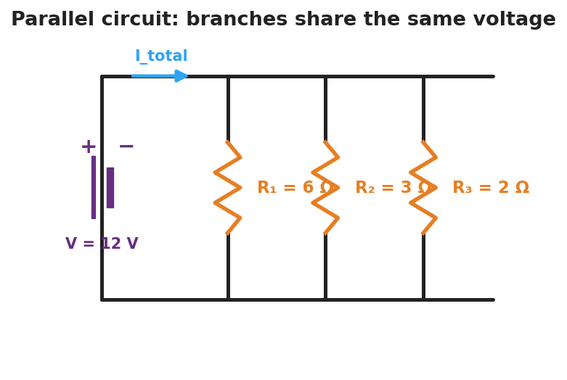
Schematic of a parallel circuit: a 12-volt battery connects to a top and bottom rail, with three vertical resistor branches between them, R-one 6 ohms, R-two 3 ohms, R-three 2 ohms; the total current splits among the branches.
Part A — Branch voltages. Measure the voltage across each branch.
Branch | Voltage (V)
R₁ (6 Ω)
R₂ (3 Ω)
R₃ (2 Ω)
What do you notice?

Part B — Currents. Measure the current in each branch and in the main wire.
Branch | Current (A)
R₁ (6 Ω)
R₂ (3 Ω)
R₃ (2 Ω)
Sum
Main wire
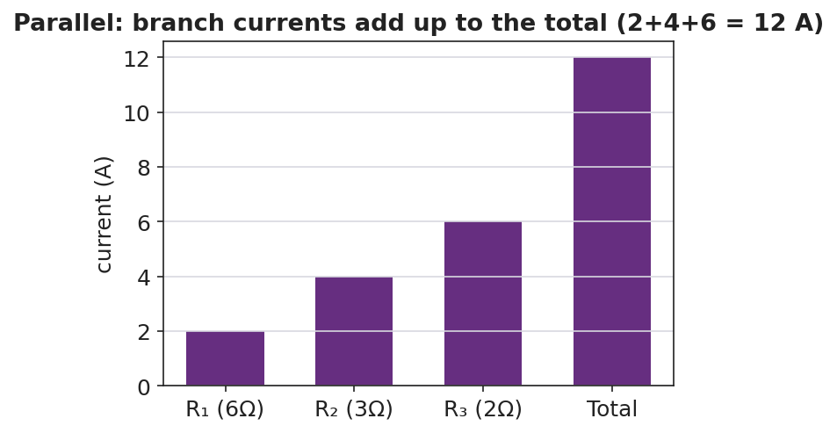
Bar chart of branch currents in a parallel circuit: 2 A, 4 A, and 6 A summing to a 12 A total.
Part C — Open a branch. Disconnect one branch. What happens to the other branches?

Key question: How do the branch currents compare to the current in the main wire? Is R_total bigger or smaller than the smallest branch resistor?

Make It Make Sense
- Two 4 Ω resistors are in parallel across an 8 V battery. Find the current in each branch and the total current.
- For those two 4 Ω resistors, find the equivalent resistance using 1/R_total = 1/4 + 1/4.
- You add a fourth lamp in parallel. Does the total current from the battery go up or down? Why?

Vocabulary in Action
Use each term in a sentence about today’s phenomenon.
- parallel circuit: _______________________________________________
- branch: _______________________________________________
- equivalent resistance: _______________________________________________

Revise Your Model
Return to your Initial Model. Did each lamp get the full voltage? Rewrite your explanation for why unplugging one lamp leaves the others lit, using parallel and branch.

Exit Ticket
A 12 V battery is connected to two parallel resistors: 4 Ω and 6 Ω.
- What is the voltage across each resistor?
- Find the current in each branch.
- Find the total current and the equivalent resistance (use 1/R_total = 1/4 + 1/6).

