Electromagnetism: The Induction Junction — Student Notes
Unit: Current Electricity — Lesson 05 Name: _______________________ Date: __________ Period: ____

Learning Targets
By the end of today’s 42 minutes I can:
- Explain that an electric current creates a magnetic field (an electromagnet).
- Describe electromagnetic induction: a changing magnetic field induces a current.
- Use a field model to explain how generators transfer energy between motion and current.

Key Vocabulary
- magnetic field — _______________________________________________
- electromagnet — _______________________________________________
- electromagnetic induction — _______________________________________________

Guided Notes
The two-way relationship (the “induction junction”):
- Current → field. A current in a coil of wire creates a __________ field. The coil acts like a bar magnet — this is an __________. More coil turns or more current makes it __________.
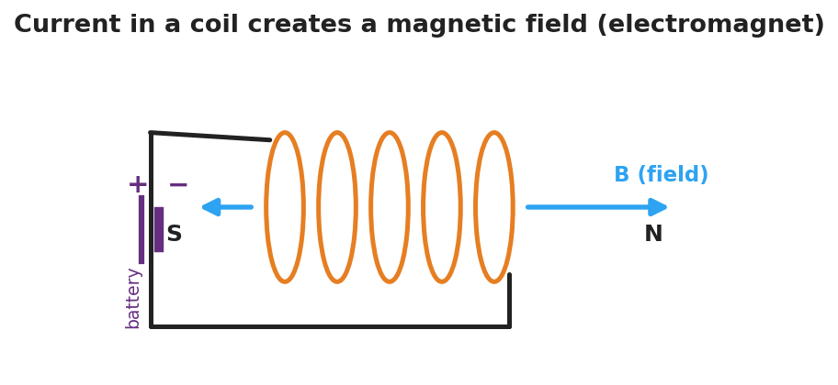
Diagram of current in a coil creating a magnetic field with north and south poles.
- Changing field → current. A changing magnetic field through a coil __________ a current. This is electromagnetic induction.
  - A magnet held __________ inside a coil induces __________ current (the field isn’t changing).
  - Moving the magnet __________ induces a larger current (faster change → more current).
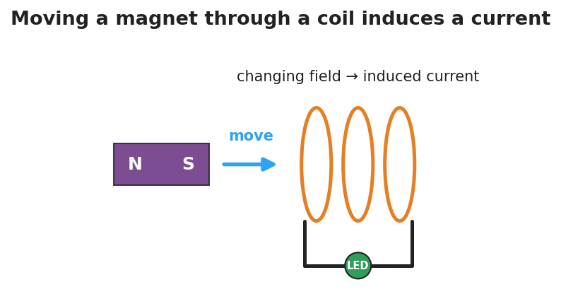
Diagram of induction: a moving magnet’s changing field through a coil induces a current that lights an LED.
Generators and motors (energy connection — HS-PS3-5).
- A generator spins a magnet near a coil; the changing field induces a current. It converts __________ energy into __________ energy.
- A motor runs the idea backward: current in → __________ out.

Worked Example
Problem. A student moves a magnet into a coil connected to an LED. (a) Why does the LED light only while the magnet moves? (b) She moves it twice as fast — what happens to the LED, and why? (c) Where does the LED’s energy come from?
Solution. 1. The LED lights only while moving because only a __________ magnetic field induces a current. 2. Moving twice as fast makes the field change __________, so the induced current is __________ and the LED is brighter. 3. The energy comes from the __________ she does moving the magnet — motion energy becomes electrical energy.

Summary
Finish the sentence (Because / But / So):
The LED lights only while the magnet moves through the coil because __________________________________________, but __________________________________________, so __________________________________________.

