Electromagnetism: The Induction Junction — Student Worksheet
Unit: Current Electricity — Lesson 05 Name: _______________________ Date: __________ Period: ____

Phenomenon
A magnet held still inside a coil of wire does nothing. But move the magnet in and out, and an LED in the circuit flashes. Across the room, a coil wrapped around a nail picks up paperclips — but only while a battery is connected.
Driving question: What is the two-way connection between electric current and magnetism?

Notice & Wonder
I notice… | I wonder…
Turn & Talk #1: What do the LED demo and the paperclip demo have in common? Use the words magnetic field.

Initial Model
Draw the coil with the magnet inside it and the LED in the loop. Mark when the LED is ON. Predict: does it matter how fast you move the magnet? What happens if you stop?

My prediction: _______________________________

Investigation
Hands-on station + Javalab/PhET simulation.
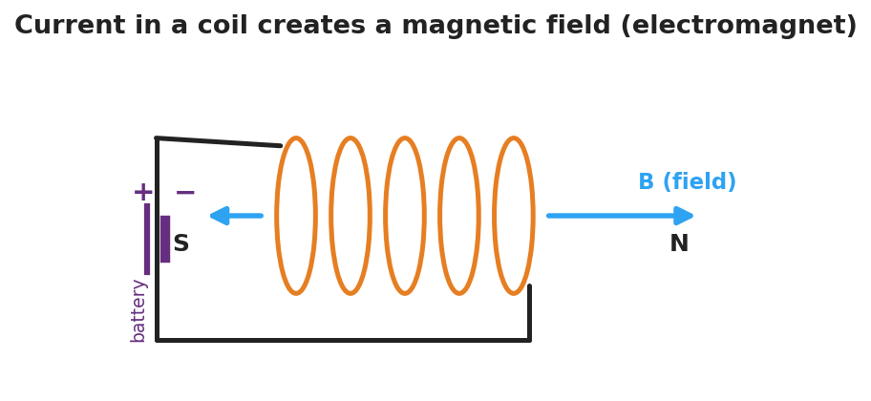
Diagram of current in a coil creating a magnetic field along its axis, with a north and a south pole like a bar magnet.
Part A — Electromagnet. Connect the nail-coil to the battery and count paperclips lifted. Then add more coil turns or a second battery.
Setup | Paperclips lifted
Battery + coil
More turns / more current
What makes the electromagnet stronger?

Part B — Induction. Move the magnet through the coil at different speeds and record the LED.
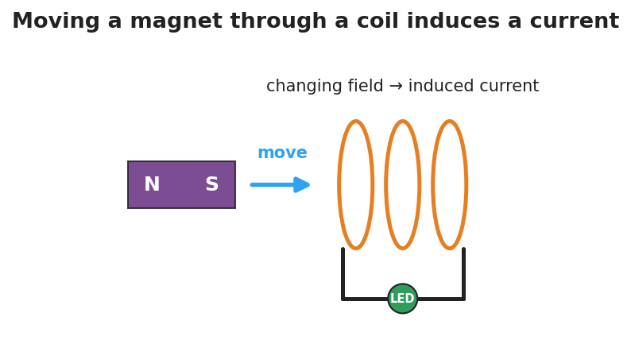
Diagram of electromagnetic induction: a moving bar magnet’s changing field through a coil induces a current that lights an LED.
Magnet action | LED (off / dim / bright)
Held still inside coil
Moved slowly
Moved quickly
Pulled back out
Part C — Reverse. When you pull the magnet out instead of pushing it in, what happens to the current direction (which LED lead lights / which way the needle moves)?

Key question: Under what condition does the coil have an induced current? What makes that current bigger?

Make It Make Sense
- A current flows through a coil of wire. What forms around the coil, and what is the coil now acting like?
- A magnet is held perfectly still inside a coil connected to an LED. Is there an induced current? Explain.
- A hand-crank flashlight has no battery. Explain where the light’s energy comes from, using electromagnetic induction.

Vocabulary in Action
Use each term in a sentence about today’s phenomenon.
- magnetic field: _______________________________________________
- electromagnet: _______________________________________________
- electromagnetic induction: _______________________________________________

Revise Your Model
Return to your Initial Model. Did the speed of the magnet matter? Rewrite your explanation for why the LED only lights while the magnet moves, using electromagnetic induction.

Exit Ticket
- A current flows through a coil of wire. What does it create around the coil?
- A magnet is held perfectly still inside a coil connected to an LED. Is there an induced current? Why or why not?
- Name one device that uses electromagnetic induction to generate electricity, and explain in one sentence where the energy comes from.

