Electromagnetism: The Induction Junction — Teacher Guide

Cover
Unit: Current Electricity — Lesson 05: Electromagnetism (The Induction Junction) East Meadow Schools × Valley Stream Central High School District Strategy chips: ACTIVE LEARNING

Curated Resources (from East Meadow Scope & Sequence)

NYSSLS Standards
This lesson is a NYS Required Investigation on electromagnetism. It supports HS-PS3-5: “Develop and use a model of two objects interacting through electric or magnetic fields to illustrate the forces between objects and the changes in energy of the objects due to the interaction.” Students model how a current creates a magnetic field, and how a changing magnetic field transfers energy into a circuit as an induced current — connecting the current-electricity unit to fields and energy. (It builds on, but does not directly assess, the Ohm’s-Law standard HS-PS3-6 from Lessons 01–04.)

Phenomenon
- A coil of wire + a magnet lighting an LED only while the magnet moves through the coil (shake-flashlight / hand-crank generator): https://www.youtube.com/results?search_query=magnet+coil+led+induction+demonstration
- A battery-powered coil (electromagnet) picking up paperclips, then dropping them when the current is cut: https://www.youtube.com/results?search_query=electromagnet+paperclips+demonstration

Javalab / Labs
- Javalab — Electromagnetic induction (move a magnet through a coil, watch the induced current): https://javalab.org/en/electromagnetic_induction_en/
- PhET — Faraday’s Electromagnetic Lab / Generator (magnet, coil, light bulb): https://phet.colorado.edu/en/simulations/faradays-law

Assessments
- Javalab/PhET induction observation table (when does the LED light? when is it brightest?) — formative during Explore.
- Exit ticket below; full key in Answer_Key.docx.

Lesson Overview
Duration | 42 minutes (1 period) · NYS Required Investigation
NYSSLS link | HS-PS3-5 (core — electric/magnetic field interaction and energy transfer)
CCC focus | Energy and Matter — energy is transferred between a moving magnet and a circuit through the magnetic field.
Strategy chips | ACTIVE LEARNING (predict-test-explain with a real coil/magnet)
Materials | Coil of magnetized wire, strong magnet, LED or galvanometer (or shake-flashlight); battery + iron nail + insulated wire for the electromagnet; paperclips; devices for Javalab/PhET.
Safety | Low-voltage only. The electromagnet wire can warm up — limit how long the battery stays connected. Keep strong magnets away from devices and pacemakers.
Prior knowledge | Lessons 01–04 — current, voltage, complete circuits; the idea that current is moving charge.
Lesson objectives — students can:
- Explain that a moving charge / electric current produces a magnetic field (an electromagnet).
- Describe electromagnetic induction: a changing magnetic field through a coil induces a current.
- Use a field model to explain how generators and motors transfer energy between motion and electric current.

Phase 1 · Engage (0 – 10 min)

0–2 min · Opening Connection (SEL)
One-sentence whip-around: “Name something you charge or power by moving it — a shake flashlight, a hand-crank radio, a bike light.” Hold the idea that motion can make electricity.

2–7 min · Phenomenon hook — coil, magnet, and LED
Teacher actions. Hold a magnet still inside the coil — the LED stays dark. Move the magnet in and out — the LED flashes. Then connect the iron-nail coil to a battery and pick up paperclips; disconnect, and they drop.
Sample teacher language:
“Holding the magnet still — nothing. But the moment I move it through the coil, the LED lights. And over here, the coil only grabs paperclips while the battery is connected. What links moving magnets and electric current?”
Anticipated student responses:
- “You have to keep moving it.” — capture; it’s the change that matters.
- “The coil becomes a magnet when the battery’s on.” — yes; current makes a magnetic field.
- “Faster shaking makes it brighter.” — flag; faster change → more induced current.

7–10 min · Notice & Wonder + Turn-and-Talk #1
“Turn to your partner: what do the LED demo and the paperclip demo have in common? Use the word magnetic field.”
Target: current ↔ magnetic field — current makes a field; a changing field makes current.

Bridge to Phase 2
Each student writes a one-sentence initial model: “The LED only lights while the magnet moves because ______.”

Phase 2 · Explore (10 – 30 min)

10–14 min · Initial Model (silent / individual)
Prompt on the board:
“Draw the coil with the magnet inside it and the LED in the loop. Mark when the LED is ON. Predict: does it matter how fast you move the magnet? Does it matter if you stop?”

14–30 min · Investigation — coil/magnet + Javalab/PhET (NYS Investigation)
Hands-on station plus the simulation.
- Electromagnet. Connect the nail-coil to the battery; count paperclips lifted. Add more coil turns or a second battery — does it lift more?
- Induction. Move the magnet through the coil slowly, then quickly. When is the LED brightest? What happens when the magnet sits still?
- Reverse it. Pull the magnet out — does the current reverse (LED on opposite lead / galvanometer needle flips)?
Teacher facilitation language:
“When the magnet sits still inside the coil, is the field changing? Is there any current?” “Faster motion — what happens to the brightness? What does that tell you about ‘rate of change’?” “More coil turns or more current — does the electromagnet get stronger?”
Use the two diagrams to consolidate the current→field and field-change→current ideas:
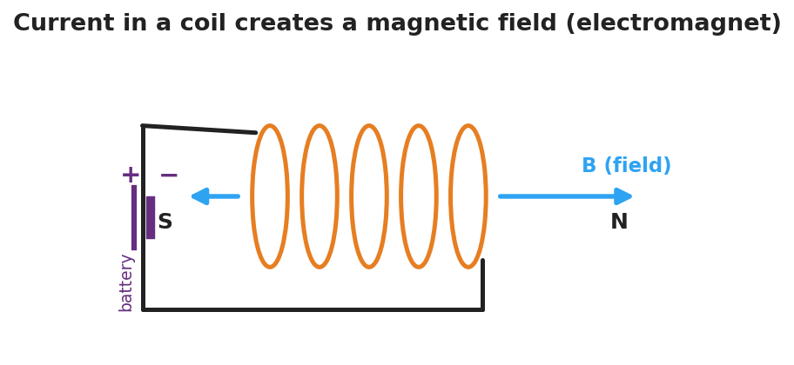
Diagram of current flowing through a wire coil: the loops of the coil create a magnetic field B running along the coil’s axis, with a north pole at one end and a south pole at the other, like a bar magnet.
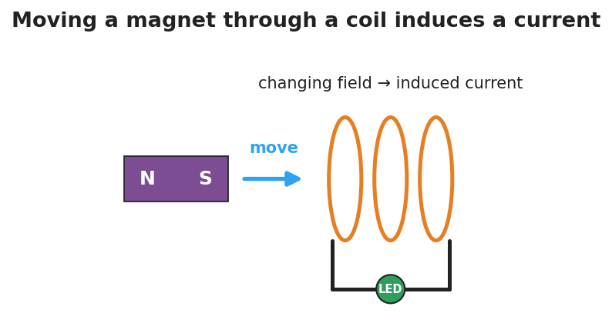
Diagram of electromagnetic induction: a bar magnet with north and south poles moves toward a wire coil connected to an LED; the changing magnetic field through the coil induces a current that lights the LED.

Teacher facilitation during Explore
- What to look for — groups stating “current only while the magnet moves” and “faster motion → brighter LED.”
- What to resist — supplying “Faraday’s law” equations; keep it at the model level (changing field → induced current).
- What to redirect — students who expect a steady LED from a still magnet: point them back to “is the field changing?”

Phase 3 · Explain (30 – 36 min)

30–33 min · Turn-and-Talk #2 + class consensus
“Across both demos, what is the two-way relationship between current and magnetic fields?”
Target consensus:
“An electric current creates a magnetic field (that’s an electromagnet). And a changing magnetic field through a coil creates — induces — a current. Faster change means more induced current.”

33–36 min · Vocabulary introduction (≤ 3 terms)
Sample teacher language:
“The region around a magnet or a current where magnetic forces act is the magnetic field. A coil carrying current that acts like a magnet is an electromagnet. And when a changing magnetic field through a coil drives a current, that’s electromagnetic induction — the principle behind every generator. A generator turns motion into current; a motor runs it backward, turning current into motion.”
Connection to energy (HS-PS3-5): the moving magnet transfers energy through the field into the circuit as electrical energy.

Discussion prompts to deploy here
- “Why doesn’t a magnet just resting inside a coil light the LED?”
  - Sample response: “The field isn’t changing, so no current is induced.”
- “How does a bike’s hand-crank/dynamo light work?”
  - Sample response: “Spinning moves a magnet near a coil, the changing field induces a current that lights the lamp.”

Phase 4 · Elaborate (36 – 40 min)

36–38 min · Apply — generators and motors
“A wind turbine spins a magnet inside a coil. Explain, using electromagnetic induction, how the wind ends up powering a light bulb.”
Target: the spinning magnet keeps changing the field through the coil, which induces a current that carries energy to the bulb — motion energy → electrical energy.

38–40 min · Return to the phenomenon
“In one sentence using electromagnetic induction, explain why the shake-flashlight only makes light while you shake it.”
Target: “Shaking keeps moving the magnet through the coil, so the changing field induces a current — stop shaking and the field stops changing, so the current (and light) stops.”

Phase 5 · Evaluate (40 – 42 min)

40–42 min · Exit Ticket + Closing Reflection
“(a) A current flows through a coil of wire. What does it create around the coil? (b) A magnet is held perfectly still inside a coil connected to an LED. Is there an induced current? Why or why not? (c) Name one device that uses electromagnetic induction to generate electricity, and explain in one sentence where the energy comes from.”
Expected: (a) a magnetic field (it becomes an electromagnet); (b) no — the field isn’t changing, and only a changing field induces current; (c) a generator/dynamo/turbine — the energy comes from the motion that keeps the field changing. See Answer_Key.docx.
Closing Reflection (SEL, 30 seconds):
“Where in your own life do you now realize electromagnetic induction is quietly working?”

Common Misconceptions
- Misconception: “A magnet sitting in a coil produces a current.” → Correction: Only a changing magnetic field induces a current; a stationary magnet’s steady field induces nothing.
- Misconception: “An electromagnet is permanently magnetic.” → Correction: It’s magnetic only while current flows; cut the current and the field collapses.
- Misconception: “Generators create energy.” → Correction: Generators convert energy — the motion that spins the magnet supplies the energy that becomes electrical energy.

Access & Differentiation
- ELL/ENL supports: Sentence frames: “A current makes a ___ field.” / *“A changing field induces a ___.”* Word box: {magnetic, current, moving, changing, induction, electromagnet}. Pair induction with the in-and-out magnet gesture.
- IEP/SPED supports: Provide the coil/magnet diagrams pre-labeled; students circle “ON” vs. “OFF” for each scenario (magnet still / moving / stopped). Offer the Javalab sim as a low-stakes alternative to the hands-on station.
- Extensions: Have students explain why a faster spin or more coil turns increases the induced voltage (Faraday’s law qualitatively) and sketch how a motor reverses a generator (current in → motion out), tying back to energy transfer (HS-PS3-5).

Strategy Spotlight
ACTIVE LEARNING (NYS Required Investigation). Students physically move the magnet and watch the LED rather than being told the rule. Build a predict → test → explain loop: predict whether the LED lights for (magnet still / slow / fast / pulled out), test each, then reconcile. The “still magnet = dark LED” result is the conceptual hinge — it isolates change as the cause. Capture each group’s observation table; the class consensus on “current ↔ changing field” should come from their data, not the slide.

NYSSLS Observation Checklist Crosswalk
# | Checklist item | Where it appears in this lesson
1 | Local/relatable phenomenon | Phase 1 — shake flashlight; coil/magnet LED; electromagnet + paperclips
2 | Turn and Talk (2–3×) | Phase 1 (TT#1 — what the demos share), Phase 3 (TT#2 — current↔field)
3 | Students develop questions/models/procedures | Phase 1 (initial model), Phase 2 (NYS investigation), Phase 4 (revise)
4 | CCC defined and used | Lesson Overview · Energy and Matter, used in Phase 2/4
5 | ENL — ≤ 3 vocab, second half | Phase 3 — magnetic field / electromagnet / electromagnetic induction at 33–36 min
6 | Revisit phenomenon with evidence | Phase 4 — why the shake-flashlight needs shaking
7 | ENL/SPED supports | Access & Differentiation block
8 | Assessment check | Phase 5 — induction exit ticket

Companion Materials
- Student_Worksheet.docx — the 5E student investigation (hand out at start of Phase 2)
- Student_Notes.docx — guided note-guide for vocabulary and the worked example
- Answer_Key.docx — answers to “Make It Make Sense” prompts and the Exit Ticket

Key Vocabulary (max 3)
- magnetic field — the region around a magnet or a current-carrying wire where magnetic forces act, represented by field lines from north to south
- electromagnet — a coil of wire that becomes magnetic only while an electric current flows through it; more turns or more current makes it stronger
- electromagnetic induction — the production of a current in a coil by a changing magnetic field; the basis of generators (motion → electricity)

