Wave Anatomy and Characteristics — Student Notes
Unit: Waves — Lesson 01 Name: _______________________ Date: __________ Period: ____

Learning Targets
By the end of today’s 42 minutes I can:
- Label the parts of a wave: crest, trough, amplitude, and wavelength.
- Tell the difference between frequency (cycles per second) and period, and use T = 1/f.
- Explain that a wave transfers energy, not matter.

Key Vocabulary
- amplitude — _______________________________________________
- wavelength — _______________________________________________
- frequency — _______________________________________________

Guided Notes
Big idea: A wave is a __________ that carries __________ from one place to another. The matter it passes through only __________ in place — it does not travel with the wave.
Label the wave below:
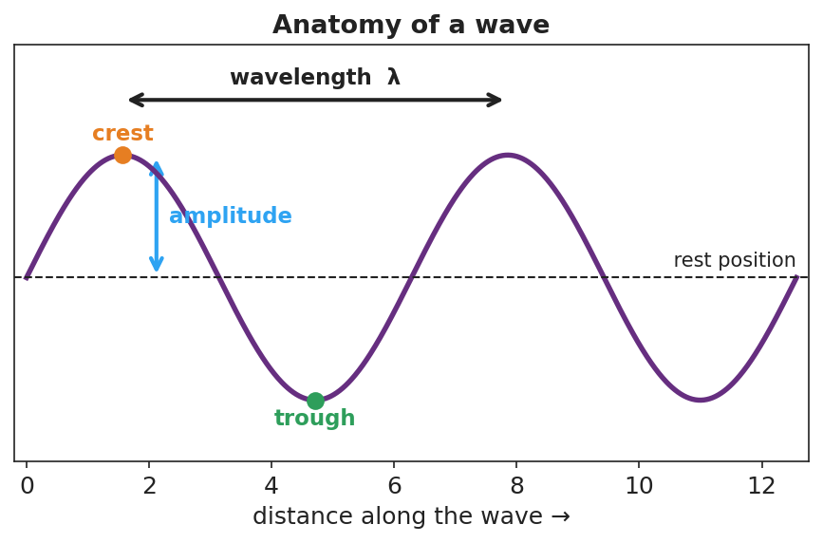
A sine wave with crest, trough, rest position, amplitude, and wavelength labeled.
- Crest — the __________ point of the wave.
- Trough — the __________ point of the wave.
- Amplitude — distance from rest to a crest; more amplitude → more __________.
- Wavelength (λ) — distance from one crest to the __________ crest.
Frequency and period.
- Frequency (f) = number of cycles per __________, measured in __________ (Hz).
- Period (T) = time for __________ complete cycle, in seconds.
- They are reciprocals: T = 1 / __________ and f = 1 / __________.
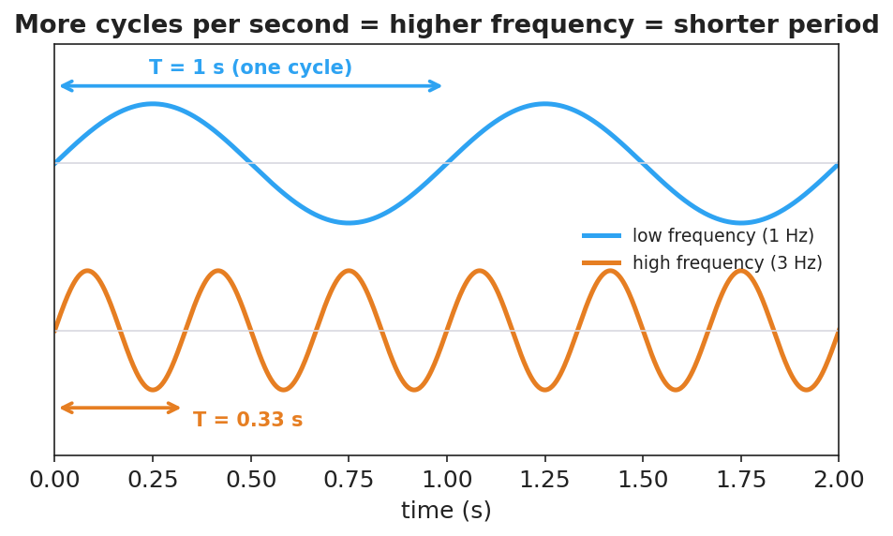
Two waves over the same two seconds: a 1 Hz wave (T = 1 s) and a 3 Hz wave (T = 0.33 s).
More cycles per second → __________ frequency → __________ period.

Worked Example
Problem. A wave passes a dock and a seagull bobs up and down 20 times in 4 seconds. Find the frequency and the period.
Solution. 1. Frequency: f = cycles ÷ time = 20 ÷ 4 = __________ Hz. 2. Period: T = 1 / f = 1 / __________ = __________ s per cycle. 3. Check: 5 cycles each second × 4 seconds = __________ cycles. ✓

Summary
Finish the sentence (Because / But / So):
A wave travels across a slinky because __________________________________________, but __________________________________________, so __________________________________________.

