Wave Anatomy and Characteristics — Student Worksheet
Unit: Waves — Lesson 01 Name: _______________________ Date: __________ Period: ____

Phenomenon
A “wave” travels all the way around a packed stadium — but every single fan stays in their own seat, just raising and lowering their arms. On the front bench, a slinky pulse races from one end to the other, yet each coil only jiggles in place.
Driving question: When a wave travels, what actually moves — and what stays put?

Notice & Wonder
I notice… | I wonder…
Turn & Talk #1: What actually traveled around the stadium, and what stayed put? Use the word energy in your answer.

Initial Model
Draw the slinky at one instant as a wave passes. Mark a high point and a low point. Draw one arrow for the direction the wave moves, and a second arrow for the direction a single coil moves.

Are the two arrows the same direction? _______________________

Investigation
Open PhET Wave on a String and keep a slinky handy. Tie a ribbon to one slinky coil.
Station | What I changed | What happened to the wave | What happened to the ribbon / tagged point
1. Amplitude (oscillator height)
2. Frequency (oscillator speed)
3. Energy, not matter (tag one point)
Use this labeled wave to name the parts you measured:
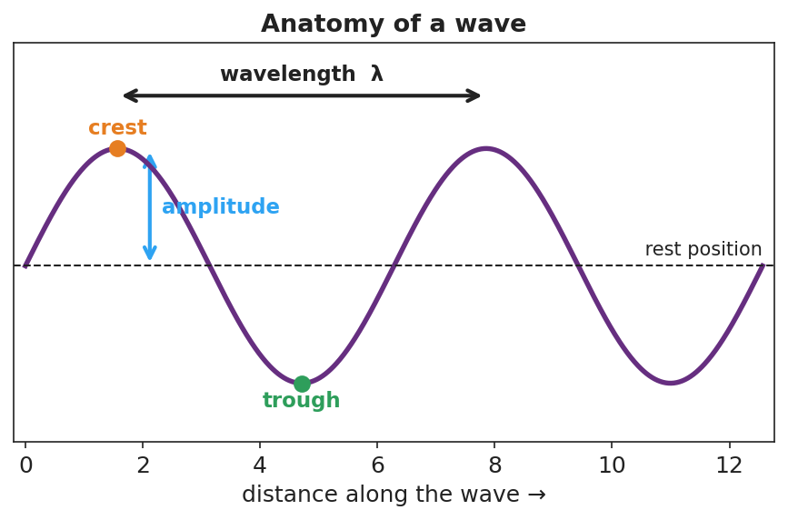
A sine wave with crest, trough, rest position, amplitude, and wavelength labeled.
Key question: Did the ribbon (a piece of matter) travel down the slinky, or move in place? What does that tell you about what a wave transports?

Make It Make Sense
- On the wave diagram above, which measurement tells you how much energy the wave carries? Explain.
- A wave’s frequency is 5 Hz. What is its period? Show the formula you used.
- Two ocean waves have the same speed, but Wave A has a larger amplitude than Wave B. Which carries more energy? Does it travel faster? Explain.

Vocabulary in Action
Use each term in a sentence about today’s phenomenon.
- amplitude: _______________________________________________
- wavelength: _______________________________________________
- frequency: _______________________________________________

Revise Your Model
Return to your Initial Model. Label the crest, trough, amplitude, and one wavelength. Rewrite your explanation using the words energy, amplitude, and wavelength.

Exit Ticket
A buoy bobs up and down 12 times in 6 seconds as ocean waves pass.
- What is the frequency of the waves?
- What is the period?
- Does the water itself travel toward the shore with the wave? Explain in one sentence.

