Wave Anatomy and Characteristics — Teacher Guide

Cover
Unit: Waves — Lesson 01: Wave Anatomy and Characteristics East Meadow Schools × Valley Stream Central High School District Strategy chips: RESTORATIVE CIRCLE

Curated Resources (from East Meadow Scope & Sequence)

NYSSLS Standards
HS-PS4-1. “Use mathematical representations to support a claim regarding relationships among the frequency, wavelength, and speed of waves traveling in various media. (Cause and Effect)”
This opening lesson builds the vocabulary and mental picture students need before they can reason mathematically with v = f·λ in Lessons 02–03. Establishing crest, trough, amplitude, wavelength, frequency, and period is the prerequisite for every wave claim that follows.

Phenomenon
- A stadium “wave” travels around the bowl, but each fan stays in their seat — only their arms go up and down: https://www.youtube.com/watch?v=njBJW9pStLA
- A slinky pulse and a plucked guitar string as live, in-room versions of the same idea.

Javalab / Labs
- PhET Wave on a String — drive a string at the left end and watch a wave travel: https://phet.colorado.edu/en/simulations/wave-on-a-string

Assessments
- PhET Wave on a String “Oscillate + Slow Motion” check: students set amplitude and frequency and measure wavelength. Exit ticket below serves as the formative check.

Lesson Overview
Duration | 42 minutes (1 period)
NYSSLS link | HS-PS4-1 (vocabulary + model foundation)
CCC focus | Cause and Effect — driving the source faster (higher frequency) causes the wave’s shape to change, but the medium itself does not travel.
Strategy chips | RESTORATIVE CIRCLE (unit opener)
Materials | Long spring/slinky; a length of rope; a guitar or ukulele (optional); rulers; whiteboards/markers; device for PhET.
Safety | Give the slinky room; do not stretch past ~3 m or release under tension.
Prior knowledge | Energy transfer (Energy unit); the idea of a repeating, periodic motion.
Lesson objectives — students can:
- Label the parts of a wave: crest, trough, amplitude, and wavelength.
- Distinguish frequency (cycles per second) from period (seconds per cycle) and state that they are reciprocals (T = 1/f).
- Explain, with evidence, that a wave transfers energy without transferring matter.

Phase 1 · Engage (0 – 12 min)

0–3 min · Opening Connection (SEL) — Restorative Circle (unit opener)
This is the first lesson of the Waves unit, so open with a brief restorative circle. Pass a talking piece. Prompt: “Name a sound or signal that travels to you every day — a voice, a song, a notification — and where it comes from.” One sentence each, no cross-talk. This seeds the central idea: something travels to you, but the air, the wire, or the screen did not come with it.

3–8 min · Phenomenon hook — the stadium wave
Teacher actions. Play the stadium-wave clip with the sound off for ~30 seconds. Then run a slinky pulse across the front bench so students see the in-room version.
Sample teacher language:
“Watch one single fan, not the whole stadium. Did that person travel around the stadium? Then what did go all the way around?”
Anticipated student responses:
- “The wave moved but the people stayed.” — exactly the target; capture the word stayed.
- “Energy went around.” — affirm and hold; we will sharpen this.
- “The people passed it on.” — good, reframe as “each one moved up and down in place.”

8–12 min · Notice & Wonder + Turn-and-Talk #1
Capture two columns on the board. Then:
“Turn to your partner: what actually traveled around the stadium, and what stayed put? Use the word energy in your answer.”
Take 2–3 responses. Desirable insight: the disturbance (energy) traveled; the matter (people, slinky coils) only moved in place and returned.

Bridge to Phase 2
Every student leaves Phase 1 with a one-sentence initial model: “In the stadium wave, ______ traveled but ______ stayed put.”

Phase 2 · Explore (12 – 32 min)

12–17 min · Initial Model (silent / individual)
Prompt on the board:
“Draw the slinky at one instant as a wave passes. Mark a high point and a low point. Draw an arrow showing which way the wave moves, and an arrow showing which way a single coil moves. Are they the same direction?”
This surfaces the matter-vs-energy distinction before any vocabulary.

17–32 min · Investigation — PhET Wave on a String + slinky stations
Students work in pairs at PhET (with a slinky available to handle):
- Amplitude — set the oscillator higher/lower. What part of the wave changes? (Tie a ribbon to one slinky coil — does the ribbon travel down the slinky, or bob in place?)
- Frequency — speed up and slow down the oscillator. Count cycles in 10 seconds. What happens to the spacing of the crests?
- Energy, not matter — pause the sim and tag one point on the string. Step it forward. Does the tagged point move along the string, or up and down?
Use the labeled-wave figure to anchor the vocabulary you will name in Phase 3:
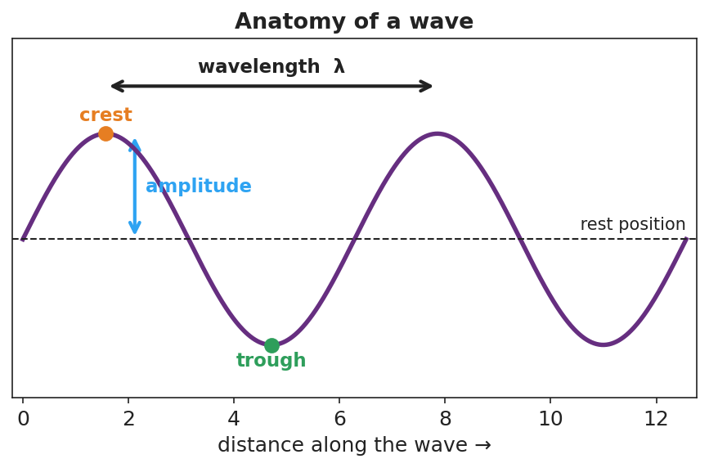
A sine wave with the crest, trough, rest position, amplitude (rest-to-crest), and wavelength (crest-to-crest) all labeled.

Teacher facilitation during Explore
- What to look for — pairs noticing that the ribbon/tagged point bobs in place while crests march along; that more cycles per second means crests are closer together.
- What to resist — don’t define “frequency” or “wavelength” yet; let the counting and the ribbon do the teaching.
- What to redirect — students who say “the string moves to the right” should be asked, “does that piece of string end up on the right, or does it come back?”

Phase 3 · Explain (32 – 37 min)

32–35 min · Turn-and-Talk #2 + class consensus
“Across both the slinky and PhET, what moved along the medium and what only moved in place?”
Target consensus:
“A wave is a disturbance that carries energy from place to place. The matter it travels through only vibrates in place — it does not travel with the wave.”

35–37 min · Vocabulary introduction (≤ 3 terms)
Sample teacher language:
“The height of the wave from rest to a crest is the amplitude — bigger amplitude means more energy. The distance from one crest to the next is the wavelength. And how many full cycles pass a point each second is the frequency, measured in hertz. The time for one cycle is its period, and period and frequency are reciprocals: T = 1/f.”
Show the frequency/period figure here:
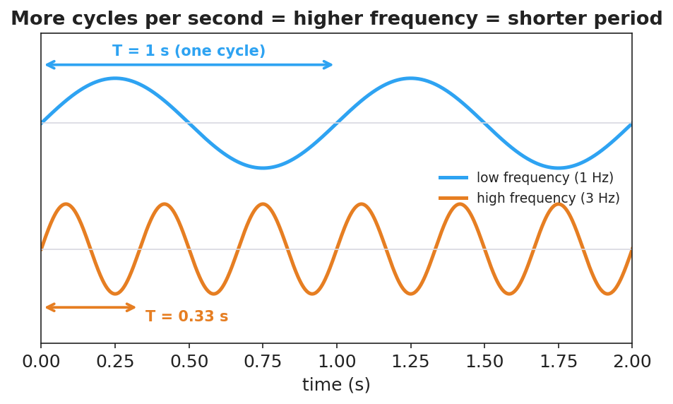
Two waves over the same two seconds: a 1 Hz wave with period T = 1 s, and a 3 Hz wave with period T = 0.33 s, showing more cycles per second means a shorter period.

Discussion prompts to deploy here
- “A wave’s amplitude doubles. Does it travel faster?”
  - Sample student response: “No — amplitude is about energy/height, not speed. Speed depends on the medium.”
- “If a wave’s frequency is 4 Hz, what is its period?”
  - Sample student response: “T = 1/f = 1/4 = 0.25 s per cycle.”

Phase 4 · Elaborate (37 – 40 min)

37–39 min · Revise the model
“Return to your slinky drawing. Label the crest, trough, amplitude, and one wavelength. Re-write your one-sentence explanation using the words energy, amplitude, and wavelength.”

39–40 min · Return to the phenomenon
“Back to the stadium: what is the ‘amplitude’ of the stadium wave, and what stayed in place? Answer in one sentence.”
Target: “The amplitude is how high fans raise their arms; the fans (the matter) stayed in their seats while the wave (energy) traveled around.”

Phase 5 · Evaluate (40 – 42 min)

40–42 min · Exit Ticket + Closing Reflection
“A buoy bobs up and down 12 times in 6 seconds as ocean waves pass. (a) What is the frequency of the waves? (b) What is the period? (c) Does the water itself travel toward the shore with the wave? Explain in one sentence.”
Expected: (a) f = 12/6 = 2 Hz; (b) T = 1/f = 0.5 s; (c) no — the water (matter) bobs in place; the wave carries energy toward shore. See Answer_Key.docx.
Closing Reflection (SEL, 30 seconds):
“What is one everyday ‘wave’ you now see differently? Who in your group helped you picture it?”

Common Misconceptions
- Misconception: “A wave carries the medium along with it (the water moves to shore).” → Correction: The medium vibrates in place; only energy is transported.
- Misconception: “Bigger waves (higher amplitude) move faster.” → Correction: Amplitude is energy/height; wave speed is set by the medium, not the amplitude.
- Misconception: “Frequency and period are the same thing.” → Correction: They are reciprocals — frequency is cycles per second, period is seconds per cycle (T = 1/f).

Access & Differentiation
- ELL/ENL supports: Sentence frame: “A wave carries ______ but not ______; the ______ moves up and down in place.” Word-choice box: {energy, matter, amplitude, wavelength, frequency, crest, trough}. Pair amplitude with a hand gesture (high vs. low).
- IEP/SPED supports: Provide a pre-printed blank sine curve; students drag/label cut-out tags (crest, trough, amplitude, wavelength) rather than drawing from scratch. Offer the slinky as a hands-on alternative to the simulation.
- Extensions: Have students measure a real wavelength in PhET by reading the ruler tool, then predict how the wavelength changes when they double the frequency at the same speed (preview of Lesson 03).

Strategy Spotlight
RESTORATIVE CIRCLE (unit opener). Today’s circle launches the Waves unit. Use a talking piece, one-sentence responses, and equity of voice (everyone speaks or passes). The prompt — a sound or signal that travels to you and where it comes from — is chosen so you can call it back in Phase 3 (“the song reached your ears, but the singer’s air did not travel to you — energy did”). Keep the circle to ~2–3 minutes; the goal is community plus a shared anchor.

NYSSLS Observation Checklist Crosswalk
# | Checklist item | Where it appears in this lesson
1 | Local/relatable phenomenon | Phase 1 — stadium wave; slinky; ocean buoy in Phase 5
2 | Turn and Talk (2–3×) | Phase 1 (TT#1 — what traveled), Phase 3 (TT#2 — along vs. in place)
3 | Students develop questions/models/procedures | Phase 1 (initial model), Phase 2 (PhET + slinky stations), Phase 4 (revise model)
4 | CCC defined and used | Lesson Overview · Cause and Effect, restated in Phase 2
5 | ENL — ≤ 3 vocab, second half | Phase 3 — vocabulary at 35–37 min (amplitude / wavelength / frequency)
6 | Revisit phenomenon with evidence | Phase 4 — stadium-wave amplitude re-label
7 | ENL/SPED supports | Access & Differentiation block
8 | Assessment check | Phase 5 — Exit Ticket (ocean buoy)

Companion Materials
- Student_Worksheet.docx — the 5E student investigation (hand out at start of Phase 2)
- Student_Notes.docx — guided note-guide for vocabulary and the worked example
- Answer_Key.docx — answers to “Make It Make Sense” prompts and the Exit Ticket

Key Vocabulary (max 3)
- amplitude — the maximum distance a wave rises from its rest position; larger amplitude means more energy
- wavelength — the distance between two matching points on a wave, such as crest to crest (symbol λ)
- frequency — the number of complete wave cycles that pass a point each second, measured in hertz (Hz)

