Transverse and Longitudinal Waves — Student Notes
Unit: Waves — Lesson 02 Name: _______________________ Date: __________ Period: ____

Learning Targets
By the end of today’s 42 minutes I can:
- Describe how the medium oscillates compared to the direction a wave travels.
- Classify a wave as transverse or longitudinal and give an example of each.
- Identify compressions and rarefactions in a longitudinal wave.

Key Vocabulary
- transverse wave — _______________________________________________
- longitudinal wave — _______________________________________________
- medium — _______________________________________________

Guided Notes
There are two ways the matter in a wave can move compared to the way the wave travels:
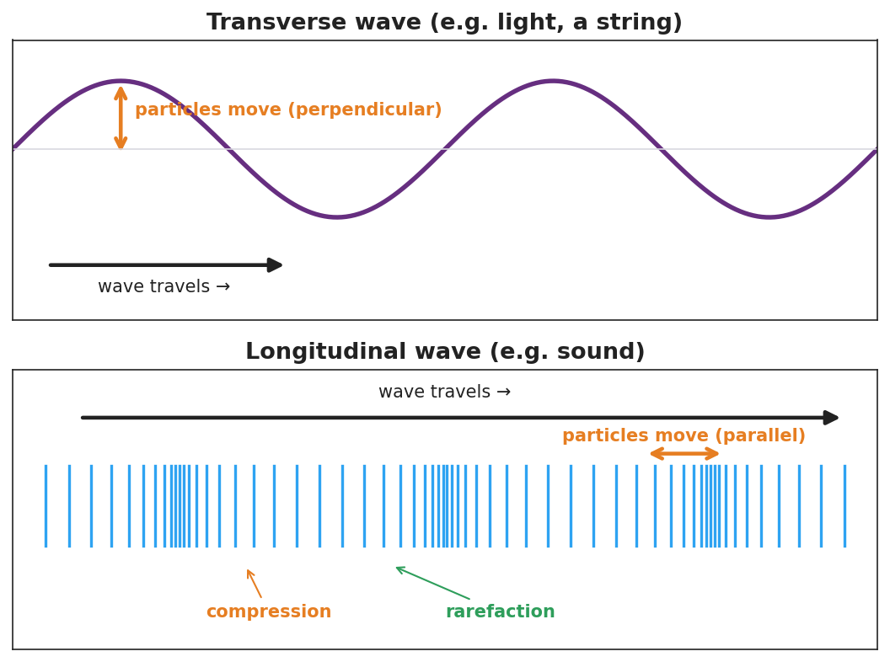
Top: transverse wave (particles move perpendicular). Bottom: longitudinal wave with compressions and rarefactions (particles move parallel).
Transverse wave.
- The medium moves __________ (perpendicular) to the direction of travel.
- Examples: light, a wave on a __________.
- Has crests and __________.
Longitudinal wave.
- The medium moves __________ (parallel) to the direction of travel.
- Example: __________ (it needs a medium to push through).
- Bunched-up regions = __________; spread-out regions = __________.
The medium is the __________ the wave travels through. A wave does not travel with the medium — the medium just __________ in place.

Worked Example
Problem. Decide whether each wave is transverse or longitudinal, and explain how you know.
Wave | Type | How the medium moves
Light from the sun | __________ | __________ to travel
Sound from a speaker | __________ | __________ to travel
Ripple on a pond surface | __________ | __________ to travel
Reasoning. I look at the direction the medium oscillates compared with the direction the wave travels. If __________, it’s transverse; if __________, it’s longitudinal.

Summary
Finish the sentence (Because / But / So):
Sound and light are both waves that carry energy because __________________________________________, but __________________________________________, so __________________________________________.

