Transverse and Longitudinal Waves — Student Worksheet
Unit: Waves — Lesson 02 Name: _______________________ Date: __________ Period: ____

Phenomenon
Your teacher takes one slinky and makes two completely different-looking waves with it. First they shake the end side to side — a wiggle travels across the room. Then they push and pull the same end along its length — a squeeze races down the coils. Same slinky, same energy. Two different waves.
Driving question: What did the teacher change about how they moved their hand to make two different wave types?

Notice & Wonder
I notice… | I wonder…
Turn & Talk #1: In each case, which way did a single coil move compared to the way the wave traveled?

Initial Model
Draw both slinky waves. For each, draw one arrow for the wave’s travel direction and one arrow for how a single coil moves. Circle the case where the two arrows are perpendicular.

Investigation
Work in a group of 4 with a slinky and the Javalab simulation. Tape a ribbon to one coil.
Station | What I did | Did the ribbon travel or move in place? | Coil motion vs. wave travel
1. Side-to-side slinky
2. Push-pull slinky
3. Human wave (step / lean)
4. Javalab tag-a-particle
Compare your two waves to this diagram:
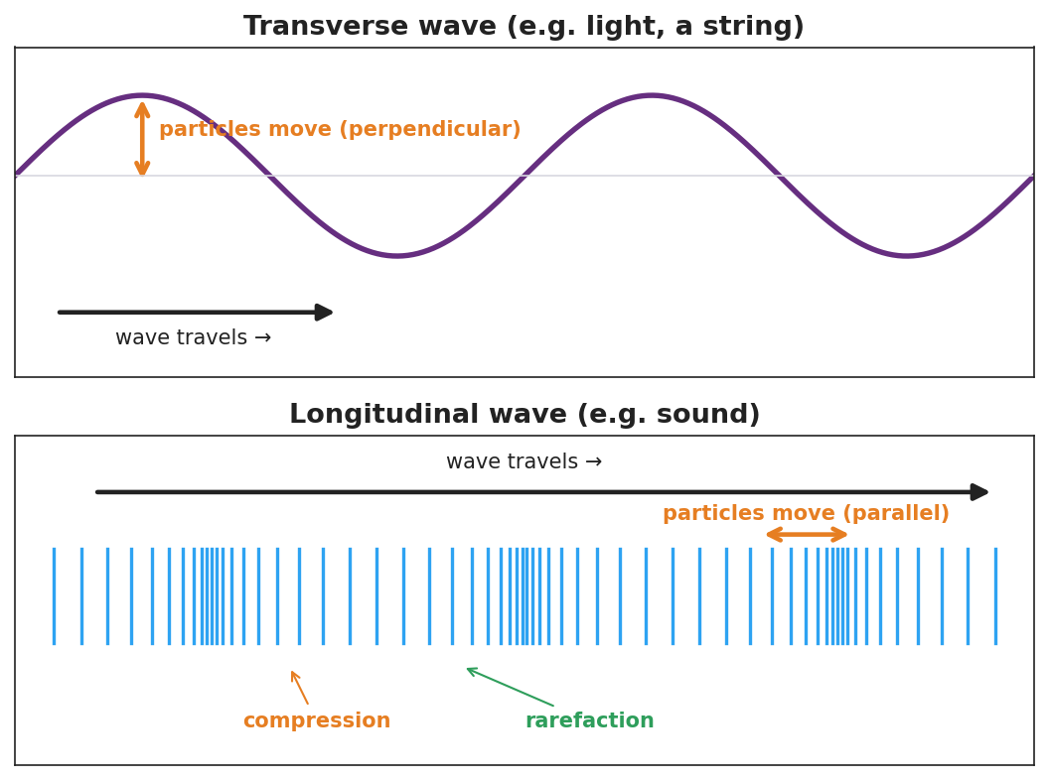
Top: transverse wave with perpendicular particle motion. Bottom: longitudinal wave with compressions, rarefactions, and parallel particle motion.
Key question: Which station moved your body across the wave’s travel, and which moved it along the travel? Which one is like sound?

Make It Make Sense
- Light is a transverse wave. Describe how the wave “oscillates” compared to the direction the light travels.
- Sound is a longitudinal wave. Why does it need a medium (air, water, or a solid) to travel?
- A wave on a guitar string — transverse or longitudinal? Justify your answer with the direction the string moves.

Vocabulary in Action
Use each term in a sentence about today’s phenomenon.
- transverse wave: _______________________________________________
- longitudinal wave: _______________________________________________
- medium: _______________________________________________

Revise Your Model
Return to your two slinky drawings. Label one transverse and one longitudinal. On the longitudinal one, mark a compression and a rarefaction. Rewrite your rule using both vocabulary words.

Exit Ticket
A sound wave travels through air toward your ear.
- Is sound a transverse or longitudinal wave?
- Describe how the air molecules move compared to the direction the sound travels.
- Name the bunched-up regions and the spread-out regions of a sound wave.

