Wave Speed, Frequency, and Wavelength — Student Notes
Unit: Waves — Lesson 03 Name: _______________________ Date: __________ Period: ____

Learning Targets
By the end of today’s 42 minutes I can:
- Use v = f·λ to solve for speed, frequency, or wavelength.
- Explain why, in a given medium, frequency and wavelength are inversely related.
- Convert between period and frequency with T = 1/f.

Key Vocabulary
- wave speed — _______________________________________________
- period — _______________________________________________
- hertz — _______________________________________________

Guided Notes
The wave equation: v = f · λ
- v = wave __________ (m/s)
- f = __________ (Hz)
- λ = __________ (m)
Big idea. In a given medium the wave speed is __________ (set by the medium). So if the source raises the frequency, the wavelength must go __________ to keep the product the same.
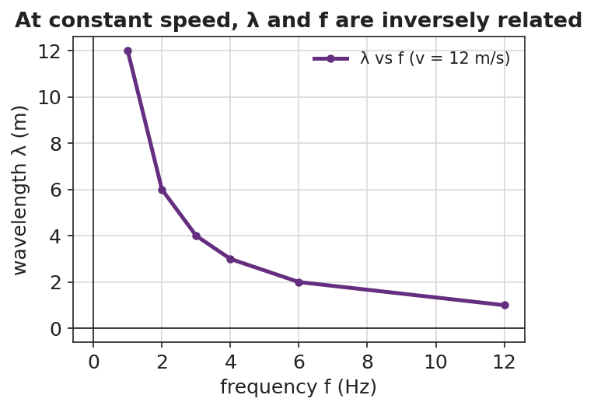
Wavelength versus frequency at constant speed — an inverse relationship.
- Higher frequency → __________ wavelength (inverse).
- The product f·λ always equals the __________.
Period and frequency are reciprocals:
- T = 1 / __________ and f = 1 / __________.
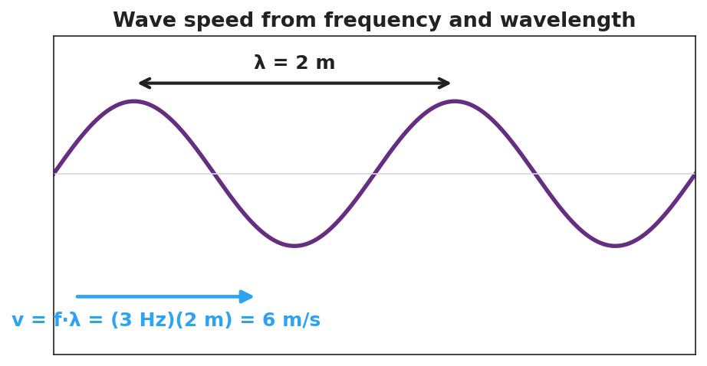
A wave labeled with λ = 2 m and v = f·λ = (3 Hz)(2 m) = 6 m/s.

Worked Example
Problem. A wave travels at 6 m/s. Its frequency is 3 Hz. (a) Find the wavelength. (b) Find the period.
Solution. 1. Rearrange v = f·λ for wavelength: λ = v / f = 6 / 3 = __________ m. 2. Period: T = 1 / f = 1 / 3 = __________ s (about 0.33 s). 3. Check with v = f·λ: (3 Hz)(2 m) = __________ m/s. ✓

Summary
Finish the sentence (Because / But / So):
In one medium the wave speed stays the same because __________________________________________, but __________________________________________, so __________________________________________.

