Wave Speed, Frequency, and Wavelength — Student Worksheet
Unit: Waves — Lesson 03 Name: _______________________ Date: __________ Period: ____

Phenomenon
Your teacher plucks a thick low string and a thin high string the same way — they sound like completely different notes. The wave speed on each string is fixed by the string itself, yet the pitches are not the same.
Driving question: If two notes travel at the same speed, what must be different about their waves?

Notice & Wonder
I notice… | I wonder…
Turn & Talk #1: If two waves on a string travel at the same speed but have different frequencies, what has to be different about their wavelengths?

Initial Model
Predict: if you keep the wave speed the same but double the frequency, what happens to the wavelength? Write your prediction and a reason.

My reason: _______________________________________________

Investigation
Open PhET Wave on a String in oscillate mode with the tension fixed (so the speed stays constant). Use the ruler to measure one wavelength at each frequency.
Frequency f (Hz) | Wavelength λ (m) | Product f × λ
These figures show the pattern you are testing:
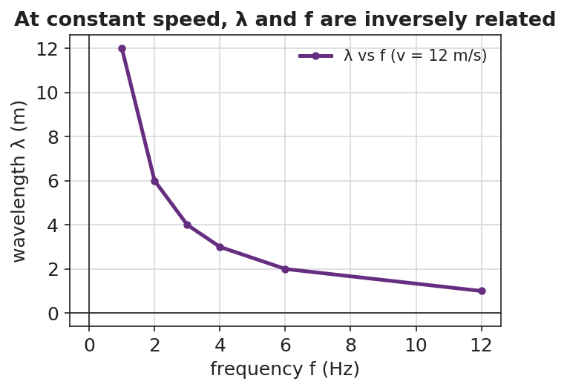
Wavelength versus frequency at constant speed — an inverse relationship.
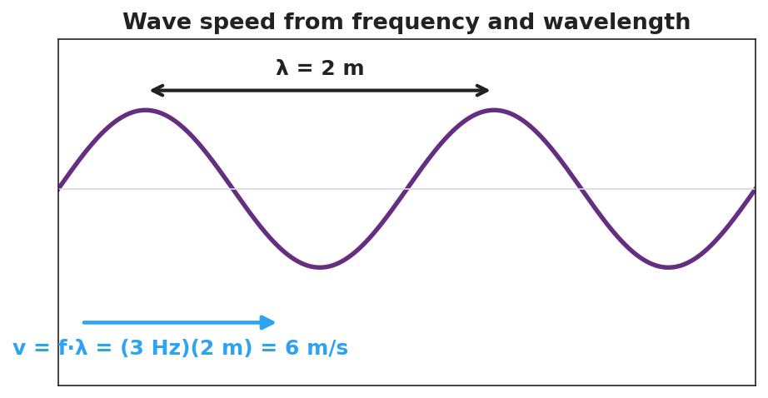
A wave labeled with λ = 2 m and the worked relationship v = f·λ = (3 Hz)(2 m) = 6 m/s.
Key question: What do you notice about the column f × λ? What does that product represent?

Make It Make Sense
- A wave travels at 340 m/s with a frequency of 170 Hz. Find its wavelength. Show v = f·λ rearranged.
- At a fixed wave speed, you triple the frequency. What happens to the wavelength, and by what factor?
- Write a Because/But/So sentence explaining why frequency and wavelength are inversely related at a constant wave speed.

Vocabulary in Action
Use each term in a sentence about today’s investigation.
- wave speed: _______________________________________________
- period: _______________________________________________
- hertz: _______________________________________________

Revise Your Model
Return to your prediction. Was it right? Rewrite it as a Because / But / So sentence using v = f·λ and the words wave speed, frequency, and wavelength.
Because __________________________________________, but __________________________________________, so __________________________________________.

Exit Ticket
A sound wave in air travels at 340 m/s.
- A note has a frequency of 256 Hz. Find its wavelength. Show v = f·λ rearranged.
- A higher note has a frequency of 512 Hz at the same speed. Without a calculator, is its wavelength longer or shorter, and by what factor?
- What is the period of the 256 Hz note?

