Standing Waves and Resonance — Student Notes
Unit: Waves — Lesson 04 Name: _______________________ Date: __________ Period: ____

Learning Targets
By the end of today’s 42 minutes I can:
- Explain how a standing wave forms from a wave and its reflection.
- Identify nodes and antinodes and count them for the first harmonics.
- Explain resonance in terms of natural frequency.

Key Vocabulary
- standing wave — _______________________________________________
- node — _______________________________________________
- resonance — _______________________________________________

Guided Notes
How a standing wave forms. A wave hits a fixed end and __________ back. The returning wave __________ (interferes) with the new wave. At certain frequencies they always add the same way, making a pattern that stays in __________.
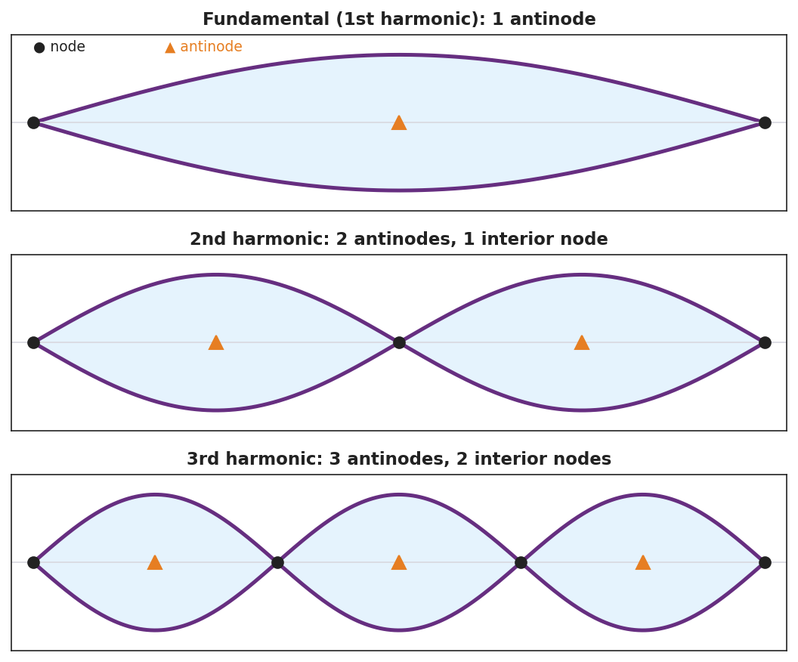
Three standing-wave harmonics with nodes and antinodes labeled.
- Node — a point that __________ moves (the waves cancel there).
- Antinode — a point that moves the __________.
- Fundamental (1st harmonic) — __________ antinode.
- 2nd harmonic — __________ antinodes, 1 interior node.
- 3rd harmonic — 3 antinodes, __________ interior nodes.
Resonance. Driving a system at one of its __________ frequencies produces a __________ (large) response. Examples: a swing pushed in rhythm, a shattering glass, a vibrating string.

Worked Example
Problem. A standing wave on a string shows 3 full loops between the fixed ends.
Solution. 1. Each loop is one antinode → there are __________ antinodes. 2. Nodes appear between loops plus at both fixed ends → __________ nodes total. 3. This is the __________ harmonic.

Summary
Finish the sentence (Because / But / So):
A shaken rope usually looks messy because __________________________________________, but __________________________________________, so __________________________________________.

