Standing Waves and Resonance — Student Worksheet
Unit: Waves — Lesson 04 Name: _______________________ Date: __________ Period: ____

Phenomenon
An opera singer holds one steady note and a wine glass shatters. On a shaken rope, most hand-speeds make a messy mess — but at one special speed the rope locks into a clean, big pattern that seems to stand still.
Driving question: What is special about the one frequency that makes a clean, standing pattern?

Notice & Wonder
I notice… | I wonder…
Turn & Talk #1: On the rope at the special frequency, where is there no motion at all, and where is the motion biggest?

Initial Model
Sketch the rope at the special frequency. Mark with an X every point that does not move, and a star at every point that moves the most. Predict: what happens to the number of loops if you shake faster?

My prediction: _______________________________________________

Investigation
Work in a group of 3–4 with a string and the Javalab Standing Wave sim.
Step | Frequency / speed | Number of loops | Nodes (still points) | Antinodes (big-swing)
1. Fundamental
2. Next harmonic
3. Third harmonic
4. Off-resonance (between) |  | (messy?)
Compare your patterns to this diagram:
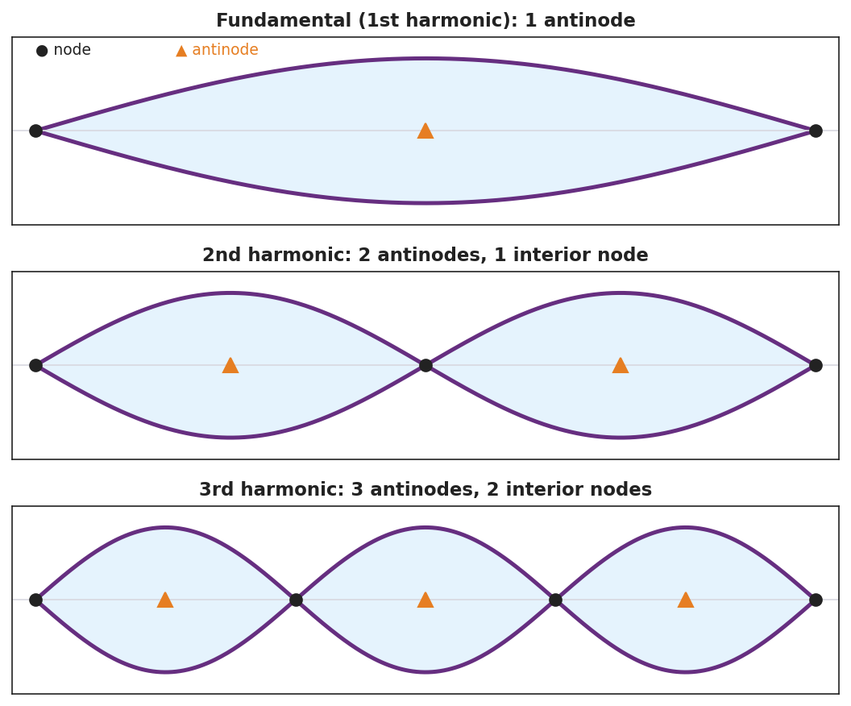
Three standing-wave harmonics with nodes and antinodes marked: fundamental, 2nd, and 3rd.
Key question: What did the rope do at a frequency between two harmonics? What does that tell you about which frequencies “work”?

Make It Make Sense
- How does a standing wave form? Use the words reflection and interfere.
- The 3rd harmonic on a fixed-end string has how many nodes (including the ends) and how many antinodes?
- Why did the wine glass shatter at only one specific pitch? Use the word natural frequency.

Vocabulary in Action
Use each term in a sentence about today’s phenomenon.
- standing wave: _______________________________________________
- node: _______________________________________________
- resonance: _______________________________________________

Revise Your Model
Return to your rope sketch. Re-label the X’s as nodes and the stars as antinodes. Add a one-sentence definition of resonance using the words natural frequency.

Exit Ticket
A standing wave on a string shows 2 full loops between the fixed ends.
- How many nodes are there in total (including the ends)? How many antinodes?
- Define resonance in one sentence.
- A bridge can sway dangerously if wind or marching feet hit a certain frequency. Which idea from today explains this?

