Standing Waves and Resonance — Teacher Guide

Cover
Unit: Waves — Lesson 04: Standing Waves and Resonance East Meadow Schools × Valley Stream Central High School District Strategy chips: ACTIVE LEARNING

Curated Resources (from East Meadow Scope & Sequence)

NYSSLS Standards
HS-PS4-1. “Use mathematical representations to support a claim regarding relationships among the frequency, wavelength, and speed of waves traveling in various media. (Cause and Effect)”
Standing waves are a direct consequence of v = f·λ on a bounded medium: only certain wavelengths (and therefore certain frequencies) “fit” between the fixed ends, producing the harmonic series. Resonance is the Cause-and-Effect link — driving a system at one of its natural frequencies causes a large-amplitude response.

Phenomenon
- A standing wave on a vibrating string (Melde’s experiment) and a “musical fire table” (a Rubens’ tube) showing standing sound waves: https://www.youtube.com/watch?v=PHRO_d0M5wo
- An opera singer shattering a wine glass by matching its resonant frequency: https://www.youtube.com/watch?v=BE827gwnnk4

Javalab / Labs
- Javalab Standing Wave — drive a fixed-end string and watch nodes and antinodes form at the natural frequencies: https://javalab.org/en/standing_wave_en/

Assessments
- Javalab “find the harmonics” task: students sweep the driving frequency to locate the first three standing-wave patterns and count nodes/antinodes. Exit ticket below serves as the formative check.

Lesson Overview
Duration | 42 minutes (1 period)
NYSSLS link | HS-PS4-1 (which wavelengths “fit”; resonance)
CCC focus | Cause and Effect — driving a bounded medium at a natural frequency causes a large, stable standing-wave pattern.
Strategy chips | ACTIVE LEARNING
Materials | Long elastic cords or strings (one per group); a function generator/string vibrator OR a hand-shaken rope; tuning forks; a wine glass + dampened finger (demo); devices for Javalab.
Safety | Eye protection if doing a real glass-shatter demo; otherwise show the video.
Prior knowledge | Lessons 01–03 — wavelength, frequency, v = f·λ; reflection of a wave at a fixed end.
Lesson objectives — students can:
- Explain that a standing wave forms when a wave interferes with its own reflection, creating fixed nodes and antinodes.
- Identify nodes (no motion) and antinodes (maximum motion) and count them for the first few harmonics.
- Explain resonance: a large response occurs when a system is driven at one of its natural frequencies.

Phase 1 · Engage (0 – 12 min)

0–3 min · Opening Connection (SEL)
Quick check-in: “Name something that ‘clicks’ for you when the timing is just right — a song, a sport, a routine.” One sentence each. This previews resonance: the right timing produces a big effect.

3–8 min · Phenomenon hook — the glass and the string
Teacher actions. Play the wine-glass shatter clip, then shake a rope at increasing speed until a clean standing-wave loop snaps into place. Most frequencies make a messy rope; one special frequency makes a clean, big, standing pattern.
Sample teacher language:
“Most of the time the rope just looks chaotic. But at one special speed of my hand, it locks into this beautiful, big, still-looking pattern. What’s special about that frequency?”
Anticipated student responses:
- “It looks like it’s standing still.” — capture standing; the loops stay in place.
- “You hit the right rhythm.” — affirm; that’s resonance in everyday words.
- “The wave bounced back and added to itself.” — excellent; this is the mechanism.

8–12 min · Notice & Wonder + Turn-and-Talk #1
Capture columns. Then:
“Turn to your partner: where on the rope is there no motion at all, and where is the motion biggest?”
Target: there are points that never move (future nodes) and points that swing the most (future antinodes).

Bridge to Phase 2
Initial model sentence: “A clean, big rope pattern formed because the wave and its ______ added together at just the right ______.”

Phase 2 · Explore (12 – 32 min)

12–17 min · Initial Model (silent / individual)
Prompt:
“Sketch the rope at the special frequency. Mark with an X every point that does not move, and with a star every point that moves the most. Predict what happens to the number of loops if you shake faster.”

17–32 min · Investigation — ACTIVE LEARNING: hunt the harmonics
Groups of 3–4, each with a string/cord (one end fixed or held, the other shaken or driven) and Javalab open:
- Find the fundamental. Shake slowly and increase frequency until one clean loop appears. Mark the still points and the big-swing point.
- Climb the series. Keep increasing frequency. Catch the 2-loop pattern, then the 3-loop pattern. Record how many nodes and antinodes each has.
- Off-resonance test. Set a frequency between two harmonics. What does the rope do? (Messy, small.)
- Javalab confirm. Reproduce the first three harmonics in the sim; count nodes/antinodes.
Use this figure to compare each group’s harmonics:
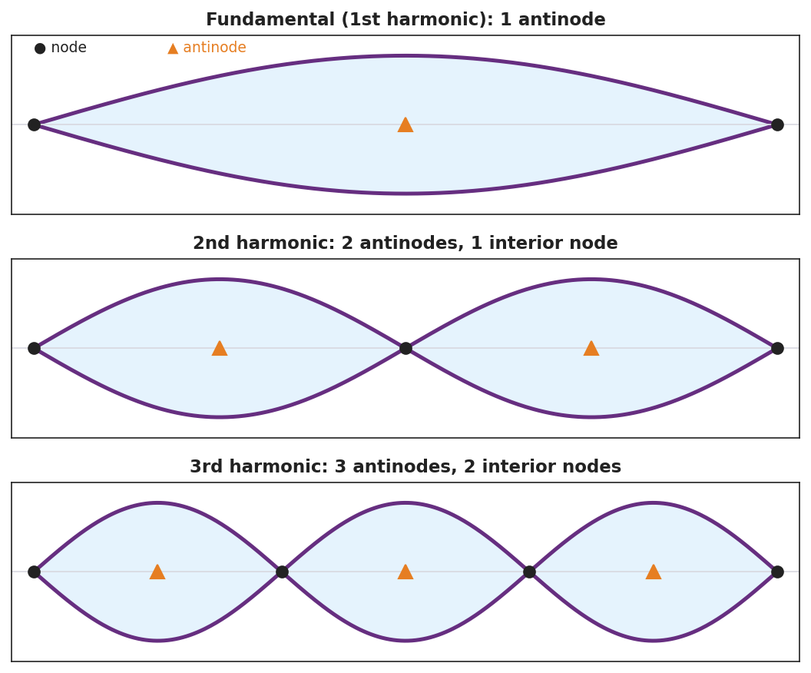
Three fixed-end standing-wave patterns: the fundamental (1 antinode), the 2nd harmonic (2 antinodes, 1 interior node), and the 3rd harmonic (3 antinodes, 2 interior nodes), with nodes and antinodes marked.
The resonance curve below explains why only the off-resonance test (step 3) gives a small, messy response — amplitude spikes sharply only at the natural frequency:
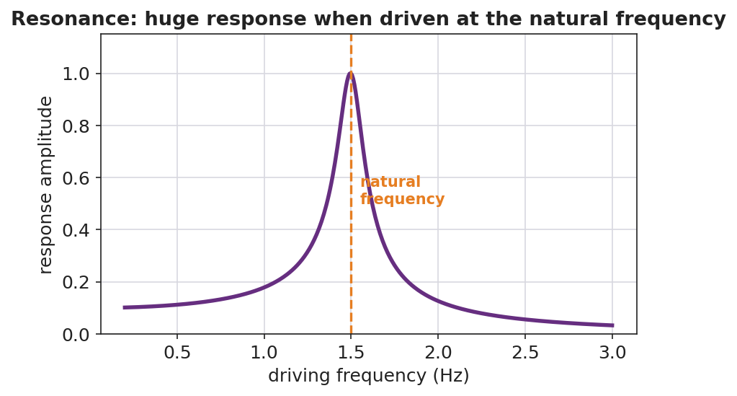
A resonance response curve: response amplitude is small at most driving frequencies but spikes sharply at the natural frequency.

Teacher facilitation during Explore
- What to look for — groups connecting “only certain hand-speeds work” to “only certain wavelengths fit between the ends.”
- What to resist — don’t name node/antinode/resonance yet; let “still point” and “big-swing point” and “the right speed” emerge.
- What to redirect — students who think the pattern travels should be asked, “do the loops move along the rope, or stay in place?”

Phase 3 · Explain (32 – 37 min)

32–35 min · Turn-and-Talk #2 + class consensus
“Why does only the right frequency make a clean, standing pattern?”
Target consensus:
“The wave reflects off the fixed end and travels back. At certain frequencies the returning wave lines up with the new wave so they always add the same way, creating a pattern that stays in place with fixed still points and big-swing points.”

35–37 min · Vocabulary introduction (≤ 3 terms)
Sample teacher language:
“A pattern that stays in place from a wave interfering with its own reflection is a standing wave. The points that never move are nodes; the points of maximum motion are antinodes. And when you drive a system at one of its natural frequencies and get this big response, that’s resonance — exactly how the opera singer shattered the glass.”

Discussion prompts to deploy here
- “How many nodes does the 3rd harmonic have between the two ends?”
  - Sample student response: “Two interior nodes (plus the two fixed ends).”
- “Why did the glass shatter only at one pitch?”
  - Sample student response: “That pitch matched the glass’s natural frequency — resonance built the vibration up until it broke.”

Phase 4 · Elaborate (37 – 40 min)

37–39 min · Revise the model
“Return to your rope sketch. Re-label the X’s as nodes and the stars as antinodes. Add a one-sentence definition of resonance using the word natural frequency.”

39–40 min · Return to the phenomenon
“Explain to a peer, in one sentence, why pushing a swing at just the right rhythm makes it go higher — and connect it to the rope and the glass.”
Target: “Pushing at the swing’s natural frequency is resonance, the same reason the rope locks into a standing wave and the glass shatters — driving at the natural frequency builds a large response.”

Phase 5 · Evaluate (40 – 42 min)

40–42 min · Exit Ticket + Closing Reflection
“A standing wave on a string shows 2 full loops between the fixed ends. (a) How many nodes are there in total (including the ends)? How many antinodes? (b) Define resonance in one sentence. (c) A bridge can sway dangerously if wind or marching feet hit a certain frequency. Which idea from today explains this?”
Expected: (a) 3 nodes (two ends + one middle), 2 antinodes; (b) resonance = large-amplitude response when a system is driven at its natural frequency; (c) resonance. See Answer_Key.docx.
Closing Reflection (SEL, 30 seconds):
“When did your group hit ‘resonance’ today — a moment where everything clicked? What made it work?”

Common Misconceptions
- Misconception: “A standing wave is not really moving.” → Correction: It is two waves moving in opposite directions; the pattern of nodes/antinodes stays fixed while the medium still oscillates.
- Misconception: “Any frequency makes a standing wave.” → Correction: Only the natural frequencies (where reflections line up) produce standing waves; other frequencies give a messy, small response.
- Misconception: “Resonance is just ‘loud.’” → Correction: Resonance is a large-amplitude response that occurs specifically when the driving frequency matches a natural frequency.

Access & Differentiation
- ELL/ENL supports: Sentence frame: “A node is a point that ______; an antinode is a point that ______. Resonance happens when the driving frequency ______ a natural frequency.” Word-choice box: {never moves, moves the most, matches, standing wave}. Pair node with a closed fist (no motion) and antinode with a wide wave of the hand.
- IEP/SPED supports: Provide the harmonics figure with blanks; students label N (node) and A (antinode) rather than drawing. Offer the hand-shaken rope as a tactile alternative to the function generator.
- Extensions: For a fixed-fixed string of length L, the fundamental wavelength is 2L. Have students predict the wavelengths of the 2nd and 3rd harmonics (L and 2L/3) and use v = f·λ to relate the harmonic frequencies.

Strategy Spotlight
ACTIVE LEARNING. Students physically sweep the driving frequency and “catch” each harmonic, marking the still points and big-swing points with their own hands before the words node, antinode, and resonance are introduced. The act of hunting — most frequencies fail, a few succeed — builds an intuition for natural frequencies that a lecture cannot. Facilitate with one prompt: “What’s special about the frequencies that work?”

NYSSLS Observation Checklist Crosswalk
# | Checklist item | Where it appears in this lesson
1 | Local/relatable phenomenon | Phase 1 — shattering glass, shaken rope; bridge/swing in Phase 4–5
2 | Turn and Talk (2–3×) | Phase 1 (TT#1 — still vs. big-swing points), Phase 3 (TT#2 — why only the right frequency)
3 | Students develop questions/models/procedures | Phase 1 (initial model), Phase 2 (harmonic hunt + Javalab), Phase 4 (revise)
4 | CCC defined and used | Lesson Overview · Cause and Effect, restated in Phase 2
5 | ENL — ≤ 3 vocab, second half | Phase 3 — vocabulary at 35–37 min (standing wave / node / resonance)
6 | Revisit phenomenon with evidence | Phase 4 — swing/glass/rope connection
7 | ENL/SPED supports | Access & Differentiation block
8 | Assessment check | Phase 5 — Exit Ticket (2-loop standing wave; bridge)

Companion Materials
- Student_Worksheet.docx — the 5E student investigation (hand out at start of Phase 2)
- Student_Notes.docx — guided note-guide for vocabulary and the worked example
- Answer_Key.docx — answers to “Make It Make Sense” prompts and the Exit Ticket

Key Vocabulary (max 3)
- standing wave — a fixed pattern of nodes and antinodes formed when a wave interferes with its own reflection in a bounded medium
- node — a point in a standing wave that stays at rest (no motion) because the two waves always cancel there
- resonance — the large-amplitude response that occurs when a system is driven at one of its natural frequencies

