Interference: Constructive and Destructive — Student Notes
Unit: Waves — Lesson 05 Name: _______________________ Date: __________ Period: ____

Learning Targets
By the end of today’s 42 minutes I can:
- State the principle of superposition.
- Distinguish constructive interference from destructive interference.
- Explain a real loud/quiet spot or noise-canceling situation.

Key Vocabulary
- superposition — _______________________________________________
- constructive interference — _______________________________________________
- destructive interference — _______________________________________________

Guided Notes
Superposition. When two waves overlap, the total displacement at each point is the __________ of the two waves at that point. You add them __________-by-__________.
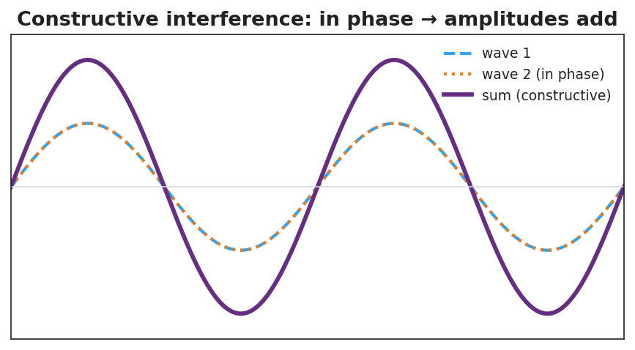
Two in-phase waves adding to a larger wave.
Constructive interference.
- The waves are __________ phase (crest lines up with crest).
- The amplitudes __________.
- Result: a __________ wave (louder / brighter).
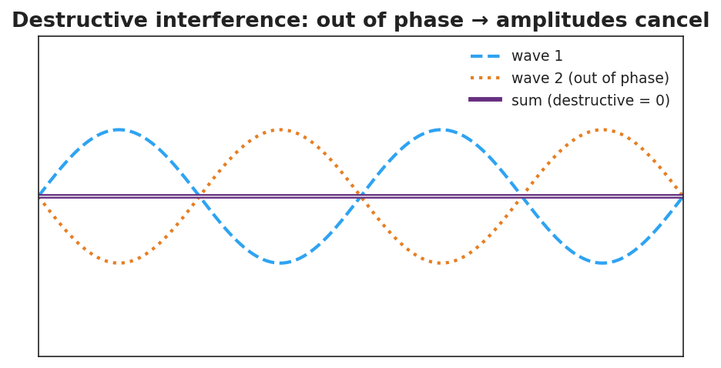
Two out-of-phase waves canceling to a flat line.
Destructive interference.
- The waves are __________ phase (crest lines up with trough).
- The amplitudes __________.
- Result: a __________ wave, or silence.
Energy is not destroyed. At a cancellation point the energy is __________ to the constructive (loud) regions — total energy is conserved.

Worked Example
Problem. Two waves, each with amplitude 5 cm, overlap. Find the resulting amplitude (a) exactly in phase, (b) exactly out of phase.
Solution. 1. In phase: amplitudes add → 5 + 5 = __________ cm (constructive). 2. Out of phase: amplitudes cancel → 5 − 5 = __________ cm (destructive). 3. So the same two waves can make a big wave or __________, depending on phase.

Summary
Finish the sentence (Because / But / So):
Two speakers playing the same tone can make a spot silent because __________________________________________, but __________________________________________, so __________________________________________.

