Interference: Constructive and Destructive — Student Worksheet
Unit: Waves — Lesson 05 Name: _______________________ Date: __________ Period: ____

Phenomenon
Two speakers play the exact same steady tone. As you walk across the room, the volume rises and falls — some spots are loud, some are nearly silent — and nobody touched the volume knob. Noise-canceling headphones do something even stranger: they add sound to create silence.
Driving question: How can adding a second wave make a spot quieter?

Notice & Wonder
I notice… | I wonder…
Turn & Talk #1: What would have to be true about two waves arriving at a quiet spot for them to cancel?

Initial Model
Draw two waves arriving at the same point. Draw one version that makes a LOUD spot and one that makes a QUIET spot. What is different about how the crests line up?

Investigation
Work in your random group of 3 at a vertical surface (one marker). Solve each task, then confirm in Javalab.
Task | Sketch the sum | What I found
1. Crest-on-crest
2. Crest-on-trough
3. Shift one wave by ½ wavelength
4. Why does covering one speaker make a quiet spot loud?
Compare your sketches to these:
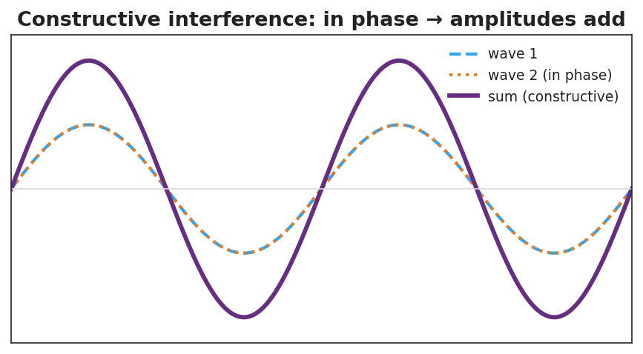
Two in-phase waves adding to a larger wave — constructive interference.
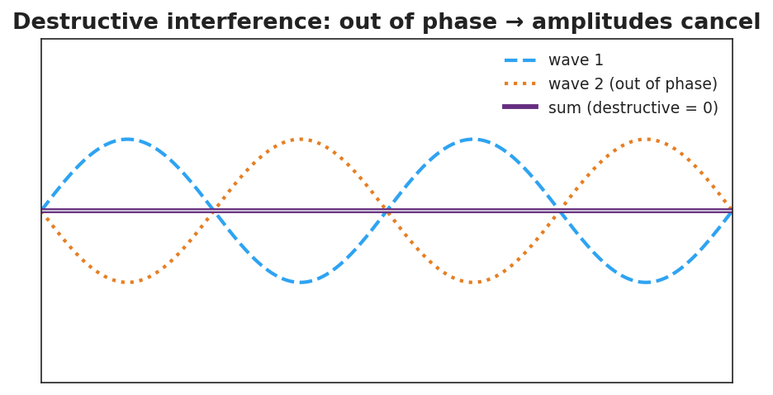
Two out-of-phase waves canceling to a flat line — destructive interference.
Key question: When two waves cancel at a quiet spot, where did the energy go? Is it gone everywhere?

Make It Make Sense
- State the principle of superposition in your own words.
- Two waves of amplitude 3 cm meet exactly in phase. What is the resulting amplitude? What if they meet exactly out of phase?
- Explain how noise-canceling headphones make a hum disappear. Use the term destructive interference.

Vocabulary in Action
Use each term in a sentence about today’s phenomenon.
- superposition: _______________________________________________
- constructive interference: _______________________________________________
- destructive interference: _______________________________________________

Revise Your Model
Return to your loud-spot and quiet-spot drawings. Label one constructive and one destructive. Add a sentence using the word superposition.

Exit Ticket
Two speakers play the same tone. At one point in the room a listener hears almost nothing.
- Is this constructive or destructive interference?
- Describe how the two waves are arriving at that point (in phase or out of phase?).
- Two waves of amplitude 4 cm meet exactly in phase. What is the resulting amplitude?

