The Doppler Effect — Student Notes
Unit: Waves — Lesson 06 Name: _______________________ Date: __________ Period: ____

Learning Targets
By the end of today’s 42 minutes I can:
- Explain the Doppler effect as an apparent shift caused by relative motion.
- Predict that an approaching source sounds higher and a receding source sounds lower.
- Connect light’s redshift to evidence for an expanding universe.

Key Vocabulary
- Doppler effect — _______________________________________________
- frequency shift — _______________________________________________
- redshift — _______________________________________________

Guided Notes
The big idea. The source makes a __________ frequency. But if the source (or observer) is __________, the observed frequency changes.
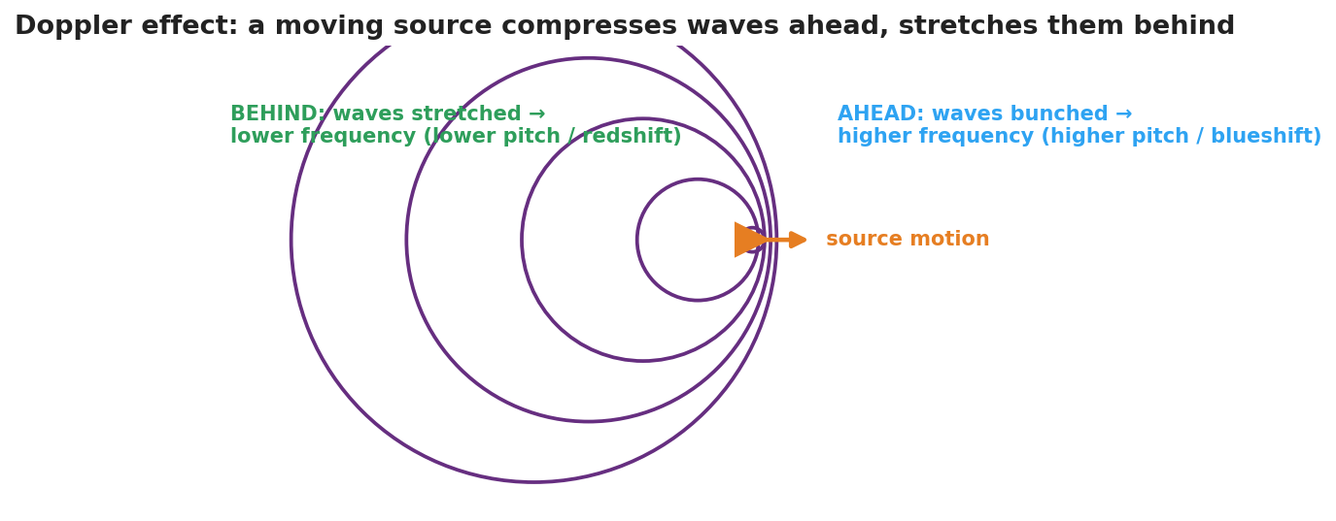
Wavefronts from a source moving right: bunched ahead, stretched behind.
Approaching source.
- Wavefronts ahead are __________ (bunched).
- Shorter wavelength → __________ frequency → higher pitch.
- For light: shifted toward blue (__________).
Receding source.
- Wavefronts behind are __________ (spread out).
- Longer wavelength → __________ frequency → lower pitch.
- For light: shifted toward red (__________).
Important: the wave speed does not change — only the observed __________ and __________ change.
Connection to astronomy (HS-ESS1-2). Distant galaxies show __________, so they are moving __________ from us — evidence the universe is __________.

Worked Example
Problem. You stand on a corner. A fire truck with a constant 700 Hz siren drives toward you, then away.
Solution. 1. As it approaches, the wavelengths bunch up, so you hear a frequency __________ than 700 Hz. 2. As it recedes, the wavelengths stretch, so you hear a frequency __________ than 700 Hz. 3. The driver always hears __________ Hz, because there is no relative motion between the driver and the siren.

Summary
Finish the sentence (Because / But / So):
A passing siren drops in pitch because __________________________________________, but __________________________________________, so __________________________________________.

