The Doppler Effect — Student Worksheet
Unit: Waves — Lesson 06 Name: _______________________ Date: __________ Period: ____

Phenomenon
An ambulance races past you. The driver hears one steady siren the whole time — but you, on the curb, hear the pitch drop the instant it passes. Out in space, astronomers see the light from distant galaxies “shifted” toward red.
Driving question: If the siren makes the same pitch the whole time, why do you hear it change?

Notice & Wonder
I notice… | I wonder…
Turn & Talk #1: If the siren’s pitch is constant, why does the listener on the curb hear it change?

Initial Model
Draw a source sitting still, making circular wavefronts. Then draw the same source moving to the right. Show what happens to the spacing of the wavefronts ahead of it and behind it.

Investigation
Open Javalab Doppler Effect.
Step | What I observed
1. Stationary source — wavefront spacing
2. Moving source — spacing ahead vs. behind
3. Observer ahead vs. behind — who hears higher f?
4. Light version — toward = ______ , away = ______
Compare to this diagram:
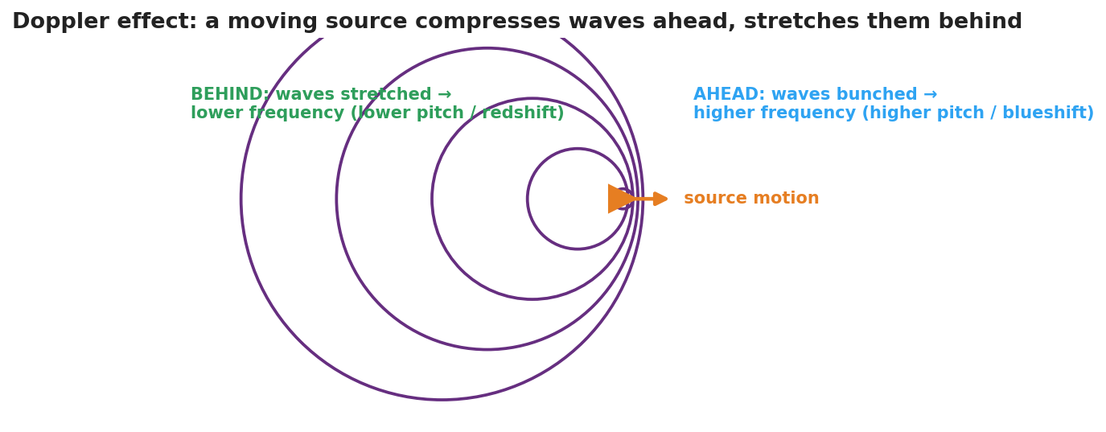
Wavefronts from a source moving right: bunched ahead (higher frequency / blueshift), stretched behind (lower frequency / redshift).
Key question: When the source moves toward an observer, what happens to the wavelength they receive — and therefore to the frequency they hear?

Make It Make Sense
- Why does an approaching source sound higher in pitch? Use the word wavelength.
- A star’s light is redshifted. Is it moving toward us or away from us? How do you know?
- Does the Doppler effect change the speed of the wave in the medium? Explain.

Vocabulary in Action
Use each term in a sentence about today’s phenomenon.
- Doppler effect: _______________________________________________
- frequency shift: _______________________________________________
- redshift: _______________________________________________

Revise Your Model
Return to your moving-source drawing. Label the bunched side “higher frequency (blueshift)” and the stretched side “lower frequency (redshift).” Then write a Because / But / So sentence.
Because __________________________________________, but __________________________________________, so __________________________________________.

Exit Ticket
A race car drives past a spectator.
- Does the engine sound higher or lower as it approaches? Explain using wavelength.
- After it passes, what happens to the pitch and why?
- Astronomers see the light from a distant galaxy redshifted. What does this tell us about the galaxy’s motion, and what does that suggest about the universe?

