The Electromagnetic Spectrum — Student Notes
Unit: Waves — Lesson 07 Name: _______________________ Date: __________ Period: ____

Learning Targets
By the end of today’s 42 minutes I can:
- State that electromagnetic waves are transverse and travel at the speed of light in a vacuum.
- Order the spectrum from radio to gamma by increasing frequency.
- Explain that all EM waves share c, so frequency and wavelength trade off.

Key Vocabulary
- electromagnetic wave — _______________________________________________
- spectrum — _______________________________________________
- speed of light — _______________________________________________

Guided Notes
What EM waves have in common.
- They are __________ waves (electric and magnetic fields oscillate perpendicular to travel).
- They need __________ medium — they travel through a vacuum.
- They all travel at the __________ of light, c = 3.0 × 10⁸ m/s, in a vacuum.
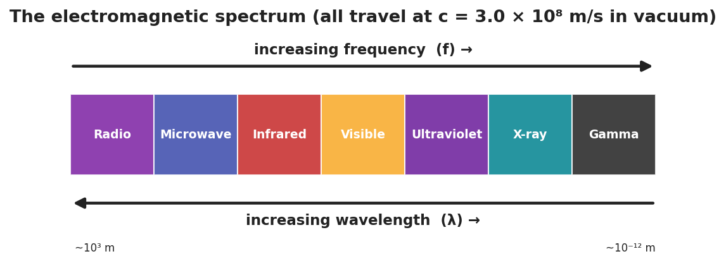
The electromagnetic spectrum from radio to gamma, with frequency and wavelength axes.
The order (low frequency → high frequency):
Radio → Microwave → __________ → Visible → __________ → X-ray → __________
- As frequency __________, wavelength __________ (because v = c is fixed: v = f·λ).
- Visible light is a __________ (small) band between infrared and ultraviolet.

Worked Example
Problem. An FM station broadcasts at 100 MHz (1.0 × 10⁸ Hz). Find its wavelength. (c = 3.0 × 10⁸ m/s)
Solution. 1. Use v = f·λ with v = c: λ = c / f. 2. λ = (3.0 × 10⁸) / (1.0 × 10⁸) = __________ m. 3. Compare: an X-ray’s wavelength is about 10⁻¹⁰ m — far __________ than a radio wave’s. ✓

Summary
Finish the sentence (Because / But / So):
A radio wave and an X-ray are the same kind of wave because __________________________________________, but __________________________________________, so __________________________________________.

