Refraction and Snell’s Law — Student Notes
Unit: Waves — Lesson 08 Name: _______________________ Date: __________ Period: ____

Learning Targets
By the end of today’s 42 minutes I can:
- Explain that light bends (refraction) when its speed changes between media.
- Use the index of refraction and Snell’s law to find an unknown angle or index.
- Describe total internal reflection.

Key Vocabulary
- refraction — _______________________________________________
- index of refraction — _______________________________________________
- Snell’s law — _______________________________________________

Guided Notes
Why light bends. When light crosses into a new medium, its __________ changes. Its frequency stays the __________, so its wavelength changes — and the ray pivots, bending at the boundary.
- Into a slower (higher-n) medium → bends __________ the normal.
- Into a faster (lower-n) medium → bends __________ from the normal.
Index of refraction: n = c / v.
- Vacuum: n = __________
- Water: n ≈ __________
- Glass: n ≈ __________
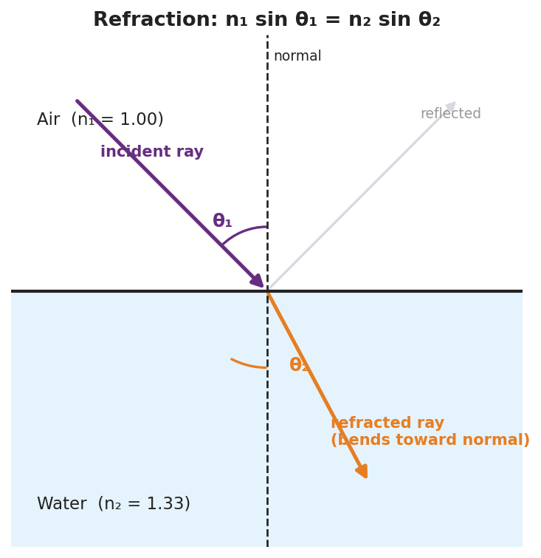
Refraction at an air–water boundary with the normal, θ₁, θ₂, and n₁ sin θ₁ = n₂ sin θ₂.
Snell’s law (reference table):
n₁ sin θ₁ = n₂ sin θ₂
Angles are always measured from the __________ (not the surface).
Total internal reflection. Going from a slower to a __________ medium, past a critical angle the light cannot escape and __________ entirely. (This is how fiber-optic cables carry data.)

Worked Example
Problem. Light goes from air (n₁ = 1.00) into glass (n₂ = 1.50) at θ₁ = 30°. Find θ₂.
Solution. 1. Snell’s law: n₁ sin θ₁ = n₂ sin θ₂. 2. sin θ₂ = (n₁ sin θ₁) / n₂ = (1.00 × sin 30°) / 1.50 = (1.00 × 0.500) / 1.50 = __________. 3. θ₂ = sin⁻¹(0.333) ≈ __________°. 4. Check: θ₂ < θ₁, so the ray bent __________ the normal (entered a slower medium). ✓

Summary
Finish the sentence (Because / But / So):
A pencil looks broken in a glass of water because __________________________________________, but __________________________________________, so __________________________________________.

