Refraction and Snell’s Law — Student Worksheet
Unit: Waves — Lesson 08 Name: _______________________ Date: __________ Period: ____

Phenomenon
A pencil standing in a glass of water looks broken at the surface. A laser beam fired into a tank of water kinks the instant it hits the water. And a Pyrex stirrer placed in oil of just the right kind seems to vanish completely.
Driving question: What changes for the light right at the surface that makes it bend?

Notice & Wonder
I notice… | I wonder…
Turn & Talk #1: The laser bends only at the boundary, not inside the water. What does that tell you about what causes the bend?

Initial Model
Draw a ray hitting the water at an angle. Draw the normal (perpendicular to the surface). Predict: when the light slows down, does the ray bend toward the normal or away from it?

My prediction: _______________________________________________

Investigation
Open PhET Bending Light. Fire rays from air into water and measure angles from the normal.
Incident angle θ₁ | Refracted angle θ₂ | sin θ₁ | sin θ₂ | sin θ₁ ÷ sin θ₂
Use this ray diagram to set up your geometry:
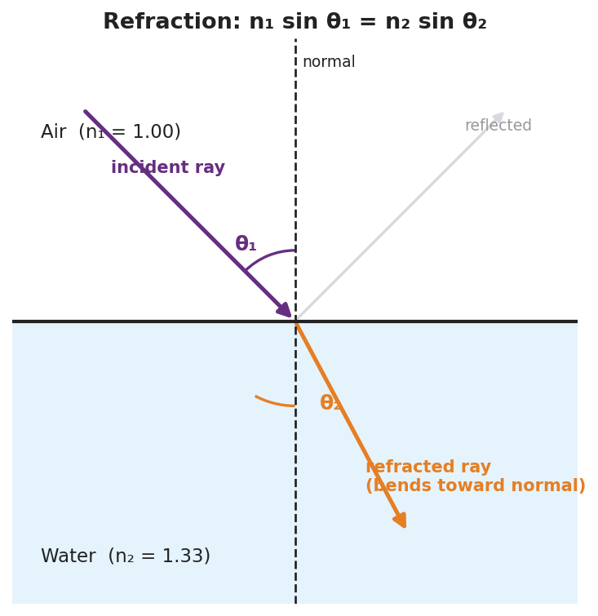
Refraction at an air–water boundary: normal, incident ray θ₁ in air (n₁ = 1.00), refracted ray θ₂ in water (n₂ = 1.33), labeled with n₁ sin θ₁ = n₂ sin θ₂.
Key question: What is the value of sin θ₁ ÷ sin θ₂? How does it compare to n₂ ÷ n₁ for air→water (≈ 1.33)?

Make It Make Sense
- Light goes from air (n = 1.00) into glass (n = 1.50) at θ₁ = 30°. Use Snell’s law to find θ₂. Show your work.
- Why does light bend toward the normal when it enters a slower (higher-n) medium? Write a Because/But/So sentence.
- Total internal reflection: under what conditions can light not escape a medium, reflecting entirely instead?

Vocabulary in Action
Use each term in a sentence about today’s phenomenon.
- refraction: _______________________________________________
- index of refraction: _______________________________________________
- Snell’s law: _______________________________________________

Revise Your Model
Return to your prediction. Label the incident angle θ₁, the refracted angle θ₂, and the normal. Confirm: into a slower medium, the ray bends toward the normal. Write your Because/But/So sentence.
Because __________________________________________, but __________________________________________, so __________________________________________.

Exit Ticket
Light travels from air (n = 1.00) into water (n = 1.33).
- The incident angle is 40°. Use Snell’s law to find the angle of refraction. Show your work.
- Does the ray bend toward or away from the normal? Why?
- The Pyrex stirrer “disappears” in oil of the same index. Explain why, in one sentence.

